**FALL PROTECTION AND ROOFTOP SAFETY PLAN**

Falls from elevation are a major cause of injuries and deaths in the workplace. Whitman College is committed to eliminating injuries caused by falls and especially falls from heights of four feet or greater.

Fall protection and rooftop safety are addressed in three separate sections of this plan

* Maintenance
* Structural Work on Low Pitch Surfaces
* Other Elevated Work

DEFINITIONS

*Competent Person*: A competent person must

* Be knowledgeable of WAC 196-155, Part C-1; and
* Know the provisions of this plan; and
* Be able to identify existing and potential fall hazards; and
* Have authority to take prompt corrective action to eliminate those hazards

*Elevated surface*: A surface 48” or more above the ground or the next lower level

*Fall protection system:* Mechanical devices compliant with WAC 296-155-24613, or a safety watch conducted in accordance with WAC 296-155-24615

*Low-pitch roof*: A roof having a slope of 4:12 or less

*Mechanical equipment*:All motor or human propelled wheeled equipment except for wheelbarrows, mopcarts, robotic thermoplastic welders and robotic crimpers.

*Protected edge*: The edge of an elevated surface where a wall or guardrail compliant with WAC 296-24-75011 is present

*Safety watch*: A fall protection system in which a competent person monitors one worker who is engaged work on low pitch roofs only.

*Unprotected edge*: The edge of an elevated surface not protected by a wall or guardrail compliant with WAC 296-24-75011

MAINTENANCE

Maintenance work consists of activities such as general surface cleaning, repair and service of HVAC systems, installation and maintenance of electrical and optical devices used for instruction and/or research, and radio communications gear. It does not include installation, modification, maintenance or repair of roofing or other structural materials attendant to such equipment, or structural elements of the building itself.

Maintenance work may be conducted under certain conditions on low-pitch rooftops without use of fall protection systems:

* Employees performing work must be knowledgeable of this plan and understand all its elements
* Portable ladders and scaffolding may not be used for work conducted under the provisions of this section of the plan
* Permissible MSM work areas may be marked by means of painted lines, warning lines (lain on surfaces or strung on pylons), or physical barricades
  + If the work area is not marked take extra care to ensure no employee approaches closer than six feet to an unprotected edge
* Employees must remain at least six feet from any unprotected edge, at all times (see diagram below)

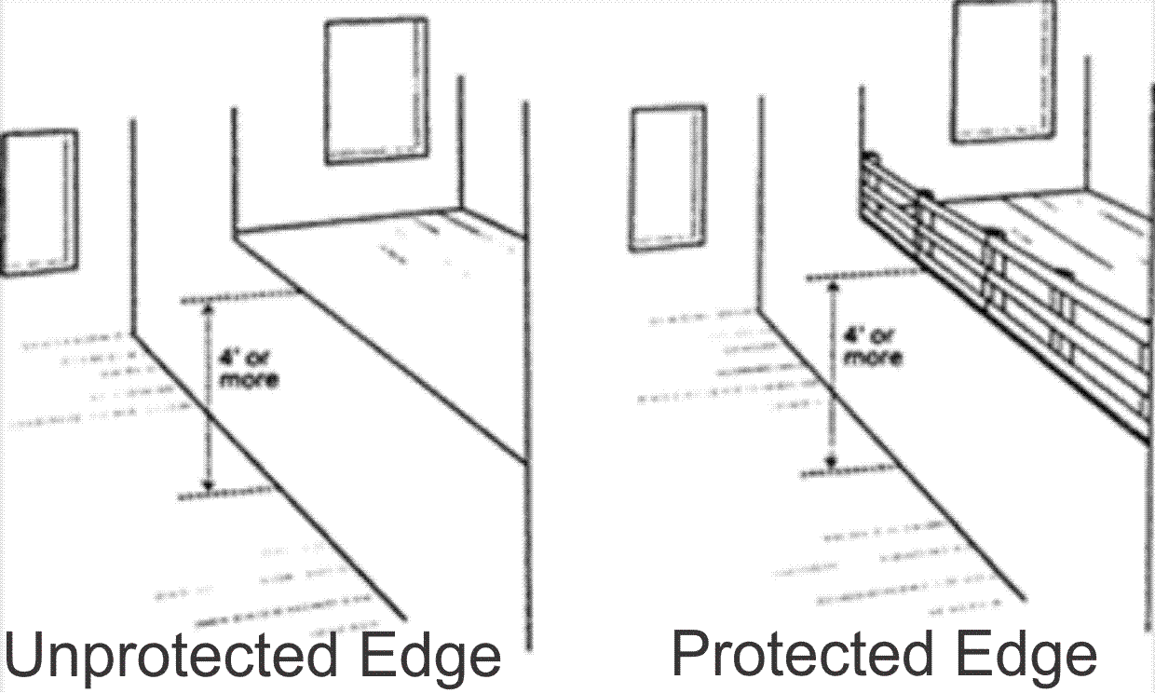

* Maintenance work requiring employees to at any time approach closer than six feet to an unprotected edge or skylight, or to stand upon an elevated surface other than a low pitch roof must be conducted in accordance with the other provisions of this plan, as appropriate to the work.

STRUCTURAL WORK ON LOW PITCH SURFACES

Structural work consists of activities such as repair and service of windows, skylights, roofs and walls, surface preparation and painting, and replacement/installation of building structural elements.

Structural and maintenance work may be conducted under certain conditions on low-pitch surfaces using a safety watch as the fall protection system. In order to utilize a safety watch for fall protection the following conditions apply:

* Employees performing work must be knowledgeable of this plan and understand all its elements
* The safety watch must be a competent person
* A Fall Protection Work Plan (FPWP) (below) must be completed prior to commencement of work on surfaces with unprotected edges.
* Only one employee, other than the safety watch, may be on the surface covered by the FPWP while work is occurring
  + If any person(s) other than the employee performing the work and the safety watch preset themselves on the rooftop, work must be stopped until they depart
* Mechanical equipment may not be utilized

Appropriate fall protections systems will be provided, installed and implemented according to the requirements of WAC 296-155 Part C-1 when employees are exposed to fall hazards of four feet or more to the ground or lower level

All work sites with fall hazards of 10 feet or more will have a site-specific, job specific **fall protection work plan** completed before any employees begin work. The employees on that specific job will be trained in the fall hazards and the method used to implement fall protection. The attached training guide will be used to train employees in the inspection and maintenance of their fall protection equipment, as well as fall protection selection criteria. Employees who fail to follow this policy are subject to disciplinary action, up to and including dismissal.

The evaluation of the jobsite and the completion of the fall protection work plan will be done by a designated “competent person,” who has an understanding of WISHA fall protection requirements, the fall protection systems available for use, and has the authority to take corrective action to eliminate employee exposure to fall hazards.

Fall protection will be provided either through the use of a fall arrest system or a fall restraint system thoroughly described in the fall protection work plan available on site for review.

**FALL PROTECTION WORK PLAN**

Date _____________________

Site Address ___________________________________________________________

Identify all fall hazards 10’ or more above the ground or lower level (check all that apply)

__ open-sided walking/working surfaces (i.e. roof with unprotected edge)

__ open-sided ramps, runways, platforms

__ floor openings

__ wall openings

__ skylight openings

__Trenches

__ Surfaces that do not meet the definition of a walking/working surface (i.e. top plate)

**\*\*Walking/working surface** = any area whose dimensions are 45 inches or greater in all directions, through which workers pass or conduct work.

Methods of fall protection used (check all that apply):

__ Safety Watch: **Low Slopes Only** (4:12 pitch or less)

__ Personal fall arrest system

__ Boom lift

__ Scissor lift

__ Other: _____________________________________________________________

Describe procedures for assembly, maintenance, inspection, disassembly of fall protection system to be used. ______________________________________________

______________________________________________________________________

______________________________________________________________________

Describe procedures for handling, storage, and securing tools, equipment, and materials.

______________________________________________________________________  
  
___________________________________________________________________

Describe methods of overhead protection for workers who may be in, or pass through work area. ______________________________________________________________________

______________________________________________________________________

______________________________________________________________________

Describe methods to be implemented for prompt, safe removal of injured worker(s).

______________________________________________________________________

______________________________________________________________________

______________________________________________________________________

______________________________________________________________________

______________________________________________________________________

Employees who received training on the above site specific fall protection work plan.

**Name (print) Date**

Name & title of person who provided training:

_____________________________________________________________