COME AND CLIMB!
Come and climb at the Whitman climbing center! The Climbing Center is located on the south end of the Sherwood Athletic Center. The Center is open to students, staff & faculty for free and they may bring family members and 2 guests for a small fee. Alumni are welcome for a small fee per use and can bring family and 2 guests.

Any level of experience can come and climb. Equipment rentals are available and clinics are held periodically for those wishing to learn more. All users need to sign the Climbing Center liability waivers. Parents need to sign waivers for minors 6-17. Anyone wishing to climb on the vertical wall needs to take a proficiency test. Bouldering requires signing the waivers and watching a safety video.
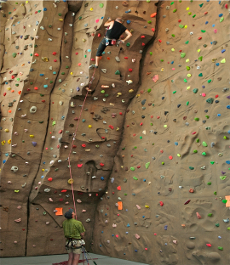
Arranged climbs for non-profit organizations possible. Contact OP Director for details.

FUN FACTS
The wall at the Climbing Center was custom built by EntrePrises Climbing Walls USA. It is made of hundreds of imprint and freeform panels that give a unique climbing experience with tremendous variety. Here are some interesting facts:
- The total climbable surface area is 5,600 ft² and exceeds 7,000 ft² when accounting for three-dimensional features and cracks.
- The main wall is 104’ long and 32.7 feet (10 meters) high with a popup section reaching a height of 39.24 feet (12 meters).
- There are 34 top rope anchors allowing for a wide variety of top rope routes.
- Many sections of the wall have been designed to mimic natural features allowing different types of climbing from crack climbing to face climbing to steep overhanging bouldering.

- The bouldering area is 98’ long and overhangs as much as 45 degrees in places.
- Eight TruBlue2 Autobelays available for use

WHITMAN
CLIMBING
CENTER
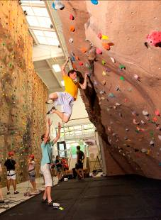
http://www.whitman.edu/outdoor_program
Sherwood Athletic Center
47 Park Ave.
Walla Walla WA, 99362

OP rental shop Climbing Center
509-527-5965 509-527-5223

CLINICS
Specific schedule and sign-ups at
Climbing Center entrance desk. If enough people have not signed up 24 hrs before the clinic, we will cancel it.

Basics Clinic (2 hrs)
$6/$12 (non-student)
Learn to top-rope climb and belay to begin using the vertical wall.
*cost includes shoes, harness and belay device

Lead Clinic (6 hrs)
$25/$35 (non-student)
Learn to lead climb and belay at the wall and outside.
*cost includes shoes, harness, and belay device

Special Clinics
Varied hours & pricing
Gri Gri, Movement and Route Setter clinics on a rotating schedule.

PROFICIENCY TESTS Free
Take a top rope or lead climb proficiency test to be able to climb on the vertical wall.

HOURS OF OPERATION
Academic Year
Monday-Thursday: 4:00-10:00pm
Friday-Sunday: 2:00-6:00pm

Summer
Monday-Thursday: 6:30-9:00pm
June - mid August

Equipment rental:
Shoes $3.50/$4.50
Harness $2.50/$3.50
Proficiency tests $10
Belay device (ATC or grigri) $1/$2
Package(shoes,harness&ATC) $6/10
Indoor Lead Rope $2
Helmets Free
Full Semester Shoes $40/$50
Full Semester Equipment Package $50/$65
Lost card fee $5

*the first price is for Whitman Community, the second price is for Whitman Community family/guests

DAY USE FEES:
- Whitman Community: Students, Faculty & Staff, Whitman retirees & Faculty Emeritus – free
- Alumni Members : $8
- Family of Alumni and Whitman Community : $8
- Guest: anyone that doesn’t fit into the preceeding categories and is accompanied by a member of the Whitman Community - $10

SWIPE CARDS:
- 5 Swipe Alumni/Family of Alumni and Whitman Community: $35
- 5 Swipe Guest: $45
- 10 Swipe Alumni/Family of Alumni and Whitman Community: $64
- 10 Swipe Guest: $80

Important Rules
- No loose chalk
- Must use own rope for leading or rent a lead rope
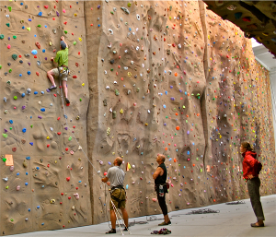

QUESTIONS?

Please Contact the Outdoor Program Director Brien Sheedy at (509) 386-4375 or at sheedybr@whitman.edu.

