Thesis Statements
By Allie Donahue
Your thesis is your primary claim, the main idea of the paper. It is what makes your paper interesting and it is what drives your paper forward. All academic papers have a thesis. A good thesis is specific, clear, prominent, defensible, intriguing and evolving. This handout presents these thesis characteristics and then offers steps to help you develop your thesis.
Thesis Statement Components
- Specific
Avoid general statements. Your thesis statement should make a specific argument about your topic.

- Clear
The reader should understand exactly what you’re getting at in your thesis. Be sure that your grammar is correct. Use active voice. Avoid extra-long sentences. Shoot for precise language.

- Prominent
Your reader should know exactly where your thesis statement is located in your paper. It should be easy to point out in the introduction.

- Defensible
You must have evidence to support your thesis. If you don’t, you can’t defend it.

- Intriguing
Your thesis needs to make your reader think. It cannot be obvious. Your thesis should make your reader scratch her head and murmur, “Aha, I’ve never thought about it that way before.”

- Evolving
Your thesis is not a static argument that appears in an identical form in the intro and conclusion of your paper. Instead, your thesis should develop. As you present your evidence, your thesis should grow more complex. Reveal your evidence in a logical order that supports the evolution of your thesis. For example, the evidence you present in the first paragraph should help the reader grasp the growing complexity of your thesis in the second paragraph.

These conceptual graphics visually represent thesis statement evolution.
Graphic concept from Writing Tutor Jesse Moneyhun, class of 2017
Evolving thesis

Evidence is connected and continually contributes to the growing complexity of the thesis.

Non-evolving thesis

Evidence is disconnected. Evidence is simply discrete examples of the original thesis. The thesis does not develop.

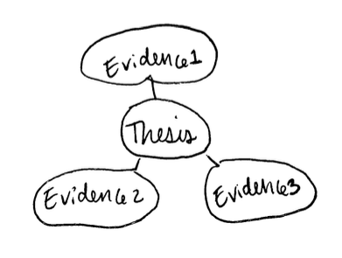
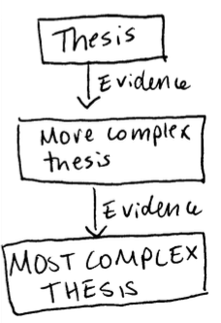

Developing your Thesis Statement

1. Analyze your resources. Look for tension and ambiguity. What intrigues you? Are there contradictions? Talk to a friend. Make an appointment with a COWS tutor. Ask questions.

2. Answer questions that came up in your analysis. This is the seed of your thesis. Write it down.

3. Outline or map out your paper. How does it support your initial thesis idea?

4. Revise your thesis. Adjust for logic-leaps and contradictions that arose in your outline.

5. Write through your paper. Notice how your thesis changes.

Write

revise

write

revise

repeat.

As you write, you will notice that your logic is constantly in flux. Plan on continually tweaking your thesis until the final draft of your paper.

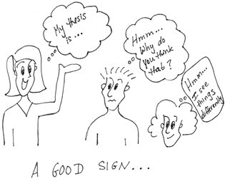
Comic by Lumen Learning
This handout does not cover everything there is to know about thesis statements; use it as a reminder or as a checklist, but certainly do not rely on it as an all-encompassing thesis statement authority. For more information on thesis statements, visit http://writingcenter.fas.harvard.edu/pages/developing-thesis, or better yet, visit the COWS library.

