**SUPERVISOR WEB TIMESHEET INSTRUCTIONS**

**FOR ASSISTANCE, CONTACT MINDY NEISSL, STUDENT PAYROLL COORDINATOR, EXT. 5130 OR** [**neisslmm@whitman.edu**](mailto:neisslmm@whitman.edu)**.**

Supervisors are responsible for reviewing and approving student hours worked at the end of the pay period. It is important to track student worker hours offline in order to verify what the student submits is correct.

**STUDENT PAY PERIOD & CUTOFF INFORMATION**

The student pay period is from the 9th of the month to the 8th of the following month. Student payday is on the 20th of the month. If the 20th falls on a Saturday, payday would be the Friday before. If the 20th falls on a Sunday, payday will be the following Monday.

Students should enter their time each day as they work during the month. Supervisors and students will have one and a half business days after the 8th to approve timesheets. The student has until noon on that day to make changes and the supervisor has until 2:00 pm on that day to give final approval. The “Complete Entry By” date is shown in the top right corner of the approval screen.

Supervisors should choose an earlier date for students to submit their timesheets to ensure there is sufficient time to review the time worked and have the students make corrections, if necessary. Supervisors should communicate this earlier deadline to students and send reminders to ensure it gets accomplished.

**STUDENT TIME APPROVAL**

You will receive an email letting you know when each student has completed and submitted their hours. To access the Web Timesheets:

* Log in to myWhitman.edu
* Click on the Staff tab
* Click on “Student Worker Time Approval”

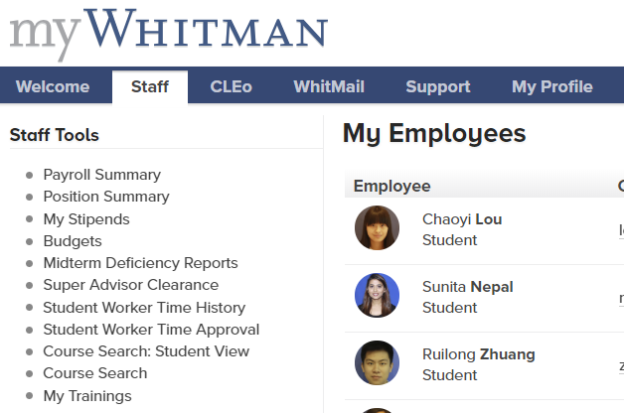

This is a current list of the students you supervise.

**Jack Doee Doe**

**John Doe**

**Jane Doee Doe**

**SS#1**

On the screen shown below, select the NAME of the student that you would like to review/approve from the list of students.

**SS#2**

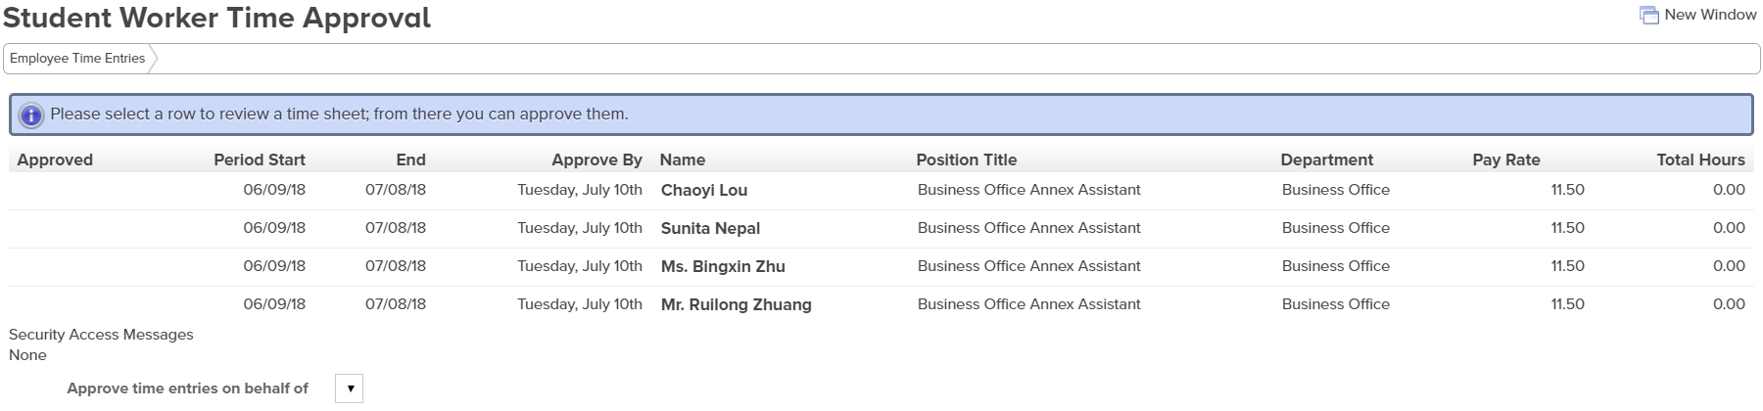

Jane Doe

Barney Ruble

Mindy Neissl

Mickey Mouse

If you are an alternate supervisor, you will not see all that the supervisor sees. You will not have the students listed on the SS#1 screen shot or the SS#2 screen shot. And you will not receive an email when the student has submitted their hours for review. You will need to click the drop down arrow where it says “Approve time entries on behalf of”. From this list, you will choose which supervisor you need to approve timesheets for.

On the top of the approval page below, you will see each student’s sick leave balance. This is how much they are able to use during the current pay period. Students can only enter Regular Hours and Sick Hours, they do not have an Overtime column as you do below. (More information on Sick Leave is listed below).

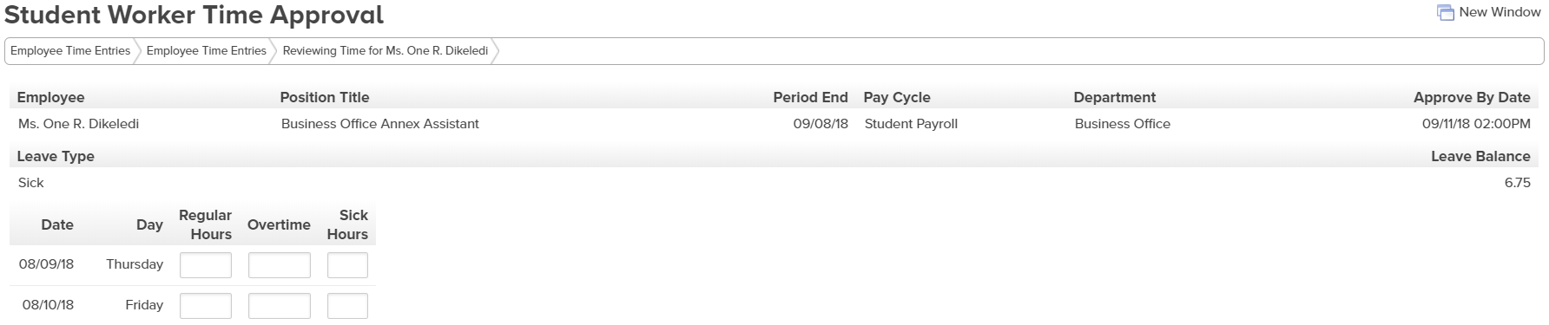

**SUPERVISOR APPROVAL/REJECTION**

After you review the student’s hours, go to the Supervisor Decision portion on the bottom of the form (see below). If it says NO by “Employee has electronically signed the time entry as complete”, that means this student has not completed and submitted their time to you. If you approve this timesheet now, you will lock the student out of the web timesheet system and we will have to track them down to come and sign a physical timesheet. This is very timely and it slows down the entire payroll process. This should be avoided if possible.

***It is the supervisor’s responsibility to ensure that all their student workers submit their time ELECTRONICALLY.***

***It is also the supervisor’s responsibility to approve all student worker timesheets ELECTRONICALLY.***

Use the drop down box to APPROVE or REJECT the student timesheet. If you are rejecting the timesheet, enter in the “E-mail Subject” and “Supervisor Comments”. This creates an email that is sent to the student to let them know why the timesheet was rejected and what they need to do to resubmit it. If you are not rejecting the timesheet, you do not put anything into these boxes. When you are done, click on “Save Changes” in the bottom right hand corner of the screen.

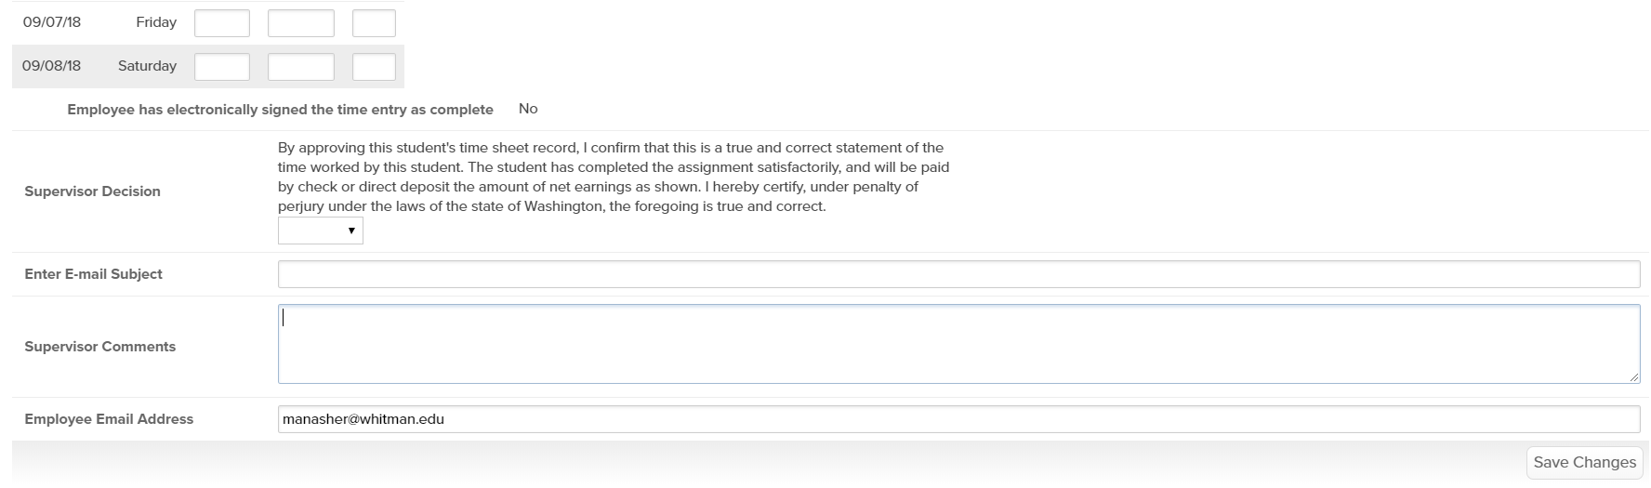

This should be marked yes when you review

Once the timesheet is approved or rejected, the student will receive an email stating that you approved or rejected it. If you reject the timesheet, the supervisor comments you entered will be included in the e‐mail. It is important to remember to include enough information to let the student know what to correct. After the student approves their timesheet, they will no longer have access to them. If they need to change a timesheet, you must reject it to allow them access.

***Supervisors are not to change a student’s timesheet in any way; they must be rejected for the students to make the changes.***

A green check mark will appear next to all students that have been approved.

Note: If a timesheet is not approved by both the student AND the supervisor, it will not be paid. The Payroll office must manually pull all information from the Web Timesheet system and create a paper timesheet of this information. They will then have to generate an e‐mail to each students and supervisor to notify them of missing approvals. Arrangements will have to be made with the Payroll office to approve the hours and arrange for payment. This is very timely and must be avoided if at all possible.

**SICK LEAVE INFORMATION**

Students can now accrue sick leave. Students earn 1.0 hour of sick leave for every 40.0 hours they work. To learn all about Student Sick Leave, go to the [Human Resources](https://www.whitman.edu/human-resources/student-employment/student-employee-paid-sick-leave) webpage.

**OVERTIME INFORMATION**

***\*OVERTIME IS NOT PERMITTED.***

***\*OVERTIME IS DEFINED AS WORKING MORE THAN 40 HOURS IN ONE WEEK.***

***\*THE 40 HOURS A WEEK INCLUDES HOURS WORKED IN ALL WHITMAN JOBS.***

***\*A WEEK IS DEFINED AS BEING FROM SUNDAY 12:00 AM TO SATURDAY 11:59PM***

***\*THE ACCUMULATION OF HOURS FOR A WEEK DOES NOT BEGIN AGAIN IF THE PAY PERIOD ENDS MID-WEEK***

***\*\*STUDENTS ARE NOT ALLOWED WORK MORE THAN 20 HOURS A WEEK (19 HOURS A WEEK FOR FEDERAL AND STATE WORK STUDY POSITIONS) DURING THE ACADEMIC YEAR WHEN CLASSES ARE IN SESSION. AGAIN, THIS IS AN ACCUMULATION OF ALL HOURS WORKED IN ALL WHITMAN POSITIONS.***

***\*\*STUDENTS CAN WORK UP TO 40 HOURS A WEEK DURING THE ACADEMIC YEAR WHEN CLASSES ARE NOT IN SESSION (I.E. WINTER BREAK, SPRING BREAK) AND DURING THE SUMMER (BETWEEN COMMENCEMENT AND THE FIRST DAY OF CLASSES OF THE FALL SEMESTER).***

**TECHINICAL DIFFICULTIES WITH WEB TIMESHEETS**

If you or your supervisor is having any technical difficulties that you cannot address, please contact the Student Payroll Coordinator first. If they cannot resolve the issue, they will contact IT to find a resolution. Please do not contact IT yourself.

More information can be found about Student Employment in the [Student Employment Handbook](https://www.whitman.edu/Documents/StudentLife/StudentEmployment/Student%20Employment%20Handbook%205.5%20x%208.5(2).pdf) on the Whitman website.

**STUDENT ADD/DELETE INFORMATION**

On Screen Shot #2 (SS#2), if you can see the student’s name on this screen, they can enter hours for the position listed. If any students no longer work for you, complete and submit a Student Employment End-Date Form available on the Business Office website [Student Payroll Forms](https://www.whitman.edu/business-office/forms). Likewise, if a student is missing from the list, complete and submit a Student New Employment Form to add them to the position. The completed forms should be submitted to [payroll@whitman.edu](mailto:payroll@whitman.edu).

Once you have cleaned up your student list by following the instructions above. Look at the students in the My Employee list as see on Screen Shot #1 (SS#1). If there are students on this list that no longer work for you, contact the Student Payroll Coordinator for assistance in updating this list.