**STUDENT WEB TIMESHEET INSTRUCTIONS**

**FOR ASSISTANCE, CONTACT MINDY NEISSL, STUDENT PAYROLL COORDINATOR, EXT. 5130 OR** [**neisslmm@whitman.edu**](mailto:neisslmm@whitman.edu)**.**

Students are responsible for tracking, entering and submitting their hours worked at the end of the pay period. When student payroll is being processed (generally between the 10th and 18th), you will not have access to your new Web Timesheet. Therefore, you need to log your hours separately to ensure you can remember the hours you worked.

**STUDENT PAY PERIOD & CUTOFF INFORMATION**

The student pay period is from the 9th of the month to the 8th of the following month. Student payday is on the 20th of the month. If the 20th falls on a Saturday, payday would be the Friday before. If the 20th falls on a Sunday, payday will be the following Monday.

Students should enter their time each day they work during the month. Supervisors and students will have one and a half business days after the 8th to complete timesheets. The student has until noon on cutoff day and the supervisor has until 2:00 pm on cutoff day. The “Complete Entry By” date is shown in the top right corner of the timesheet screen.

It is requested of supervisors to specify an earlier date that they expect students to submit their timesheets. Please follow the directions of your supervisor. This is done to ensure they have sufficient time to review the time worked and reject timesheets back to students for corrections, if necessary. Supervisors will communicate this earlier deadline to students.

**ENTERING STUDENT WORK HOURS**

To access Web Timesheets:

* Log in to myWhitman.edu
* Click on the Student tab
* Click on “Enter My Work Hours”

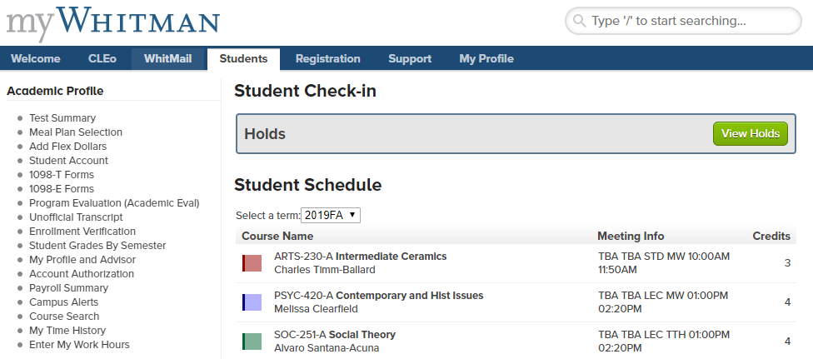

This is a current list of the students you supervise.

**Jack Doee Doe**

**John Doe**

**Jane Doee Doe**

On the screen shown below, select the POSITION TITLE you want to enter hours for. Be sure you enter hours into the correct position. You will notice this screen also includes the cutoff date/time under “Complete By Date”.

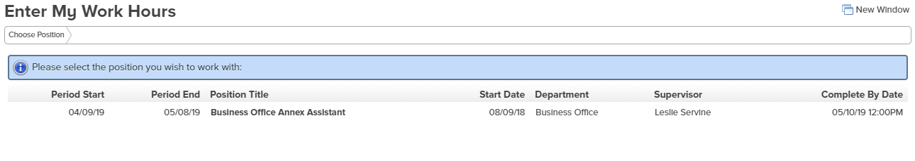

On the top of the Web Timesheet screen below, you will see your sick leave balance. This is how many hours that you have earned. And, if approved, this is how many hours you can use, for all positions, during the current pay period. You will have to keep track of sick hours used, as the system will allow you to enter up to your balance amount on each timesheet for each position you hold during the current pay period.

(More information about Sick leave below).

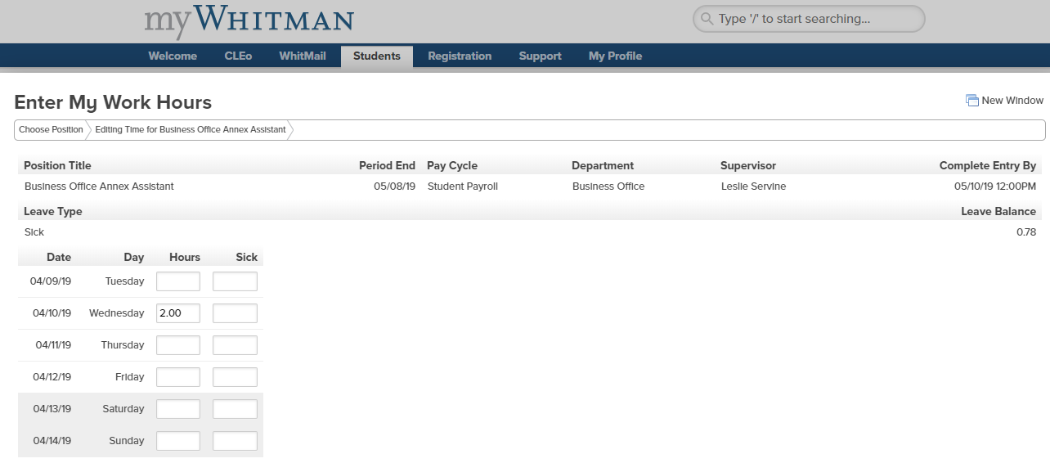

After you enter your hours during the pay period, you will only need to click on SAVE CHANGES at the bottom of the page to save your hours. Once you have entered all hours for the pay period and want to submit them for approval, you will need to click into the box that states, “Checking this box becomes your electronic signature acknowledging your submitted time as accurate and ready for supervisor approval”. And then click on SAVE CHANGES. At this point, you will no longer have access to this timesheet.

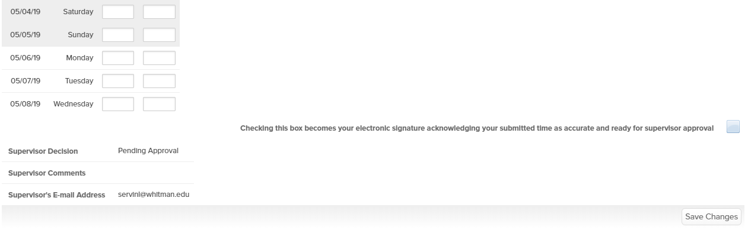

**SUPERVISOR APPROVAL/REJECTION**

Once the timesheet is approved or rejected by your supervisor, the student will receive an email. If you receive an email that your timesheet has been rejected, the supervisor will have comments to let you know why it was rejected. You will need to make any necessary changes and resubmit your timesheet prior to the deadline.

If a timesheet is not submitted by the student AND/OR not approved by the supervisor, it will not be paid. An e‐mail will be generated by the payroll office after each payroll’s due date, and students and supervisors will be notified via email of missing approvals. Arrangements will have to be made with the payroll office to approve the hours and arrange for payment.

**SICK LEAVE INFORMATION**

Students can now accrue sick leave. Students earn 1.0 hour of sick leave for every 40.0 hours they work. To learn all about Student Sick Leave, go to the [Human Resources](https://www.whitman.edu/human-resources/student-employment/student-employee-paid-sick-leave) webpage.

**OVERTIME INFORMATION**

***\*OVERTIME IS NOT PERMITTED.***

***\*OVERTIME IS DEFINED AS WORKING MORE THAN 40 HOURS IN ONE WEEK.***

***\*THE 40 HOURS A WEEK INCLUDES HOURS WORKED IN ALL WHITMAN JOBS.***

***\*A WEEK IS DEFINED AS BEING FROM SUNDAY 12:00 AM TO SATURDAY 11:59PM***

***\*THE ACCUMULATION OF HOURS FOR A WEEK DOES NOT BEGIN AGAIN IF THE PAY PERIOD ENDS MID-WEEK***

***\*\*STUDENTS ARE NOT ALLOWED WORK MORE THAN 20 HOURS A WEEK (19 HOURS A WEEK FOR FEDERAL AND STATE WORK STUDY POSITIONS) DURING THE ACADEMIC YEAR WHEN CLASSES ARE IN SESSION. AGAIN, THIS IS AN ACCUMULATION OF ALL HOURS WORKED IN ALL WHITMAN POSITIONS.***

***\*\*STUDENTS CAN WORK UP TO 40 HOURS A WEEK DURING THE ACADEMIC YEAR WHEN CLASSES ARE NOT IN SESSION (I.E. WINTER BREAK, SPRING BREAK) AND DURING THE SUMMER (BETWEEN COMMENCEMENT AND THE FIRST DAY OF CLASSES OF THE FALL SEMESTER).***

**TECHINICAL DIFFICULTIES WITH WEB TIMESHEETS**

If you or your supervisor is having any technical difficulties that you cannot address, please contact the Student Payroll Coordinator first. If they cannot resolve the issue, they will contact IT to find a resolution. Please do not contact IT yourself.

More information can be found about Student Employment in the [Student Employment Handbook](https://www.whitman.edu/Documents/StudentLife/StudentEmployment/Student%20Employment%20Handbook%205.5%20x%208.5(2).pdf) on the Whitman website.