Review Questions for Chapter 1: Some Fundamental Concepts.

- In the early 19th century the origin of igneous rocks was hotly debated between the “Plutonists,” who believed in an igneous origin, and the “Neptunists,” who believed that the crystalline nature originated as a submarine precipitate. What field and textural criteria can you imagine that would indicate the former rather than the latter?

- What distinguishes:
a. Volcanic from plutonic rocks?
b. Pyroclastic volcanics?
c. Magma from lava?
- What are the four principal compositional subdivisions of the Earth? What material or rock type broadly represents each and what is the approximate thickness of each?

- An alternative way to consider the makeup of the Earth is to categorize it on the basis of mechanical properties. What are the five principal rheological subdivisions of the Earth and how do their rheological properties differ?

- On the basis of your answers to questions 4 and 5, what defines the base of the crust and what defines the base of the lithosphere? Which one is shallower? What compositional subdivisions, then, make up the lithospheric plates?

- Why are the inner planets “terrestrial” and the outer planets “gaseous?”

- How do lithophile, chalcophile, and siderophile elements differ?

- According to theory, when and how did the core and mantle separate?

- The crust probably did not separate at the same time as the core/mantle. Do you have any idea how these two subdivisions (oceanic and continental crust) may have evolved?

- What type of meteorite do we think most closely approximates the composition of the early primitive mantle of the Earth? Why do we think so?

- What is the approximate pressure gradient of the Earth? What is the pressure at the base of typical (35 km thick) continental crust?

- What are the two principal sources of heat in the Earth?

- What are the four ways that heat can be transferred? Briefly describe each.

- Imagine you are sitting beside a campfire, roasting a sausage on an iron skewer. Describe the heat transfer processes in a practical sense with respect to your fire.

- What is meant by the geothermal gradient?

- What are reasonable average oceanic and continental geothermal gradients? Why is one greater than the other?

- What evidence do you have from your introductory geology class that large-scale melting is not a natural occurrence in the crust or mantle under normal geothermal conditions? (Hint: think about earthquakes).
Review Questions and Problem for Chapter 2:
Classification and Nomenclature of Igneous Rocks.

- What are the three principal categories of igneous rocks? What characterizes each?

- What is the difference between aphanitic and fine-grained?

- How does a felsic mineral differ from a mafic mineral? Which minerals on Bowen’s Series are mafic? Which are felsic?

- What does the term acidic mean, and how does it differ from felsic? How does basic differ from mafic?

- Does the IUGS system consider pure albite to be an alkali feldspar or a plagioclase feldspar? Why?

- Why does the QAPF diagram present problems for P-rich rocks? What are the three possible phaneritic P-rich rock names and on what basis they may they be distinguished?

- What are the two contrasting P-rich aphanitic rock names and how they are distinguished?

- What would you name a rock in which the weight percentage of Na₂O = 2%, K₂O = 4% and SiO₂ = 49%?

- What would you name a rock in which the weight percentage of Na₂O = 5%, K₂O = 3% and SiO₂ = 58%?

- What would you name a rock in which the weight percentage of Na₂O = 4%, K₂O = 4% and SiO₂ = 53%?

- What would you name a rock containing 60% ash, 30% fragments between 3 and 15 mm, and 10% fragments over 64 mm if it were a light pink color?

PROBLEM

Complete the table below, and, using the appropriate diagram, name each rock.
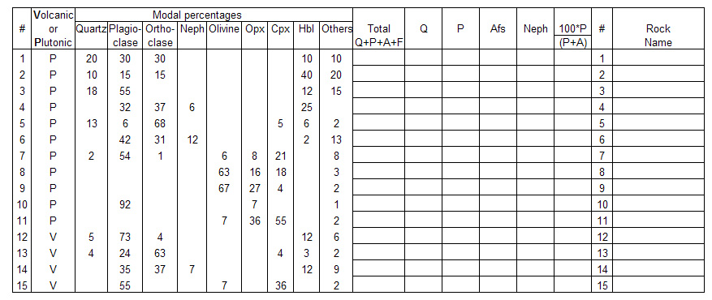
Review Questions for Chapter 3: Textures of Igneous Rocks.

- Other than the externally-imposed cooling rate, what are the three principal rates that govern rock texture?

- What is typically the determining (limiting) rate when large crystals form? Explain.

- What is the determining rate when dendritic crystallization takes place? Explain.

- What is the distinction between primary textures and secondary textures?

- Explain how porphyritic texture is most likely to develop.

- Pyroxene can be replaced by hornblende, biotite, or chlorite as a pluton cools. Hornblende can be replaced by biotite or chlorite. Biotite can be replaced by chlorite. What common feature of these sequences most easily explains them? Hint: look up the formulas of each mineral.

- Quartz commonly exhibits interstitial texture with respect to feldspars. What does this imply in terms of crystallization sequence? Why?

- What is “normal” zoning in a plagioclase? Give two reasons why plagioclase typically exhibits zoning in thin section whereas olivine does not.

- What is cumulate texture and how does it form?

- Are vesicles more plentiful in the upper portions or the lower portions of basaltic lava flows? Why?
Review Questions and Problems for Chapter 4:
Igneous Structures and Field Relationships.

- How does magma viscosity vary with the concentration of a) SiO₂ and b) H₂O? Explain.

- Basaltic eruptions are rarely explosive. What evidence is there, however, that basaltic magma, when erupted, contains significant dissolved volatiles?

- If both basaltic and rhyolitic magmas have considerable volatile content, why are rhyolite eruptions typically far more explosive?

- Contrast a shield and a composite/strato-volcano.

- What type of plutonic body would be associated with a fissure eruption?

- How does a maar differ from a scoria cone?

- How does an endogenous dome differ from an exogenous one?

- How does pahoehoe differ from aa?

- How do pyroclastic falls and flows differ in terms of the style of eruption and the type of material deposited?

- How do lava tubes form?

- What do columnar joints and mudcracks have in common?

- The dark shaded material in the cross-section of vertically tilted strata is tabular intrusive igneous rock. What are the names of each of the bodies A and B? Explain your choice of names.
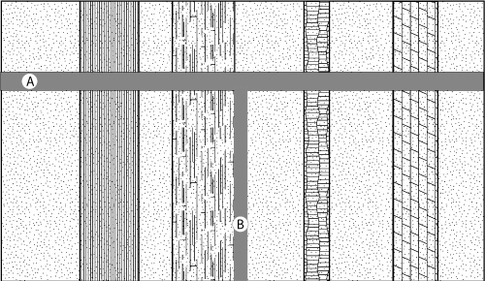

- Suppose you were to encounter a basaltic layer in a sequence of sedimentary layers. What field criteria would you look for to determine if it was emplaced as a flow or a sill?

- In what ways does a laccolith differ from a lopolith. Sketch each. Which is typically larger?

- How does a batholith differ from a stock? Discuss the merits of this distinction.

- How does a pluton and its margin in the catazone typically differ from one in the epizone?

- What do a roof pendant, a septum, and a raft have in common? In what way(s) do they differ?

- What is a diapir? Where in the Earth is diapiric rise of magma most likely? Why?

- Where in the Earth is roof lifting by a magma chamber most likely? Why?

- What is the principal limitation on the amount of material that can be assimilated by a magma body?

- Describe the “room problem.”

- What feature of batholiths has been revealed in the past few decades that best helps us to reconcile the room problem?

- What is the difference between juvenile and meteoric groundwater? Which is typically predominant in hydrothermal systems in geothermal areas?

PROBLEMS.

- Use the analyses in Table 8.3 and the procedure described in Appendix A to estimate the viscosity of basaltic magma at 1100 and 1400ºC, andesitic magma at 1100 and 1400ºC, and rhyolitic magma at 800 and 1100ºC. Explain your results.

- Use the spreadsheet in Appendix A and increase each oxide value for the basalt given by 10 relative percent (multiply each value by 1.1) and determine the percent increase or decrease in the resulting viscosity. Return each to the initial value before proceeding to the next. Which element(s) increase the viscosity? Why? Which elements most effectively decrease the viscosity? Why?
Review Questions and Problems for Chapter 5:
An Introduction to Thermodynamics.

- The molar Gibbs free energy of formation of quartz is the energy change involved in the reaction of Si metal with O₂ gas to form a mole of quartz SiO₂: Si (metal) + O₂ (gas) = SiO₂ (quartz). What does the value = –856.3 kJ/mol tell us about the stability of quartz (as compared to Si metal and O₂ gas) at 25ºC and 1 atmosphere pressure? Explain.

- What would be the entropy of any phase at 0K? Explain. Can you explain this on the molecular level?

- How do we determine the enthalpy of formation of a mineral?

- In what order would you place crystals, gases, and liquids in terms of increasing (molar) entropy. Explain.

- In what order would you place crystals, gases, and liquids in terms of increasing (molar) volume. Explain.

- At constant pressure, dP = 0, so dG = -SdT. We could integrate eq. 5-3 (assuming a constant S) to produce:
so that where all properties are molar
Explain in words the meaning of equation on the right (think in terms of a slope).

- Does the equation in question 6 indicate that the molar Gibbs free energy of quartz will increase or decrease with increasing temperature? Explain.

- Does the equation in question 6 indicate that the molar Gibbs free energy of a solid or its melt will decrease more for any given rise in temperature? Explain.

- Again referring to the equation in question 6, would a solid or melt become more stable as temperature rises? Explain in terms of the respective Gibbs free energies and your natural intuition/experience.

- At constant temperature, equation 5-3 can be integrated with respect to pressure:
so that where all properties are (again) molar
What do we assume in this equation?

- Does the equation in question 10 indicate that the molar Gibbs free energy of a solid or its melt will increase more for any given rise in pressure? Explain.

- Will the melt or the solid therefore become more stable as pressure rises? Explain in terms of the respective Gibbs free energies and your natural intuition/experience.

- For any reaction amongst phases: dΔG = ΔVdP – ΔSdT (5–11)
Both Δ and d in the equation above refer to a change in some property. What is the difference between Δ as in ΔV and d, as in dP?

- The diagram represents a schematic P-T phase diagram for the melting of a mineral.
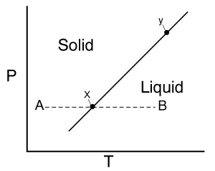
  - Write the melting reaction and express ΔG in terms of the Gibbs free energy of the reactants and products.

  - What is the sign or value of ΔG at points A, B, and x in the figure? Explain.

  - If we address the change in Gibbs free energy between any two points along the reaction (melting) equilibrium curve, such as points x and y in the figure, what would be the value of dΔG? Explain.

- If dΔG = 0, then Eq. 5–11 reduces to ΔVdP = ΔSdT, so that
Explain in words what this equation means. Use the signs of ΔS and ΔV for the melting reaction to apply it qualitatively to the melting phase diagram in question 14. Is the slope correct? Explain.

- If the change in volume for the melting reaction in the question 14 diagram were to increase (with no accompanying change in entropy), how would the diagram change? Explain.

- The diagram on the right is a P-T phase diagram, showing the relative stability fields of the Al₂SiO₅ polymorphs. Petrology deals extensively with phase equilibrium and phase diagrams, and we will be seeing many such diagrams in subsequent chapters. Each of the three reaction curves shown is determined experimentally.
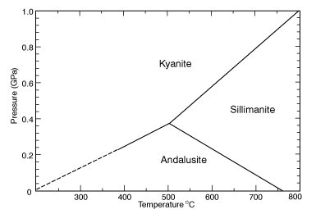

  - How can you tell that this particular system is metamorphic, rather than igneous?

  - Does the diagram suggest that kyanite has a lower molar volume than sillimanite or higher? Explain.

  - Does the diagram suggest that sillimanite has a lower entropy than andalusite or higher? Explain.

  - Would you expect to find andalusite in higher pressure or lower pressure metamorphic terranes than kyanite? What about sillimanite?

  - Write the balanced chemical reaction for the transformation of kyanite to sillimanite with increasing metamorphic grade.

  - At what temperature would the above reaction occur at 0.6 GPa? How deep is 0.6 GPa?

  - What does the diagram suggest about the stability of sillimanite under atmospheric conditions? Why is it possible to have sillimanite samples available in a mineralogy lab? Is it stable, unstable, or metastable? To what should it revert according this phase diagram? Why doesn’t it?

- The diagram here is another P-T phase diagram showing the position of a stable metamorphic reaction as determined experimentally.
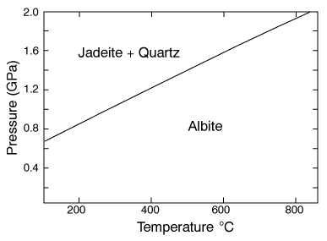

  - Write the balanced chemical reaction.

  - Do you think albite has a large molar volume or small? Explain.

  - What does your answer to part (b) suggest about the stability of plagioclase at great mantle depths? Explain.

  - Imagine this system is at equilibrium with coexisting albite, jadeite, and quartz. Where on the diagram would this occur?

  - When at a point corresponding to 3-phase equilibrium, what can you say about the rates of the forward (left-to-right) and reverse (right-to-left) directions of the reaction as written in part (a)?

  - If you begin to cool the three-phase equilibrium system will the forward or reverse reaction occur at a faster rate? Use Le Châtelier’s Principle to explain why. Why can’t the temperature vary while all three phases are present at equilibrium? What will eventually limit this situation and permit temperature to fall?

  - Where on the diagram is albite stable? Explain.

  - If you began to heat the three-phase equilibrium system instead, would the forward or reverse reaction (as written in part (a)) occur at a faster rate? What will eventually limit this situation and permit temperature to rise? Be careful here as you consider this.

  - To what extent can you place limits on the stability of jadeite on the diagram? Explain.

PROBLEMS.

- Given the following data, calculate the molar Gibbs free energy of forsterite at 600 and 1200ºC at both 0.1 MPa and 1 GPa (assuming that V and S are constant).

G_{forsterite} = −2,053,600 J/mol
V_{forsterite} = 43.65 cm³/mol
S_{forsterite} = 94.11 J/mol K

2. If H₂O is added to the simple melting reaction S = L and the solid mineral is naturally anhydrous, the liquid will be the only phase that accepts some dissolved H₂O. The reaction then becomes:
where the subscript means that the phase is aqueous (it contains H₂O).
Use Le Châtelier’s Principle to qualitatively evaluate the effect of adding H₂O to the initial anhydrous melting system. Will it lower or raise the melting point? Explain.
3. This exercise is designed to prepare you for the next chapter. Either use the handout provided by your instructor or read the file EXPT.DOC from http://www.prenhall.com/winter and then run the two simulated experiments on the computer program set up in your computer lab.
4. If you have access to the Excel Visual Basic program PTGIBBS (Brandelik and Massonne, 2004; available by following from http://www.prenhall.com/winter ...under Min-Pet Links), do the following:

a. Select Calculate energy of a specific phase. Determine the free energy (of formation) of pure andalusite (activity = 1) at 25ºC and 0.1 MPa (1 bar). Is it more stable than the elements from which it is formed? How can you tell from your result? Calculate G at 800ºC and 1000 bars (0.1 GPa). How did the change in temperature and pressure affect its stability as compared to the elements? Did thermal expansion or pressure compression have a greater effect on the volume of andalusite between these conditions and the standard state? Calculate G for andalusite, kyanite, and sillimanite at 500ºC and 0.2 GPa (2000 bars). Which is most stable? Repeat for 500ºC and 0.8 GPa and 700ºC and 0.4 GPa. How do your results compare with the phase diagram in Review Question 17? Calculate G for all three polymorphs at 493ºC and 3485 bars. Given the precision of the data to about 1%, how can you tell this is close to the point where all three are stable together?
b. Select the Calculate 2D option and determine the value of G for QUARTZ-ALPHA from 100 to 1000ºC at 1 bar (0.1 MPa). The Gpure(T) option calculates G for the pure phase at various temperatures. Do the values follow a straight or curved line? What does this tell you about the entropy of quartz as temperature is raised [see Equation (5–9)].
c. Calculate a reaction among SiO₂ polymorphs. Select Clear Input Data and then enter the following in the first cells of the Input sheet (see the sheet tabs at the bottom).
QUARTZ-ALPHA | -1
COESITE | 1
end

Column 2 is contains the stoichiometric coefficients for the reaction. Next click the Calculate Equilibria button at the top and check the box before the reaction, and click OK. You will next see the P-T diagram of the equilibrium boundary separating the stability fields of alpha quartz and coesite (on the PT_PLOT sheet). Select a P and T value anywhere below the curve shown and return to Calculate energy of a specific phase. Determine G for QUARTZ-ALPHA and for COESITE at these conditions. Which is more stable? Explain. Return to the PT_PLOT sheet and select a P and T value above the equilibrium curve and recalculate G for each phase under these conditions. Which polymorph is more stable? Finally, go to the PT_DATA sheet and select any P and T for the equilibrium curve itself. Return to Calculate energy of a specific phase and compare G for the polymorphs. Explain your results. Compare the reaction curve with Figure 6.6.

5. Melting Experiments on Simple Binary Mineral Systems

This exercise is designed to introduce you to the phase diagrams in the next chapter (Chapter 6). It is devised to simulate a series of experimental runs in which two-component (binary) mineral mixtures are melted using very high-temperature furnaces in order to determine the characteristics of mineral systems and igneous melts. Of course, natural melts are far more complex compositionally, but it is surprising how much one can learn from simplified analog systems. The simulation is a program called MinExp, that can be downloaded from my web site (http://www.prenhall.com/winter) or it may already have been installed by your instructor on a laboratory computer. Run the program and choose Experiment 1. You begin the exercise by preparing mixtures of two (unknown) minerals in various proportions. The minerals are commonly ground finely and placed in a platinum crucible. Platinum (or gold) is used because of its high melting temperature and lack of contamination of the “charge” (as the sample is commonly called). The crucible is placed in the furnace and heated to a specified temperature for several hours. When the “run” is over, the charge is quickly removed from the furnace and rapidly cooled in a stream of compressed air or occasionally in water. Any melt that may have been produced will solidify immediately as glass. Any minerals that may have been stable at the run temperature, will of course, be present as crystals, either recrystallized in the solid state below the melting temperature, or imbedded in glass if some melting occurred. Several runs are repeated, using various proportions of the two starting minerals defining the system over a range of temperatures. It is also possible to determine the composition of the run products (both glass and crystalline) by cutting the charge, making a thin section, polishing the surface, and microprobing the constituents.
From the compiled data, including: 1) initial mixture composition, 2) the run temperature, 3) the phases present in the resulting charge, and 4) the composition of each phase; a phase diagram can be constructed. There are several types of phase diagrams, but this type is a careful plot of temperature versus composition (a “T-X” diagram) for all phases present at equilibrium in the run products (either solid or glass/liquid) for a particular temperature.
Since many schools lack proper high temperature furnaces, and you can get a very nasty burn anyway, we will use the computer to simulate the process. You will be asked to perform experimental runs for 2 different mineral systems by picking the initial mineral proportions in a mixture and then the run temperature. The computer will allow you unlimited experimental runs, an advantage not enjoyed by the true experimental petrologists who must invest more time and money to perform the real thing. You should do fine with 30 or so runs for each system. You may quit at any time and resume later if you care to digest initial results before proceeding. The crucible will handle about 1 gram of sample, so try to make your totals nearly equal to that number. Next pick a run temperature (between 1000ºC and 1700ºC should be adequate). When the run is “complete” observe the graphic representation of the crucible. The colors will represent specific phases, either a certain mineral or glass, and their approximate relative amounts. This data may be useful to you for estimating your next experimental run.
When you finish, plot a phase diagram for each system on graph paper with temperature as the ordinate (y-axis) and composition as the abscissa (x-axis). Composition may be expressed as X₂ = n₂/(n₁+n₂), where n₁ and n₂ are the number of grams of minerals 1 and 2, respectively. Since (n₁ + n₂) is the total number of grams, X₂ is commonly called the weight fraction of component 2. If we measured n₁ and n₂ in moles, X₂ would be the mole fraction. We will use weight fractions here. Of course, in binary mixtures X₁ = 1 - X₂. For your plots, the abscissa will thus run from a value of zero (pure component #1) on the left to one (pure component #2) on the right.
For each temperature of your results, plot the composition of each phase that occurs in the run at that temperature. Be sure to label what each phase is as you do this (maybe use a color or symbol code). Plot these points lightly. You may discover that two or more phases coexist at equilibrium under some conditions, and that such occurrences are worth searching for and concentrating in your graphs. If more than one phase is present in a run, you might want to plot these points more boldly. You may also want to be sure to cover the composition spectrum fairly well, including the melting points of the pure end-member phases. Once all of your data are plotted, connect all of the points for any single phase that coexists with any specific other phase(s). In other words, connect all of the points representing liquid compositions that coexist with a certain solid, and all points for solid compositions that coexist with a liquid or another solid. The connected points should produce a smooth curve for each phase. The liquidus is defined as the curve representing the composition of the liquid that coexists with a solid phase. If solid solution is possible, there may also be a solidus, which is the curve representing the composition of the solid that coexists with a liquid. These curves separate the diagram into fields. When a diagram is complete, you should be able to place your pencil point at any place on the diagram, and predict what phase or phases are stable under those T-X conditions. Label each field with a label that describes the phase or phases that would be present if your experiment were conducted at the T and X conditions appropriate to that field. You may want to use a spreadsheet to record and plot your data. It is possible to run Excel in one window and the program in another, or use two adjacent computers. Plotting multiple points for a single temperature is a problem for most students, and it may take you some time to figure out how to do this. If you are not yet comfortable with Excel, you may want to do this one by hand. If you do use a spreadsheet, use small symbols, and make those representing one phase quite distinct from those representing another.
Next look at the various fields on your diagram. Briefly write at the bottom of the diagram for each field whether the composition of any phases are temperature dependent. In other words, would the composition of a phase shift if the temperature were raised or lowered slightly? Some courses may elect to discuss the results in class. If so, make photocopies to hand in, and keep the originals for your use in class.
Experiment 2 is a second type of binary system. If assigned, repeat the exercise for it, using the second worksheet.

Review Questions for Chapter 6, Part 1:
The Phase Rule and One-Component Systems.

1. A system is some portion of the universe that we want to define/explore. We can define the state of a system by determining all the necessary variables of that system. Such variables include (but are not limited to) the following. After each, indicate whether it is an extensive or an intensive variable with a capital I or E.
Mass of each phase
Volume of the system
Molar Gibbs free energy of each phase
Density of the system
Molar volume of each phase
Entropy of the system
The number of moles of the albite component in plagioclase
The mole fraction of albite in plagioclase
Clearly, a huge number of potential variables is possible for any system. Although it may be nice to know how much stuff you have, from a practical petrological standpoint it is more important to know the intensive variables in a system than the extensive ones. For example, it is generally enough to know that jadeite is stable under a particular set of conditions than how much jadeite occurs in some rock. That eliminates a lot of variables to worry about. It also turns out that many intensive variables are redundant. For example, if you know the molar volume and molecular weight of a substance, you can calculate the density. The Gibbs Phase Rule is a formula that tells us the minimum number of intensive variables that we must specify in order to completely determine the state of a system. Once this number is determined, all of the intensive properties become fixed (determined).
F = C - φ + 2 the Gibbs phase rule (Equation 6-1)

2. The Phase Rule is an important tool which helps us address and evaluate phase diagrams of all types. When using it, what do we mean by a phase?

3. How many phases are represented by the following systems:
Ice
Ice-water (with the cubes)
Albite
Plagioclase
A tequila sunrise

A component is a chemical constituent, such as Si, H₂O, O₂, SiO₂, or NaAlSi₃O₈. We can define individual components as we please, but, for purposes of the phase rule treatment, we shall define the number of components as the minimum number of chemical species required to completely define the system and all of its phases.
4. How many components are represented by the following systems:
Ice
Ice-water (with the cubes)
Albite
Plagioclase
Calcite
5. F is the number of degrees of freedom of the system. It can be defined in either of two different ways. What are they?

6. The diagram at right is a portion of the SiO₂ phase diagram (Fig. 6-6).
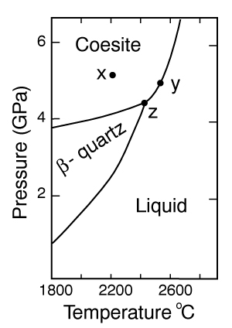

  - Determine F at point x in the diagram. Show your work. What are some possible intensive variables that you could determine?

  - Do the same for point y. Compared with point x, are there more or fewer variables that could be determined? Is it necessary to determine more or fewer? Why?

  - Assuming that pressure is variable, in a single sentence, describe as accurately and completely as you can the meaning of F in this particular circumstance. I’ll get you started:
In a one-component system composed of coexisting coesite and liquid, any change in pressure requires …

  - What feature on the diagram is a graphic representation of F as it applies to coexisting coesite and liquid?

  - Whenever the variables in a system are constrained, a degree of freedom is lost for each one so constrained. Suppose, for example, that a magmatic system cools and crystallizes at a constant pressure (called an “isobaric” system). In what way might we modify Equation 6-1 of the phase rule for such an analysis?

  - Assume you heat a system in the lab at a constant pressure with coexisting coesite and liquid (i.e. the furnace is on, consuming energy). Determine F. Does the temperature rise? If so, why? If not, where does the heat go?

  - Sketch a graph of temperature vs. time for constant heating of coesite from 2300ºC to 2700ºC. What discontinuities do you note?
Temp

time

  - When F is limited, there is generally a reaction taking place. Write the reaction. If pressure is held constant, is the reaction a continuous reaction or a discontinuous reaction? Why?

  - Which phase has the larger molar volume, coesite or β-quartz? How do you infer this from the phase diagram?

  - Which phase has the larger entropy, coesite or β-quartz? How do you infer this from the phase diagram?

  - Use the Clapeyron equation (dP/dT = ΔS/ΔV) to determine the sign of the slope of the coesite - β-quartz reaction surface. Does your result agree with the diagram?

  - Determine F at point z. Describe F for such a situation in words.

Binary systems are, by definition, 2-component systems. We refer to the composition of the system as the bulk composition. Because it is composed of amounts of components, it is an extensive property, and not addressed by the phase rule. The composition of any phase, however, is independent of the amount of the phase present, and is an intensive property. We typically refer to the composition of a phase as the fraction (X) of each component in the phase. For example, the mole fraction of albite in plagioclase, = n_{Ab}/(n_{Ab} + n_{An}) where n is the number of moles of each component in the binary plagioclase solid solution. Of course n is an extensive variable, but dividing any extensive variable by another yields an intensive variable because the extent factors cancel out. The weight fraction is similarly determined when n is the number of grams of each component.

- If you combine 5 grams of NaAlSi₃O₈ with 3 grams of CaAl₂Si₂O₈ what is the weight fraction of albite in the resulting plagioclase? Show your work.

What is the weight fraction of anorthite?

Express the plagioclase composition as An_{xx} (by weight).

8. Plagioclase contains Na, Ca, Al, Si, and O. For phase rule treatment, what is C? Why?

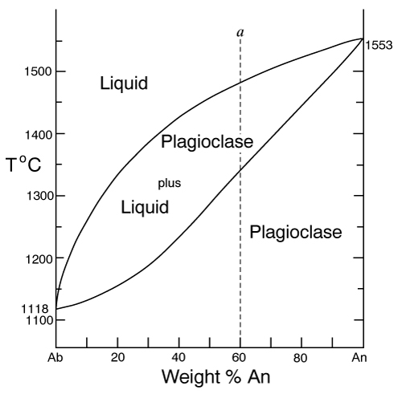
It would require 3-dimensions to illustrate the P-T-X variables for a 2-component system, so we simplify our diagrams by concentrating on the most important variables, typically T and X. We thus construct T-X diagrams at some specified pressure.
9. The temperature-composition (T-X) Ab-An binary phase diagram at 1 atmosphere pressure is shown on the right.

  - If we were to heat pure anorthite at this pressure, what would be the variance (F) when it began to melt? Show your work. What intensive variables specifically addressed by the diagram could vary between the first occurrence of melt and the last bit of anorthite to disappear? What extensive variables on the diagram most obviously change during that interval?

  - Begin with composition a at 1550ºC. What is the weight fraction of An in the liquid () ?

  - Determine the variance for this (isobaric) situation (show your work). List the intensive variables that are relevant to this diagram and could contribute to F. Which in your list, if any, are not independent?

  - If the liquid of composition a is isobarically cooled, at what temperature will a solid first begin to form? What will be its composition ()?

  - What are the names of the two curves in the diagram? What is the meaning of each?

  - Determine F for this situation, showing your work. Does the number of potential intensive variables increase or decrease when compared to the one-phase situation? Does F correspondingly increase or decrease? Why is this?

  - As the system continues to (isobarically) cool, temperature is the only intensive variable to change independently. Because F = 1, all of the other variables must vary in some dependent fashion. What feature on the diagram expresses how , for example, varies with T?

  - Use the lever principle to determine the relative weight proportions of plagioclase and liquid at 1450ºC. Show your work.

  - Place an ↑ or ↓ and E or I before each of the following variables to indicate whether they increase or decrease and are extensive of intensive as temperature is lowered from 1450ºC to 1350ºC.
T
Amount of liquid Amount of plagioclase

  - Some chemical reaction must be taking place across this interval to enable the change you have just described. Because the reaction must occur throughout the interval, the reaction is called a continuous reaction, meaning that it will occur incrementally over an interval (in which F = 1) with no discontinuities in any of the variables. If you begin with liquid of composition A (Liquid_{A}) coexisting with solid of composition B (Solid_{B}) propose an appropriate reaction for a single increment along the reaction path.

  - At what specific point on the diagram will the reaction terminate? Explain.

  - Determine F for all temperatures below this point.

  - Over what temperature range did the liquid crystallize?

- Using the diagram on the right
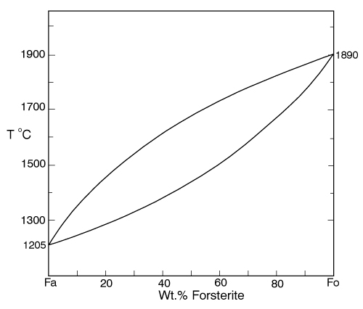
  - Use colored pencils or different pencil lines to draw the liquid/solid evolution paths for both equilibrium melting and perfect partial melting (each drop of liquid produced is removed) of an olivine of composition Fo₂₀ (weight fraction). How do the paths differ?

  - Which of the observations on page 85 do the Ab-An and Fo-Fa systems explain?

- The temperature-composition (T-X) Diopside (CaMgSi₂O₆)-An (CaAl₂Si₂O₈) binary phase diagram at 1 atmosphere pressure is shown below.
  - Begin with a melt of composition X_{An} = 80 at 1600ºC and derive F (remember it’s isobaric). Suggest likely independent T-X variables for F.
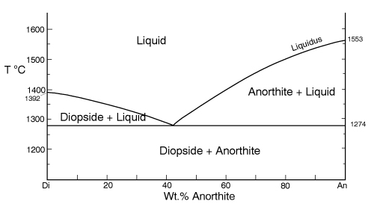

  - At what temperature will F change, and what occurs at this point? Derive F and suggest likely independent T-X variables.

  - Draw in colored pencil the liquid and solid evolution paths for cooling from the first appearance of a solid. What is the continuous reaction that occurs and how does it differ from the one in the Ab-An system?

  - What occurs at 1274ºC? Derive F at this point.

  - What happens as the system continues to cool (lose heat) at this temperature? Write the reaction involved and compare it to the reaction you wrote for step (18) above. Is the reaction continuous (occurring progressively over a temperature range) or discontinuous (occurring entirely at a single temperature). Suggest a general rule for deriving such reactions based strictly on the positions of the three points along the isothermal tie-line connecting them.

  - What must happen before such an isobaric system can reach a lower temperature? Explain.

  - Determine the phases at 1200ºC and derive F. Use the lever principle to determine the relative proportions of the two phases.

  - Over what temperature interval did the liquid of composition a crystallize?

  - Briefly describe the cooling of a liquid of composition An₁₅. In what ways does it differ from the cooling of An₈₀?

  - Must every liquid of a composition other than pure Di and pure An reach the eutectic upon cooling? Explain.

  - What is the composition of the first liquid derived by melting any mixture of Di and An? Explain.

  - How can you know whether Di of An will be consumed first by the eutectic reaction when melting a mixture of Di and An under equilibrium conditions?

  - Will fractional crystallization (removing the crystals as they form by sinking and burial of floating) affect the path of liquid evolution during cooling? Explain.

  - Describe the process of perfect partial melting (removing each drop of liquid from the system as soon as it forms), beginning with a mixture of 60%An and 40%Di (by weight) until the system is entirely molten.

  - In what way(s) do continuous and discontinuous reactions differ?

  - Which of the observations on page 85 does the An-Di system explain?

- The isobaric temperature-composition (T-X) Ab-Or binary phase diagram at 1 atmosphere pressure is shown below.
  - Label the field that was left blank.
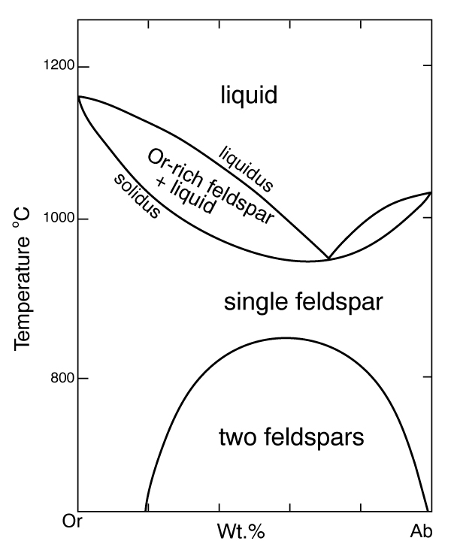

  - Begin with composition Ab₄₀ at 1200ºC. Determine the variance for this (isobaric) situation (show your work). List the intensive variables that are relevant to this diagram and could contribute to F. Which in your list, if any, are not independent?

  - Draw the liquid and solid evolution curves to 1000ºC. Determine F at this temperature and indicate what likely independent intensive T-X variables might be represented.

  - Use the lever principle to determine the proportions of liquid and feldspar at 1000ºC. Show your work.

  - At what temperature will the remaining melt be consumed by the continuous reaction consuming it? Make your reasoning clear.

  - How many phases are present for the Ab₄₀ bulk composition at 900ºC? What is the variance (assuming isobaric) and what are the most probable independent intensive T-X variables? Suggest a typical geologic setting for such a situation.

  - Describe what would occur under equilibrium conditions as the feldspar in part (f) above were to continue cooling. Draw the equilibrium path(s) on the diagram and determine the variance, suggesting the most probable independent and dependent intensive T-X variables.

  - What would be the most probable texture of the cooled feldspar in the situation described immediately above? Why?

- The isobaric temperature-composition (T-X) Fo-SiO₂ binary phase diagram at 1 atmosphere pressure is shown below.
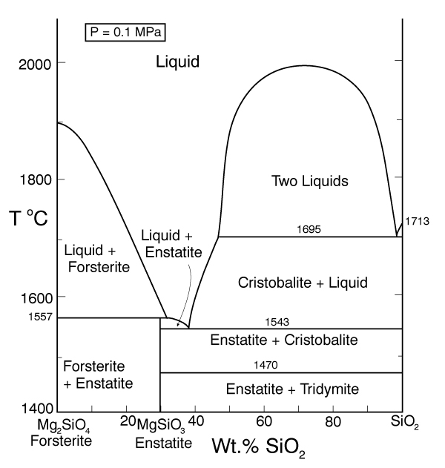

a
  - Begin with composition a at 2000ºC. Determine F at this point.

  - At what temperature will the first solid form, and what will that solid be? Show your work on the diagram.

  - Draw the solid and liquid evolution curves to 1700ºC and determine F at this temperature. Suggest the most probable independent and dependent intensive T-X variables under these circumstances.

  - What new phase appears at 1557ºC? Determine F at this temperature.

  - As in the Di-An eutectic situation, there are three phases that plot in a collinear fashion along an isothermal-isobaric tie-line. Use their positions to infer the proper discontinuous reaction relating them under these conditions. What “rule” did you use? How does this reaction differ from the Di+An+Liq eutectic reaction?

  - Consider the system in a geologic sense for a moment. You began with a melt in a magma chamber at a constant pressure. As the melt cooled olivine appeared, then orthopyroxene. What happened next? Why? What feature of the Makaopuhi Lava Lake does this explain?

  - In the present situation, which of the three phases will be consumed first by the reaction? On what do you base your answer?

  - What is the final equilibrium mineral assemblage of the resulting rock (and in what proportions do they occur)? Refer to Chapter 2 and name the rock.

  - Suppose the system were 32 wt.% SiO₂, rather than 10%. How would the cooling between 1557ºC and 1543ºC differ from the example just discussed? Explain fully.

  - What is the variance and the nature of the continuous reaction between 1557ºC and 1543ºC?

  - What is the variance and the nature of the discontinuous reaction at 1543ºC? Which phase must be consumed before the temperature can be lowered further? Why?

  - Describe the system and the variance at 1500ºC.

  - Describe the system and the variance at 1470ºC. What is the nature of the discontinuous reaction at this temperature? What exactly is it?

  - Describe the melting of pure enstatite until it is entirely molten.

  - At equilibrium for an entirely solid mineral assemblage with no solid solution, the isobaric variance should be one, because only temperature can change (there are no compositional variables in the pure solids). If C = 2 and F = 1, then φ = 2. That is exactly the number of phases in the areas at the bottom of the diagram. If the bulk composition is to the left of the En point, the mineral assemblage must be Fo + En. If the bulk composition is to the right of the En point, the mineral assemblage must be En + Q. Why can’t Fo + Q occur?

- Describe the cooling history of bulk compositions a, b, and c in Figure 6.7c (below). For each, indicate the temperature at which crystallization begins and ends, and the composition of all phases that form. Describe the nature of any continuous and discontinuous reactions that occur and what is responsible for any changes in φ.
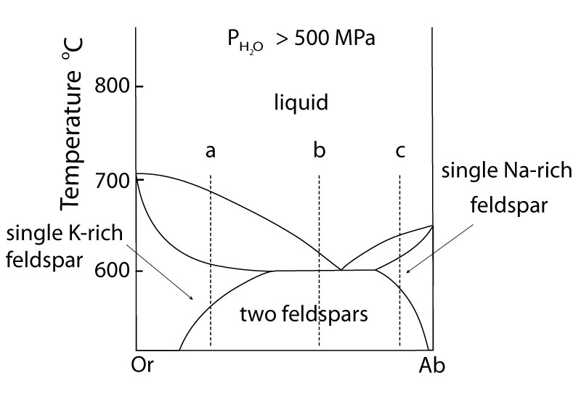

Problems
1. Illustrate each of the observations listed on pages 94-5 of your text using an example from one of the phase diagrams.
2. Choose a composition on each side of the eutectic minimum of Figure 6.17c and discuss the cooling history of a melt in terms of the phase rule and the intensive variables involved.

3. Given the 2-component phase diagram below at P = 1 atm.
Budlite has the formula AC, and Bovene has the formula BC.
The absissa (x-axis) is then 100B/(A+B), which, for the sake of brevity, we shall call “mole % B.”

1. What is the exact stoichiometric formula of Wallaclase?

2. Label all fields with appropriate phase(s).

3. Begin with a liquid of composition P.

a) Use the phase rule to derive F at 1500ºC:______________________________________

b) At what temperature does the liquid begin to crystallize? _______________

c) What is the name of the curve that you intersect at this temperature? ____________________

d) What is the name and “mole % B” of the phase that forms? _____________________________

e) Use the phase rule to derive F at this point. ____________________________________

f) As it would apply to this particular situation (the one in parts b-e), what does the diagram and your value of F tell you about how the compositions of each phase behaves with cooling?

g) What happens when the system just reaches 1000ºC? ____________________________________

h) Determine F at this temperature. ___________________________________

i) What is the name of point x? ____________________________________

j) What is the composition of the liquid at this temperature (in mole% B)? __________________

k) What is the molar ratio of Budlite to liquid at the instant you reach this temperature (before a new phase forms)? Be accurate and show your work with clear labels and references to the diagram.

l) What must happen before you can continue to lower the temperature? Explain using the phase rule.

m) What is the reaction that takes place at 1000ºC? _________________________________

n) How can you determine what the reaction is strictly from the positions of the phase compositions on the tie-line z? (You can ignore the stoichiometric coefficients for the reaction)

o) What proportion of the crystallization of the original liquid occurred in the 500ºC interval between 1500ºC and 1000ºC and what proportion took place at 1000ºC? Be specific (hint: use your answer to k).

p) Assuming equilibrium crystallization, what is the ratio of Budlite to Wallaclase (in moles) in the final rock?

q) Describe the texture of the final rock.

r) What effect would fractional crystallization have on the path the liquid follows?

s) What effect would fractional crystallization have on the composition of the final rock?

4. a) If a liquid of composition Q is cooled from 1500ºC, at what temperature will it begin to crystallize?_________________
b) At what temperature will it become completely solid? ___________________
c) Explain your answers to the two previous questions.

5. a) If pure Wallaclase is heated, at what temperature will it melt? ____________________
b) What will be the product(s) of this melting, and what is this type of melting behavior called?

c) What is the composition of the liquid (in mol % B) _________________________________

d) What is point y called? ________________________________

e) If you begin with 10 moles of Wallaclase, how much liquid can be generated at this temperature? Show your work.

f) At what temperature will melting be complete? _________________

6. If a rock of composition R, containing Budlite and Wallaclase is heated.
a) At what temperature will it begin to melt?

b) What will be the composition (in mol %B) of the first melt to form? Label the point on the diagram.

c) What must happen before the temperature can be raised further? Why?

d) How can you use the tie-line geometry to determine which phase will be the first to be consumed?

d) At what temperature will the last solid phase disappear? _______________________

e) What solid is it? ________________________

7. Cool a magma of composition S.
a) At what temperature will the first crystals appear? ______________________

b) What mineral is it? _______________________________

c) At what temperature during cooling will F change next, and why? Be specific.

d) At this temperature can you use the lever principle to determine the relative proportions of liquid and solid? Why or why not?

e) What must happen before you can lower the temperature further? Use the phase rule to show your reasoning.

f) How can you use the positions of the compositions of the phases and the bulk composition along the tie-line to determine which phase will have to disappear in this situation?

g) What will be the composition (in mol % B) of the last drop of liquid to crystallize? ____________

h) What will it crystallize to, and at what temperature?

8. a) If a magma with a bulk composition A:B ratio of 1:4 (be careful here) is cooled from 1800ºC, at what temperature will it first begin to crystallize? ________

b) At what temperature will it become completely solid?

c) What will be mineralogy and ratio of the minerals in the final rock?
d) If fractional crystallization were to occur until 1200ºC, and equilibrium crystallization after that, what would be the mineralogy and mineral ratio in the final rock?

9. In what rocks would you find coexisting Budlite and Bovene at equilibrium? Explain.

10. If you began with a rock containing approximately equal amounts of Wallaclase and Bovene, describe a geologically plausible method of melting and crystallization by which you would end up with a mixture of Wallaclase and Budlite.

Review Questions for Chapter 7: Ternary Systems.

Ternary systems are, by definition, 3-component systems. The addition of another component to a 2-component system requires 3-dimensions to illustrate the T-X variables for an isobaric system, but we cannot further simplify our diagrams by ignoring T or a component, so we construct isobaric T-X diagrams by contouring the liquidus surface for temperature, as illustrated in the ternary Fo-An-Di system below. The inset shows the system in 3-D perspective, showing the three binary eutectic systems.
1. Begin with composition a at 1800ºC. What is the weight fraction of An in the liquid ()? What about? ?
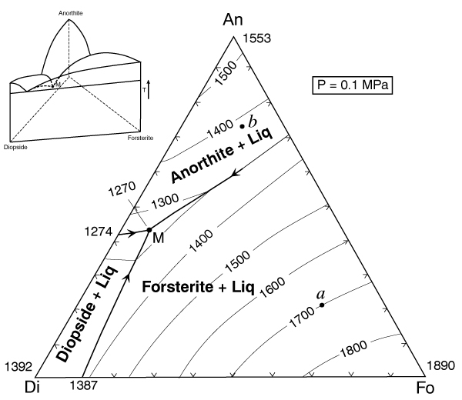

2. What is the variance at 1800ºC? Show your work. List the intensive variables that are relevant to this diagram and could contribute to F. Which variables in your list, if any, are not independent?

3. What mineral begins to crystallize as a liquid of composition a is cooled to 1700ºC? What is the variance? Show your work.

4. Illustrate with a dashed line labeled “4” the “liquid line of descent” as the liquid continues to cool below 1700ºC. Why does it move in the direction you have indicated?

5. What is the “continuous reaction” involved that permits the liquid composition to change?

6. Indicate with an “6” the point along the liquid line of descent where a new phase begins to crystallize. What phase is it?

7. Derive the variance at this point and show your work.

8. Show with a heavy line and an “8” the liquid line of descent from the point at which the new phase in part (6) formed. Write the new continuous reaction responsible for the change in liquid composition.

9. Choose a point along the cotectic between (6) and point M and show how you derive the bulk solid extract crystallized from the liquid at that point. How does that bulk solid extract differ from the total amount of solid crystallized?

10. Determine a general geometric rule relating the bulk composition to the compositions of the three phases that compose it (liquid, forsterite, and anorthite).

11. Will the liquid line of descent reach point M under equilibrium conditions? Why or why not?

12. If the liquid reaches point M, what occurs there? What is the variance for a system in which the liquid reaches point M? Show your work.

13. What is the final crystallization reaction? Is it a continuous or discontinuous reaction? Explain.

14. What was the sequence of minerals that formed for the liquid of composition a?

15. What sequence of minerals would form for a liquid of composition b?

16. Show in colored or labeled lines the liquid lines of descent for the crystallization sequence:
c. Fo-Di-An
d. Di-An-Fo
e. Di-Fo-An
f. An-Di-Fo
17. What would be the composition and temperature of the first partial melt of any mixture containing Fo+An+Di?

18. Outline as completely as you can the perfect partial melting (removing each increment of melt as it forms) of an initial mixture of Di + An + Fo in the proportions equivalent to point a in the diagram.

The ternary Fo-An-SiO₂ system at atmospheric pressure is shown below (without the temperature contours). The inset is a “chemographic” diagram showing the position of all solid phases with “tie-lines” connecting phases that can stably coexist together. You can use this insert to determine the final equilibrium mineral assemblage. For example, most bulk compositions in the Fo-An-SiO₂ system will fall within the En-An-Q triangle with the remainder in the Fo-En-An triangle. These then represent the final solid 3-phase assemblages of any rock plotting within the respective triangle. Only rarely will a bulk composition plot on a 2-phase tie-line or a 1-phase point (also reducing the components).
19. Suppose a bulk composition does plot on the An-En tie-line. What will be the low-T mineral assemblage and what would be an appropriate choice for the components of such a system? Why?
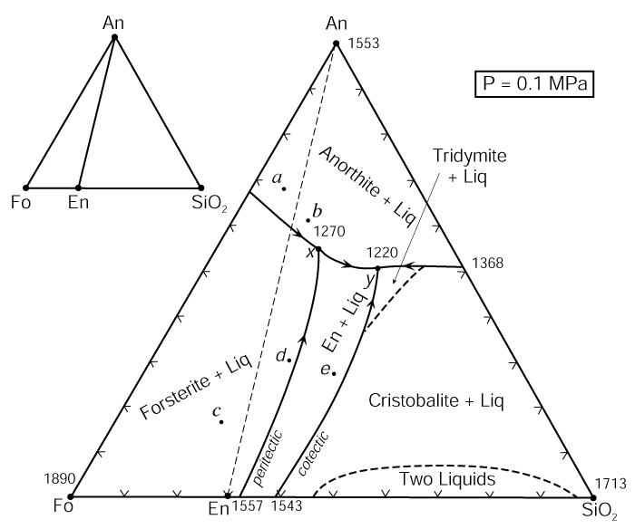

20. Begin with composition a. What will be the final mineral assemblage? Why?

21. Derive the variance at a temperature above the liquidus. Show your work.

22. What will be the first mineral to form? Determine F when that occurs and interpret its meaning for an isobarically cooling magma.

23. Draw the liquid line of descent as the mineral crystallizes. What continuous reaction is occurring?

24. What happens when the liquid reaches the cotectic? Be specific. Derive and interpret the variance for the new phase-assemblage.

25. What continuous reaction is responsible for the evolution of the liquid composition along the cotectic curve.

26. Determine the bulk solid extract composition for the initial evolution of the liquid along the cotectic and use the lever principle to compute the ratio of Fo/An crystallizing.

27. Bearing in mind your answer to question 20, how can you be sure that the liquid cannot be completely crystalline before reaching point x?

28. Explain the change in the number of phases that occurs at point x. Derive the variance.

29. Note that a tie-line connecting Fo-Liq(x) crosses one connecting An-En. Note also that Fo + Liq may be combined in appropriate proportions to create a system of composition z (see right). Likewise En + An may be similarly combined to produce z. Use these observations to propose a geometric method for deriving the discontinuous reaction that must occur.
Fo
L
An
En
z

30. Is the reaction you derived a eutectic-type reaction (solids → liquid) or a peritectic-type [solid(s) + liquid → solid(s)]? Is point x, then, a ternary peritectic or eutectic point?

31. Noting where X_{bulk} plots in the figure with Question 29, which phase will be consumed first by the reaction? Explain.

32. Describe the remaining phase assemblage and derive the variance.

33. Begin with a liquid of X_{bulk} = b. What will be the final mineral assemblage? Why?

34. Outline the phases that form and the liquid evolution until it reaches point x.

35. Repeat the process of Question 31 for this bulk composition.

36. Will the liquid evolve to point y or crystallize first? Explain.

37. Determine the continuous reaction responsible for the evolution of the liquid composition between points x and y.

38. What new phase will form when the liquid reaches point y? Derive the variance.

39. Construct a geometric diagram similar to the one in question 29 and use it to propose a purely geometric method for deriving the discontinuous reaction that must occur at point y

40. What phase will be consumed first? What is the remaining phase assemblage and the variance?

41. Begin with a liquid of X_{bulk} = c. What will be the final mineral assemblage? Explain.

42. What is the first mineral to form? Derive the variance at this point.

43. Show the liquid line of descent until the liquid reaches the peritectic curve. Why does it follow the path you have indicated?

44. What new mineral forms when the liquid reaches the peritectic curve? Derive the variance.

45. As the liquid follows the peritectic, does the bulk solid extract point lie between Fo and En or En and Qtz? Why is this a problem if the system consists of forsterite, enstatite, and liquid?

46. The only solution to the conundrum is that the bulk solid extract (BSE) cannot consist of Fo + En (as it would if the bulk solid extract point had fallen between them). The BSE must consist of En and (-) Fo (negative forsterite) because the BSE composition is on the negative Fo side of En. In other words, the continuous reaction as the liquid evolves along the curve is not Liq_{A} → En + Fo + Liq_{B}, but rather what?

47. Why must the liquid composition reach point x with further cooling?

48. What mineral forms when the liquid reaches x and what is the variance? What is the reaction and is it continuous or discontinuous? Why?

49. Will the liquid composition reach point y? Why or why not?

50. A liquid of X_{bulk} = d has an interesting variation on the evolution path described above. As with X_{bulk} = c, forsterite forms first, followed by enstatite as the liquid composition reaches and evolves along the peritectic curve. Note, as deduced previously, that the X_{bulk} always lies within the triangle with corners equal to the three coexisting phases. In other words, the whole must lie within the geometry of the parts. But at some point along the peritectic En-X_{bulk}-X_{liq} become collinear so that the X_{bulk} lies on the edge of the 3-phase triangle, not within it. How much forsterite can remain from the reaction you proposed in question 46? Explain.

51. What is the new phase assemblage and variance after that?

52. On the basis of your answers to Question 50, what is the new continuous reaction and liquid evolution path immediately after Fo disappears? Explain.

53. Outline the remainder of the liquid evolution until the system is completely solid. At what point do new minerals form, and what are they? What is the variance at each stage, and what reactions occur. Are the reactions continuous or discontinuous?

54. Outline the liquid evolution of X_{bulk} = e from the moment a solid forms until the system is completely solid. At what point do new minerals form, and what are they? What is the variance at each stage, and what reactions occur. Are the reactions continuous or discontinuous?

55. If a liquid of X_{bulk} = c crystallizes under equilibrium conditions, what will be the mineralogy of the final rock? Determine the minerals and their relative weight proportions. Clearly show your work, showing what you measured as well as your calculations.

- If a liquid of X_{bulk} = c fractionally crystallizes, what will be the mineralogy of the final rock (simply estimate the proportions)? Explain your reasoning.

- What phases are present and what is the variance for the following bulk compositions in the isothermal-isobaric phase diagram Fig. 7.9 (on right).
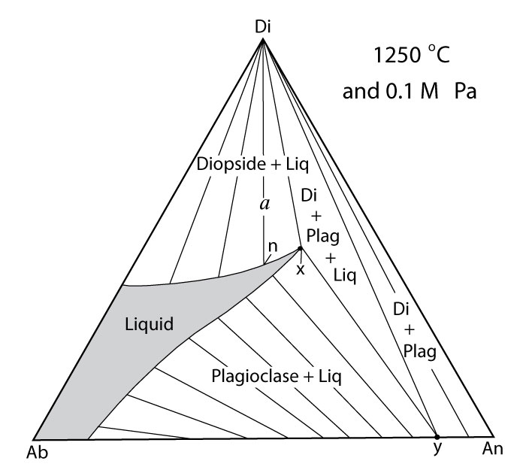
Phases F
  - Ab₄₀-An₄₀-Di₂₀:
  - Ab₅-An₉₀-Di₅:
  - Ab₈₀-An₅-Di₁₅:
  - Ab₂₀-An₂₀-Di₆₀:
  - Ab₅-An₃₅-Di₆₀:
- At any particular pressure, what governs the sequence of minerals that crystallize from a cooling melt?

- Given your answer to question (58), evaluate the strengths and weaknesses of Bowen’s Reaction Series.

- What is the general effect of increasing pressure on the melting point of a solid? Why is that so?

- What would be the T and X effect of changing pressure on the eutectic point between minerals A and B if mineral A has a higher coefficient of compressibility?

- Imagine the reaction A + B = C involving anhydrous minerals. If mineral B is the only one that can hydrate, describe the effect of adding H₂O to the system. How does the reaction change? Use Le Châtelier’s Principle to describe how equilibrium would shift in response to adding more H₂O, and the effect this would have on the position of the equilibrium reaction curve on a P-T phase diagram. Sketch the hydrous reaction curve on the accompanying hypothetical phase diagram.
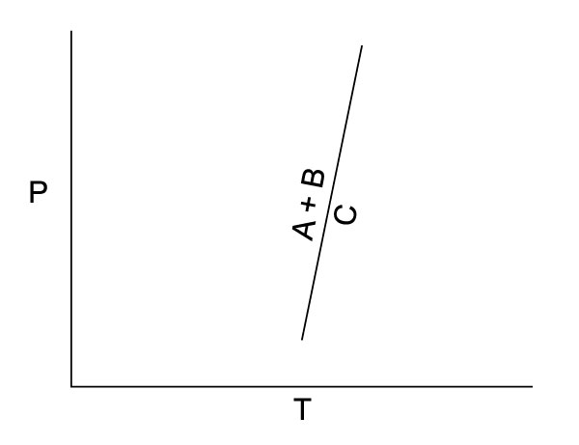

- Use the same reasoning to explain the effect of H₂O on the melting temperature of a silicate mineral.

- Use Le Châtelier’s Principle to explain why the effect of H₂O on melting temperature is greater at high pressure than at low pressure.

- Use the Clapeyron equation to explain the curvature of the H₂O-staurated melting curve in Fig. 7.19 (right).
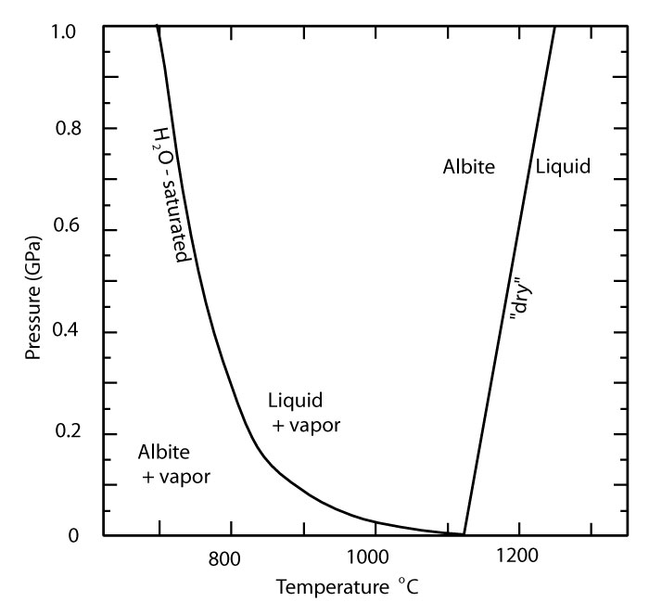

- What is the major conclusion you can draw about the effect of H₂O on melting and the amount of melt generated from the discussion of heating of H₂O-undersaturated rocks in association with Fig. 7.22 (right)?
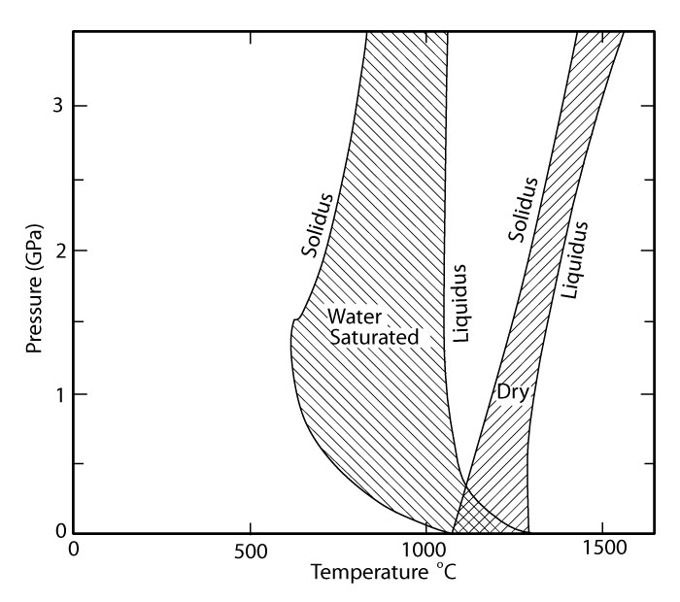

- What are the major conclusions you can draw about the effect of H₂O on a rising H₂O-undersaturated magma in association with Fig. 7.22?

PROBLEM

1. Ternary Phase Diagram Exercise
Given the 3-component phase diagram at P = 1 atmosphere above.
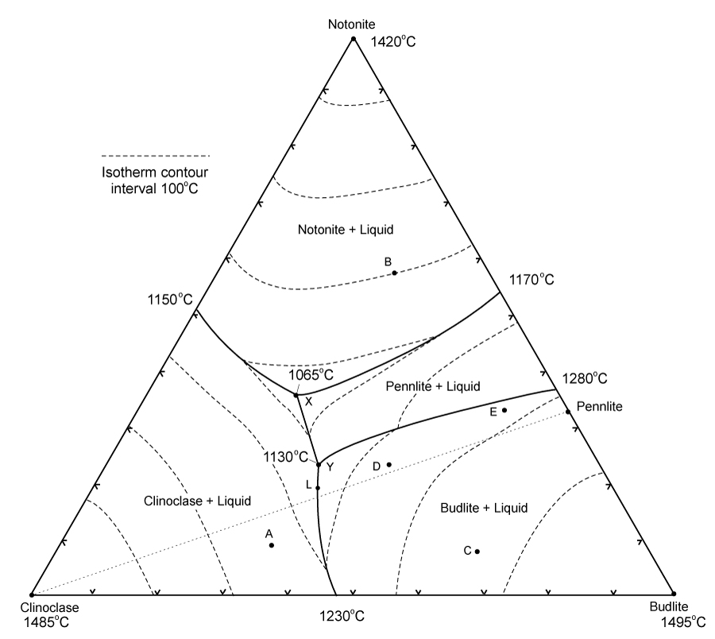

P = 0.1 MPa

(pts) 1. Begin with a liquid of composition A at 1500ºC.
(2) a) Use the phase rule to derive F at 1500ºC __________________________________________
(2) b) At about what temperature will the liquid begin to crystallize? __________________________
(2) c) What is the name of the surface that you intersect at this temperature? __________________
(2) d) What mineral forms at this temperature? _________________________________
(5) e) Draw the liquid line of descent in red on the diagram until the next phase begins to crystallize. Why does it move in the direction you indicated and what is the reaction responsible?

(3) f) Is the reaction continuous or discontinuous? Explain.

(2) g) At ~ what temperature does the next phase begin to crystallize? ______________________
(2) h) What is the phase? _________________________
(2) i) What is the name of the curve that you intersect at this point? ____________________
(3) j) Use the phase rule to derive F at this point ____________________________
(5) k) As it would apply to this particular situation, what does the diagram and your value of F in part (j) tell you about how the compositions of each phase behaves with cooling? (i.e. which diagram intensive variables are likely to be independent, and which dependent? Which can vary and which are fixed?).

(2) l) Draw the liquid line of descent in blue as it would continue for this liquid.
(4) m) What is the ratio of solid phases in the “bulk solid extract” that is crystallizing from the liquid at the moment it reaches point L? Show and label your construction lines (do it in sharp pencil). Sketch the lever below with the same labels as on the figure above. Include your measurements and your calculations.

(7) n) An instant before the liquid first reaches point Y what are the proportions of the three coexisting phases at this temperature? Express the proportions as percentages, and show your work, clearly labeled as in part (m).

(2) o) What happens when the liquid first reaches point Y? _________________________________
(2) p) What is the name of point Y? ___________________________________
(4) q) Determine F from the phase rule and interpret its meaning as it applies to the situation in (o).

(5) r) Use the geometry of the phases coexisting at Y to determine the reaction that occurs. Explain your reasoning.

(3) s) Is the reaction continuous or discontinuous? Explain.

(4) t) When will the reaction be complete? What will be the first phase consumed? How do you determine this?

(2) u) Will the liquid continue to evolve toward point X? Why?
(5) v) What proportion of the crystallization of the original liquid occurred prior to 1130ºC and what proportion occurred at the single temperature 1130ºC? Be specific.

(5) w) What are the approximate proportions of the minerals in the final rock (as %)? Show your work.

(2) x) How will fractional crystallization affect the liquid evolution curve? Explain.

(3) y) How will fractional crystallization affect the mineral composition of the final rock? Be specific.

2. Heat a solid rock of composition B (and assume equilibrium melting).
(2) a) At what temperature will the rock begin to melt. Explain.

(5) b) Write the reaction that takes place at this temperature and explain how you determined it on the basis of the phase geometry. Is the reaction continuous or discontinuous? Why?

(4) c) Which phase will be the first one consumed, and how did you determine this?

(1) d) Draw in green the path the liquid follows from the initial composition until it reaches about 1080ºC.
(2) e) Use the phase rule to determine F as the liquid follows the path that you have just drawn.

(3) f) What is the continuous reaction that occurs along this path? ____________________________
(5) g) At what temperature will one of the reactants in (f) be consumed, and which one will it be? How can you determine this? Show and label any required construction lines on the diagram.

(2) h) Draw the rest of the liquid path in orange until the system is completely liquid. At what temperature is melting complete? ________________________________

(6) 3. a) If perfect partial melting occurs for composition B, and each increment of melt created is removed, what will happen between 1065ºC and 1100ºC? Why?

(4) b) After leaving point X, what is the next melt composition, and at what temperature does it occur? Explain.

(3) c) What is the melt-producing reaction in part (b)? Is the reaction continuous or discontinuous? Why?

(2) d) At what point does melting in the situation (b) cease?

(5) e) What is the composition of the next melt increment, and at what temperature does if occur?

4. Begin with a melt of composition C.
(2) a) At what temperature does the melt begin to crystallize? _________________________
(2) b) What is the first mineral to appear? ______________________________
(2) c) Draw the liquid evolution curve in yellow from the point of first crystallization until a new phase forms and explain your choice of paths.

(2) d) What is the next phase to form? _________________________
(2) e) At what temperature does it form? _______________________
(3) f) What is the continuous reaction that occurs along the curve toward point Y?

(2) g) What happens when the liquid composition first reaches point Y?

(4) h) What is the discontinuous reaction that occurs at point Y? Explain how you determined this on the basis of the phase geometry.

(2) i) What phase will be the first to be consumed? Explain your reasoning.

(3) j) Will the liquid composition leave point Y? Y or Y not?

5. Cool a melt of composition D.
(2) a) At what temperature will the first mineral crystallize? _________________________
(2) b) What mineral will it be and how did you determine this?

(2) c) Draw the liquid line of descent in purple from this point until the next phase forms and explain your choice of paths.

(4) d) What is the next phase to crystallize, and at about what temperature does it form?

(5) e) What will be the continuous reaction that occurs as the liquid evolves toward point Y, and how do you determine this?

(2) f) What is the discontinuous reaction at point Y?

(2) g) Use the phase rule to derive F at this point. ________________________________________

(5) h) What will be the first phase to disappear at point Y? Will the liquid leave point Y with further cooling? Will it reach point X? Explain.

(3) i) What will be the continuous reaction that occurs after the liquid leaves point Y? Explain how you determined this.

(2) j) What will happen when the liquid reaches point X?
(4) k) Show how you use the phase geometry to determine the reaction that occurs at X.

(2) l) At what temperature will the last of the liquid crystallize? ______________________

(3) m) What will be the approximate proportions of the minerals in the final rock?

6. Begin with a liquid of composition E.
(2) a) At what temperature will the first mineral crystallize? _________________________
(3) b) What mineral will form and how did you determine this?

(2) c) Draw the liquid line of descent in light green from this point until the next phase forms.
(4) d) What is the next phase, and at about what temperature does it form? ____________________
(2) e) What will be the continuous reaction that occurs as the liquid evolves toward point Y.

(5) f) At what point will this liquid leave the peritectic curve? Show your construction lines and explain their significance. What phase is consumed when this occurs? How do you know?

(2) g) Draw the liquid line of descent in brown from this point until the next phase crystallizes.
(4) h) What is the next phase to crystallize, and at about what temperature does this occur?
(2) i) What will happen when the liquid reaches point X?

(2) j) At what temperature will the last of the liquid crystallize? Explain.

(3) k) What will be the approximate proportions of the minerals in the final rock?

Review Questions and Problems for Chapter 8:
Chemical Petrology I: Major and Minor Elements.

- What is AA spectroscopy, and in what way(s) does it differ in principle from XRF?

- In what principal way does the EMP differ from AA, XRF, and INAA?

- If the intensity of some emitted or absorbed spectrum is the type of data supplied by instrumental analysis, how do we convert the counts/second to meaningful concentrations?

- Use Figure 2.4 to determine whether the rocks analyzed in Table 8.3 are correctly named.

- Convert the Fe₂O₃ and FeO in the basalt in Table 8.3 to FeO*

- Explain in a single sentence what a norm attempts to do. How does a norm differ from a mode?

- How would you recognize a silica-oversaturated plutonic rock from a silica-undersaturated plutonic rock?

- Suppose you have the chemical analysis of a volcanic glass. How would you determine whether it represents a silica-oversaturated or undersaturated composition?

- Suppose you have chemical analyses for two volcanic rocks with identical wt. % SiO₂, but one has a higher alkali/Al₂O₃ ratio. Which is more likely to be silica-undersaturated? Why?

- Given the following mineral compositions, explain the trends in Fig. 8.2 assuming that fractional crystallization is responsible.
Olivine: (Mg,Fe)₂SiO₄
Orthopyroxene: (Mg,Fe)SiO₃
Clinopyroxene: Ca(Mg,Fe)Si₂O₆
Albite: NaAlSi₃O₈
Anorthite: CaAl₂Si₂O₈
Orthoclase: KAlSi₃O₈
Quartz: SiO₂

- What would you call the set of rocks collected at Crater Lake and shown in Fig. 8.2? Why?

- What would you conclude if the D-P trend in Fig. 8.6b did not extrapolate to a point between A and B on the A-B line?

- How does the tholeiitic trend differ from the calc-alkaline trend on an AFM diagram (Fig. 8.14)? What binary phase diagram in Chapter 2 helps you understand the initial tholeiitic trend? Explain.

- In what way is the Ab composition in Fig. 8.13 a “thermal divide”? What is the effect of the divide on cooling silica-oversaturated vs. undersaturated melts?

Problems
The ability to use a spreadsheet will greatly reduce your workload throughout your petrology course (and beyond). If you are inexperienced with spreadsheets, there is a document called EXCEL.DOC available on my web site (http://www.prenhall.com/winter) that will get you started. Just click on How to Use Excel on the main page. If you are doing any problem using a spreadsheet as a class exercise, I recommend you hand in your spreadsheet for grading electronically, either as an email attachment or into an class drop-box, so your instructor can check your cell formulas if a correction is necessary.

1. Calculation of C.I.P.W. Norm

Use the method supplied in Appendix B to calculate a Norm for the following volcanic rock:

Tholeiite, Imnaha of the Columbia River Basalts

SiO₂ 51.1
TiO₂ 2.24
Al₂O₃ 15.1
FeO* 13.0
MnO 0.22
MgO 5.07
CaO 9.31
Na₂O 2.58
K₂O 0.91
P₂O₅ 0.42

Total 99.95

I suggest you use a spreadsheet to mimic the calculation in Appendix B. Simply copy columns 1-3 from the appendix and calculate column 4. Note that MnO is added to FeO in column 4 and H₂O is ignored (norms are anhydrous). Once you have the numbers in column 4 correct (the same as in the appendix), replace the oxide data in column 2 with that from the table above). Do all calculations to 4 decimal places and round off in the final two rows (the norm) to 2 decimals.
Note what the norm calculation is attempting to do. It is apportioning the oxides out to create idealized minerals, attempting to approximate the preferences for certain minerals over others. For example, assuming that K2O occurs only in orthoclase, all K₂O is initially put into that mineral (column “4a” in Appendix B), thereby requiring some Al2O3 and SiO2 to constitute the rest of the orthoclase molecule. SiO2 balancing is the crucial requirement, and you can see in Appendix B how complex it can be to both accommodate some minerals and still balance the silica. The calculation makes a “first-pass” in which some minerals are “provisional” minerals (with a hyphen). If the “first-pass” works, and there is sufficient SiO₂ in the analysis to accommodate the other oxides in the analysis and still have enough left over for a bit of free SiO₂ (as normative quartz) the process is complete. If there isn't enough silica to satisfy all of the minerals, you must go back and “borrow” some from some of the provisional minerals you have already calculated (or’, ab’, hy’ etc.) and create other, less siliceous minerals in order to free up SiO2 and balance the calculation. For example, you can reduce hy’ and produce ol + SiO₂ (Mg₂Si₂O₆ → Mg₂SiO₄ + SiO₂). Not all of the hy’ can be consumed by this, so the remaining hy is no longer provisional (first-pass) and has no prime. Thus hy’ disappears, replaced by hy and ol in the norm as SiO₂ is liberated. Similar SiO₂ producing reactions are ab’ = ne + SiO₂ or’ = lc + SiO₂ etc.
If you begin with your initial 4 columns, you can follow the procedure in Appendix B by adding columns and apportioning the molecular proportions into the minerals as described. I’ll get you started: phosphate occurs only in the mineral apatite. So we begin by putting the 0.0030 moles of P2O5 (this should be the number you have in your column 4) into the ap column. Simply copy and paste the value in the new column cell. But apatite has the formula Ca5(PO4)3(OH). This is equivalent to 5 CaO + 1½ P2O5 + ½ H2O. Thus for every 1.5 P2O5 we must add 5 CaO. If we multiply through by 2/3 we get 3.33 CaO for every P2O5 in apatite. Thus we put 3.33 x 0.0030 = 0.0100 CaO in the ap column as well. Norms ignore hydrous phases and water, so we overlook the OH. What have we done here then? We've used .0030 moles of P2O5 + 0.0100 moles of CaO to make 0.0030 moles of apatite (assuming a 2/3 apatite formula of Ca3.3(PO4)2 ). All of the P₂O₅ is accounted for now, but some CaO obviously remains.
What next? Because there is no Cl, Cr, or S, so we turn to Ti. The most common Ti-bearing mineral in igneous rocks is ilmenite (not rutile). Ilmenite has the formula FeTiO3, or 1 TiO2 + 1 FeO. So we copy and paste all of the TiO2 into the TiO₂ cell of the il column, and put an equivalent amount of FeO in it as well. We have thus used 0.0280 moles of TiO2 and 0.0280 moles of FeO to make 0.0280 moles of ilmenite. Note that we have not made 0.0280+ 0.0280 = 0.0560 moles of ilmenite, because one mole of ilmenite contains one mole each of TiO2 and FeO.
Next we allocate our K2O to (provisional) orthoclase. Put the 0.0097 moles of K₂O in the or’ column. What else do we need to make orthoclase? KAlSi3O8 is the formula that you know so well. Because we're using K2O (double K) it might be wise to double the orthoclase formula. Thus, to make K2Al2Si6O16, we need an amount of Al2O3 equivalent to K2O and 6 times as much SiO2. Thus we put 0.0097 moles of K2O, 0.0097 moles of Al2O3, and 0.0386 moles of SiO2 to make 0.0097 moles K2Al2Si6O16
You should be able to continue from here. The method quite complete in the way it treats all of the various chemical possibilities. Follow it precisely. It should be easy until you reach diopside. Then remember that diopside is Ca(Fe,Mg)Si2O6 (1 CaO + 1 (FeO + MgO) + 2 SiO2). You have to allocate both FeO and MgO, but you don't know how much of each. The norm simplifies this by allocating FeO and MgO to all mafic minerals in the proportion that they occur in the whole-rock composition (at least the FeO remaining after some has been allocated to ilmenite and magnetite). This is never true in real rocks, but it is good enough for the purposes of the norm. Thus you need to find a mathematical way to be sure that FeO + MgO sum to the same number as CaO in the di column and still have the same ratio that they have in the whole-rock. Once you have done this, you must find the proper formula weight for diopside. This is a simple interpolation between the pure Fe (248 g/mole) and Mg (217 g/mole) end members. You must do the same calculations for hypersthene.
Be sure you show your subsidiary calculations, such as Y, D, D1, Fe/Mg, formula weights for Di and Hy, etc.
2. Next change the SiO₂ value in your spreadsheet to 49%. Because you did not change any other oxides, all of your normative mineral quantities should remain the same, except that you now have a deficit of silica (not enough to make the provisional silicate minerals) in your norm. Return to your norm calculations and proceed through steps 9 and 10. Hand in that spreadsheet also and explain what you had to do to “free up” some silica to accommodate all of the other oxides into appropriate minerals.
- Open the Excel® file NORM.XLS (available from my web site: http://www.prenhall.com/winter). This spreadsheet was created by Kurt Hollicher of Union College. Enter the wt. % oxide data for the basalt in Table 8.3 in column 2. This spreadsheet calculates a reasonable norm (if you do not try some very unusual compositions). It follows the norm procedure described in Appendix B. Are the minerals appropriate for a basalt? Determine the plagioclase composition (scroll to the right).
Now vary the silica content between 52% and 46% in successive 1% increments. Explain the effect this has on the normative minerals. Then return to your initial SiO₂ value and vary Al₂O₃ between 19% and 14% in 1% increments, and explain the effect on the norm. Return again to the original values and increase Na₂O in 1% increments to 5%. Then do the same for K₂O to 5%. Explain the changes.
4. Use IGPET® to calculate norms for the rocks in Table 8.3. Discuss the results.
5. In Chapter 7 we studied the system diopside-anorthite-forsterite (Fig. 7.2). The file CH8-3.XLS is a partially completed spreadsheet for the liquid line of descent for composition a to the ternary eutectic, M. I have calculated the compositions of diopside, anorthite, and forsterite in weight % oxides, and estimated the Di:An:Fo ratios of several points along the liquid line of decent.
Complete the spreadsheet, calculating the composition of the liquid at each point. This is easily done for each oxide by multiplying the weight fraction of each phase times the wt.% of the oxide in that phase, and summing for the oxide. Thus the wt.% MgO in “a 1700” is 0.36 · 18.61 + 0.10 · 0 + 0.54 · 50.22 = 33.82, etc.
You will next create Harker-type diagrams of the data for liquids along the liquid line of descent. Choose an oxide to act as a good differentiation index. Note that wt.% SiO₂ is not a good one, why? If you choose one such as wt. % MgO (as I did), you may want to scale the x-axis from high to low, so the more evolved liquids plot on the right.
Create 3 Harker-type variation diagrams (X-Y scatter charts), using your differentiation index and the other three oxides. Print the results, and then connect linear segments of the liquid lines of descent, and extrapolate back to the bulk mineral extract appropriate for each segment. Discuss your results in conjunction with the analysis that accompanied Fig. 7.2.
6. The file TUOLUMNE.ROC on my web site is an IGPET® file for a series of rocks from the Tuolumne Intrusive Complex, shown in Fig. 4.30.
Using IGPET®, load the file, and create a series of Harker diagrams. Choose the Diagrams, option, and print all 8 options. You will have to adjust the x-axis to 55-75% SiO₂ in order to get all of the points to plot. You can print a set of Harker diagrams by printing each in order, and only affirming the last diagram to be printed when you finish the P₂O₅ diagram. In Chapter 4 we proposed that the sequence of injections that comprise this intrusive complex were part of a consanguineous magma series. Discuss this proposal in light of the Harker diagrams. Which elements are depleted, and which are conserved? The symbols are: + = marginal quartz diorite, open triangle = non-porphyritic Half Dome granodiorite, filled triangle = porphyritic Half Dome granodiorite, open square = Cathedral Peak granodiorite, filled square = Johnson granite porphry.
Use the Diagrams option and plot an AFM diagram (Irvine and Baragar, or “irvbar.dgm”) to determine if the Tuolumne Series is tholeiitic or calc-alkaline. The Miyashiro (1974) diagram under “petrol.dgm” will also discriminate based on SiO₂ vs. FeO/MgO. As a final test, plot an X-Y diagram using X = SiO₂ and Y = (Na₂O+K₂O)/CaO. Y will take some fiddling about with the parameters. For example, you must choose A+B and then A = Na₂O and B = K₂O, then A/B with A = Na₂O+K₂O and B = CaO before you can select this as Y. The SiO₂ value at which this value exceeds 1.0 will give you Peacock’s (1931) “alkali-lime index,” which can be used to determine his estimate of alkalinity. Are your results for the various tests consistent? You may want to experiment with other diagrams. If you plot any diagrams that use normative minerals, you must first run the norm program (preferably cation norm).
7. The analyses for two volcanic rocks from the same vent are given in the accompanying table:
Both rocks have less than 5% phenocrysts, and it is believed that the more silicic rock #2 was derived from the more mafic rock #1 by a process of fractional crystallization in a shallow magma chamber beneath the vent. The few phenocrysts in the more mafic rock were plagioclase and augite. Microprobe analyses of each are included in the table.

Enter all 4 analyses into either an Excel® spreadsheet or the program IGPET®. Because IGPET® will not plot zero values, I substituted 0.01 for 0.0 in the data. Then create six Harker diagrams with SiO₂ as the X-axis and the other six major oxides as the Y-axis. If you use IGPET®, use the XY Plot option. Print the results each time, and connect the olivine and plagioclase points on each diagram. Next draw a line from rock #2 to rock #1, and extend it back until it intersects the olivine-plagioclase line. Determine the ratio of olivine/plagioclase required to produce rock #2 from rock #1 from each plot. Is this bulk mineral extract consistent for all of the diagrams? Discuss the probability that rock #2 was derived from rock #1 by a process of fractional crystallization.
Next find the silica content of the bulk mineral extract (note that the SiO₂ content at which K₂O = 0 on a Harker can give it directly). Use the silica content for the bulk mineral extract and equation (8.4), using rock #1 and rock #2 to calculate the CaO content of the bulk mineral extract. Does this agree with your graphical result?
Plot both rocks of an alkali-silica diagram, and name them. This can be done in IGPET® using the Diagrams option and choosing the “TAS (total alkalis-silica) LeBas diagram” under “irvbar.dgm.” As what does the plagioclase + augite rock plot?
8. The analyses for two volcanic rocks from the same vent plus their contained phenocrysts are given in the accompanying table:
Enter all 5 analyses into either an Excel® spreadsheet or the program IGPET®. Because IGPET® will not plot zero values, I substituted 0.01 for 0.0 in the data. Then create six Harker diagrams using the XY Plot option with SiO₂ as the X-axis and the other six major oxides as the Y-axis. Print the results each time, and connect the olivine, plagioclase, and augite points on each diagram. Carefully label the olivine, plagioclase, and augite points for each triangle. Next draw a line from rock #2 to rock #1, and extend it back until it passes completely through the olivine-plagioclase-augite triangle. Note the sides of the triangle that are pierced by the extended line. Determine the two points of interception for each triangle. Express the points as a percentage along the triangle side (for example: 27% of the distance from plagioclase toward olivine, etc.). Be sure you do this carefully, because the triangle may invert from one diagram to another. Then, on a sheet of triangular graph paper, mark the points for each of the Harker triangles and connect them with the line (equivalent to the extension from point #2 through point #1). Use the point of mutual intersection of these lines to determine the percentages of olivine, plagioclase, and augite in the bulk mineral extract. Discuss the probability that rock #2 was derived from rock #1 by a process of fractional crystallization.
9. The IGPET® file BOQUERON.ROC contains a series of analyses for the Paraguayan volcano. There is an older, calc-alkaline suite, and a younger, tholeiitic suite that issued from the vent. Fairbrothers et al. (1978), in a detailed analysis employing a great number of least-squares mixing calculations, determined that the calc-alkaline fractionation trend was caused by fractional crystallization of plagioclase + clinopyroxene in the proportion [plag/ (plag+cpx)] = 0.55, whereas the tholeiitic trend was caused by the fractionation of the same minerals in the proportions [plag/(plag+cpx)] = 0.72.
Run IGPET and load the file BOQUERON.ROC. Plot Harker diagrams for MgO, FeO, K₂O, CaO, and Al₂O₃ vs. SiO₂ (at least). This can be done as an X-Y diagram or as a Special Diagram and choosing the Harker option. I prefer the former, because IGPET® for Windows makes smaller Harker diagrams on the screen via the latter option. The green triangles represent the calc-alkaline series, and the small circles the tholeiitic series. Discuss your results. Note the scatter for some diagrams.
Much of the scatter may be the result of the “closure problem” that results from the requirement that any analysis must total 100%, regardless of whether it relates to another analysis by material loss. We can compensate for this by dividing the x and y parameters by a “conserved” element, one not lost by fractional crystallization. Pick a Harker diagram with large scatter, and divide both x and y by a conserved element, such as K₂O. This will take some fiddling about with the parameters. For example, you must choose A/B and then A = SiO₂ and B = K₂O before you can select this as X. Compare your results to the original Harker diagram.
Choose Pearce Parameters (leaving the ferric/ferrous ratio). Return to the X-Y plots and plot x = Si/K vs. y= [0.5(Mg+Fe) + 2Ca + 3Na]/K. The y parameter should have a slope of 1.0 if plagioclase fractionation causes the liquid trend, and 1.25 if clinopyroxene does. For example, if pure anorthite fractionates and Si changes by 2, y changes by 2 times the one Ca in anorthite, or 2. The slope is thus 1.0. If albite fractionates and Si changes by 3, y changes by 3 times the one Na in albite, or 3. The slope is thus 1.0. For diopside, if Si changes by 2, y changes by 2 times the one Ca plus 0.5 times the one Mg, or 2.5. The slope is thus 1.25. Discuss the resulting diagram, including the scatter. Compare it to your Harker diagrams.
Now plot x = (2Ca + Na)/K and y = Al/K. What is the slope of this line for plagioclase? For clinopyroxene? How will this slope vary with plag/(plag+cpx)? Use the Symbols option and select each symbol group separately to plot. Then Regress the data for each set. Discuss your results for the fractionation of the Boqueron suite.

10. Use IGPET® and load in the file CERRONEGRO.ROC. Create a SiO₂ vs. MgO X-Y diagram. Label the points. Note the positions of CN4 (more primitive) and CN1 (more evolved). Next use the program MIXING.EXE that comes with IGPET® to simulate the evolution of liquids from the Cerronegro volcano. Select the CN.MIN file and the CERRONEGRO.ROC file. Then choose Fractional Crystallization as the process to model. Select a mineral of each type (magnetite, plagioclase, olivine, and clinopyroxene). Then choose CN4 as the parent and CN1 as the daughter. The Coefficients in your result are the amounts of each mineral that must be removed (or added if negative) to generate the daughter from the parent. The program uses these values and the mineral analyses to generate a model parent composition that best approximates the true parent. The value of “Sum of squares of residuals” is a measure of the closeness of the fit between the real parent and the model. A value close to zero is good. A value close to 100 is awful. Interpret your results.
Review Questions and Problems for Chapter 9:
Trace Elements in Chemical Fractionation

V.M. Goldschmidt proposed the following simplistic rules to qualitatively predict element distribution:
A. Two ions with the same radius and valence should enter into solid solution in amounts proportional to their concentration. In other words, they should behave about the same.
B. If two ions have a similar radius and the same valence, the smaller ion is preferentially incorporated into the solid as compared to the liquid.
C. If two ions have a similar radius but different valence, the ion with the higher charge is more readily incorporated into the solid than the liquid.
1. Look at the periodic table and use Rules A and B to predict the general behavior of Rb in minerals and melts: to what element will it behave similarly? Will it enter first-forming minerals on Bowen’s Series, or remain in late melts? In which minerals will it concentrate?

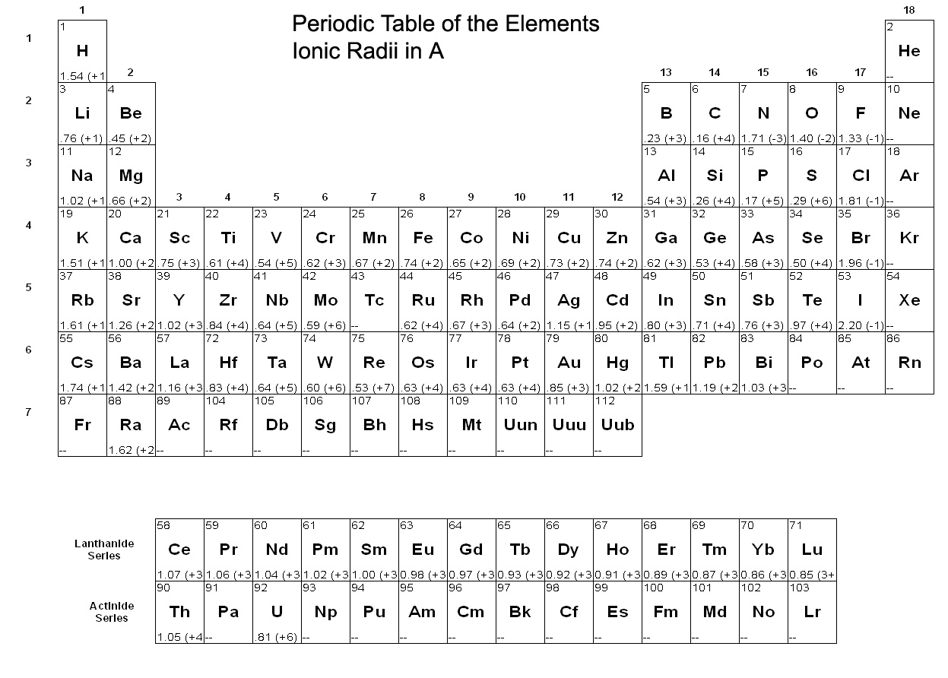

2. Ni, in contrast to Rb, typically has a valence of +2. To what major elements will it most likely be similar? In which minerals is it likely to concentrate? Will in concentrate in late melts?

3. Use the periodic table and Rule B to predict whether Fe²⁺ or Mg²⁺ will concentrate more in liquids than will coexisting mafic minerals. Can you support your contention with a binary phase diagram from Chapter 6?

4. Use Rule C to predict whether Cr⁺³ and Ti⁺⁴ are preferred in solids as compared to liquids.

A more rigorous and quantitative approach is to actually measure the distribution of elements between minerals and coexisting liquids in melting experiments. From them we can define:
(9.1) Always write the reaction before you analyze one.
K_{D} = (9.2) distribution constant
Where is the mole fraction of component i in the solid phase = n_{i}/(n_{i} + n_{j} +n_{k}…)
K_{D} = = D for traces (9.3) distribution coefficient or partition coefficient
Where C_{S} is the concentration of component i in the solid.
5. Use Table 9.1 (next page) to determine whether Rb is an incompatible or a compatible element. What about Ba? Ni? Cr? Eu?

6. Consider a magma with phenocrysts of olivine, orthopyroxene, clinopyroxene, and plagioclase. The olivine phenocrysts contain 1200 ppm Ni. Use Table 9.1 to estimate the concentration of Ni in all the other phases.

Bulk D for a rock:
_{i} = (9.4 )
W_{A} = weight fraction of mineral A in the rock
= the distribution coefficient for the element i in mineral A.
Suppose you have a garnet lherzolite with the following mode (volume %)
Olivine 54% Clinopyroxene 14%
Orthopyroxene 21% Garnet 9%
Magnetite 2%

7. Use the tables above to calculate the bulk distribution coefficient for Nd and Sm in the rock.
8. Which is more incompatible? Is the difference great? Will a partial melt of the lherzolite have more Nd and Sm than the initial rock? Would you expect the concentration of Nd in the melt to vary with the % melted? (hint: consider the concentraton if the source rock were completely melted)

Given the following:
Batch melting (9.5)
C_{O} is the concentration of the trace element in the original assemblage before melting began
F is the weight fraction of melt produced [= melt/(melt + rock)]
9. What is meant by “batch melting?”

10. How can the concept of batch melting be applied to partial melting?

11. What does Equation (9.5) reduce to as F → 1?

12. In plain English, what does your answer to question 11 tell you about C_{L} at high F (and how might that be applied to the Earth)?

13 What does Equation (9.5) reduce to as F → 0?

14. If we determine C_{L} for a melt representing low F, and we know D_{i} what can we infer about the nature of the source rocks?

15. Given the plot in Figure 9.2, for what types of elements and for what degrees of partial melting will the concentration of an element vary most extremely?
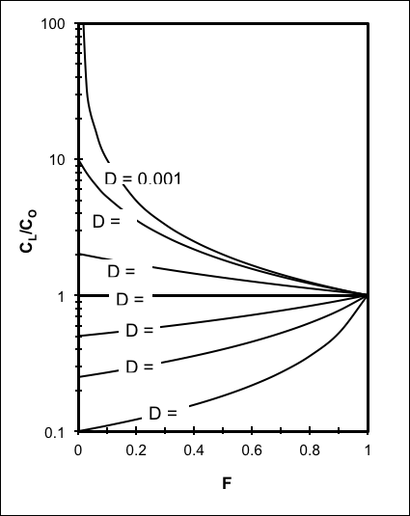
Figure 9-2. Variation in the relative concentration of a trace element in a liquid vs. source rock as a fiunction of D and the fraction melted, using equation (9-5) for equilibrium batch melting.

16. How can the batch melting concept be applied to incremental partial melting in which melts are generated and removed in 10% increments? What variables in Equation (9.5) change as melting proceeds?

17. Can we simply reverse the melting process, and treat F as the fraction left un-crystallized in a cooling magma chamber? Why does or doesn’t this make sense?

18. Rayleigh fractionation treats melting and crystallization as involving the immediate separation of crystals (during crystallization) or melts (during melting) as soon as they are created. How does this model differ from incremental batch melting/crystallization?

The rare earth elements (REE) compose the lanthanide series. The series is characterized by progressive filling by electrons of the 4f orbital.
19. Are the REE incompatible or compatible? On what do you base your answer?

20. What can you say about the variation in ionic radius as the atomic number increases? To what can you attribute this effect?

21. Use Goldschmidt’s rule B to predict how the incompatibility of the REE varies with atomic number.

22. Compare your result for question 21 to Table 9.1.

The typical petrologic REE diagram is a plot of C_{Sample}/C_{Chondrite} vs. atomic number, based on the assumption that chondrite meteorites approximate the trace element (and isotopic) composition of primordial mantle from which many common melts are derived:
23. Draw on the graph below the curve representing the REE pattern for a volcanic rock derived by complete melting of primitive chondritic mantle. Explain your answer.
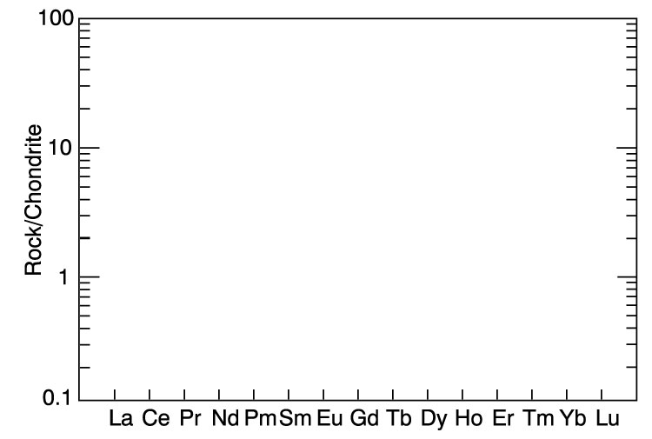

24. Explain the REE diagram on the right.
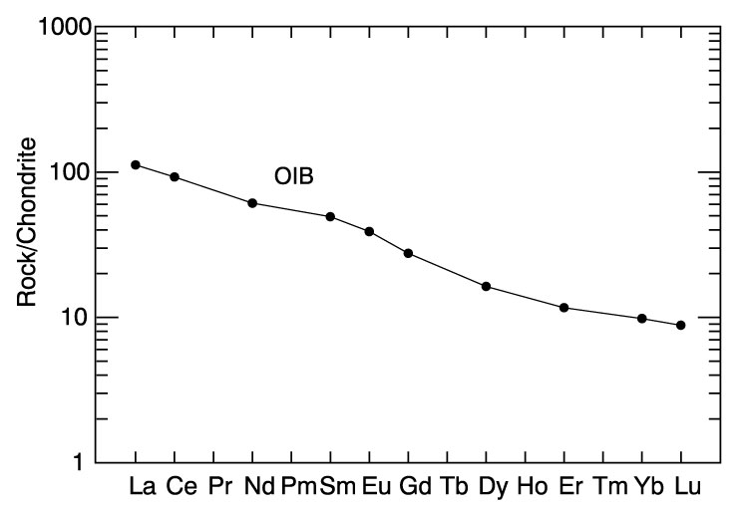

25. Use Table 9.1 on page 3 of this handout to explain the accompanying two REE diagrams. What minerals are indicated to be involved? Compare the lower diagram to that in Question 24. Explain your reasoning. How might you characterize the nature of the mineral involvement?
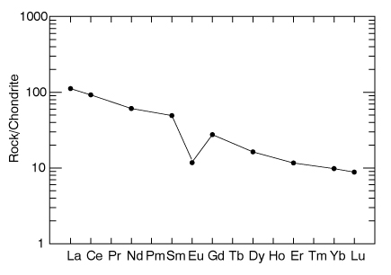
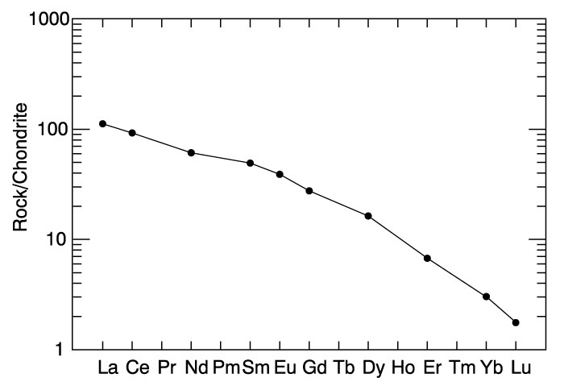

26. Spider Diagrams are an extension of the REE diagram concept. If the accompanying diagram represents the pattern for a “typical” partial mantle melt, what can you say about the way the elements are ordered across the abscissa (x-axis)?
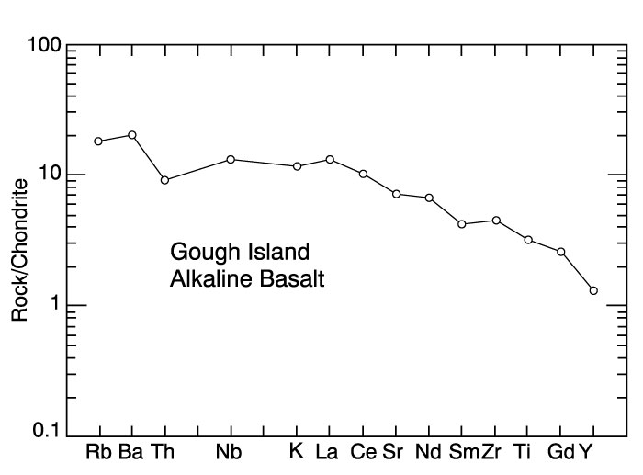

27. Suppose you analyze two rocks and find rock A has a much higher concentration of La than rock B.
  - How could a contrast in the nature of the source that melted be responsible?

  - How could a difference due to melting of the same source be responsible?

  - How could a difference due to crystallization of the same melt be responsible?

28. How might you use the ratio of La/Ce to distinguish from among at least some of the variables above or to evaluate the extent of partial melting or fractional crystallization?

29. What REE ratio would you judge to be particularly sensitive to the involvement of garnet in petrogenesis? Explain.

30. Refer to Table 9.1 on page 3 of this handout and propose a trace element ratio that might be sensitive to variations in crystal fractionation of olivine vs. clinopyroxene during crystallization of a magma. Explain.

31. How do isotopes of a particular element vary from each other?

32. To what extent would you predict that two isotopes of any particular element would fractionate chemically during melting or crystallization processes? Explain.

33. Isotopes of some elements do indeed fractionate during melting or crystallization processes. On what basis would this be possible? Explain.

34. Is ¹H vs. ³H more likely or less likely to fractionate than ²⁰⁶Pb vs. ²⁰⁷Pb during liquid/solid or liquid/vapor transitions? What about ¹H vs. ²H? Explain your answer.

35. How might we generalize as to what types of elements are most likely to fractionate efficiently?

As a general rule, when two isotopes fractionate during melting, crystallization, vaporization, or condensation, the light isotope is preferentially incorporated into the higher entropy phase (vapor > liquid > solid). We can define the extent of fractionation of oxygen isotopes by:
δ(¹⁸O/¹⁶O) = $\frac{(\text{O/}O)_{\text{sample}}−(\text{O/}O)_{\text{SMOW}}}{(\text{O/}O)_{\text{SMOW}}}x\text{1000}$ (9.10)

36. If ocean water (SMOW) evaporates to become clouds, what constraints can you place on values of δ(¹⁸O/¹⁶O) (abbreviated as “δ¹⁸O”) for a sample of water vapor from the clouds?

37. Suppose you had a liter of seawater, and evaporated it experimentally. How would you expect the value of δ¹⁸O in the vapor to vary as evaporation progressed? Explain.

Value for SMOW
0

δ¹⁸O

0 % evaporated 100
38. Would you expect the magnitude of δ¹⁸O for “typical” cloud vapor to have a large of small δ¹⁸O value? Why?

39. Rain and snow are simply the result of precipitation from clouds. Use what you have discussed above to explain the accompanying diagram:
Figure 9.9. Relationship between δ(¹⁸O/¹⁶O) and mean annual temperature for meteoric precipitation, after Dansgaard (1964).

40. What is the difference between a radioactive nuclide and a radiogenic one?

41. Given the following equation for the decay of ⁴⁰ K to ⁴⁰Ar:
⁴⁰Ar = ⁴⁰Ar_{o} + ⁴⁰ K(e^{-λt}-1) (9.16)
where: λ_{e} is the decay constant for the electron capture process (λ_{e} = 0.581 x 10⁻¹⁰ a⁻¹)
λ is the decay constant for the entire decay process (λ = 5.543 x 10⁻¹⁰ a⁻¹)
⁴⁰Ar is the total amount of radiogenic ⁴⁰Ar daughter in the rock
⁴⁰Ar_{o} is the original ⁴⁰Ar in the rock at the beginning point of the decay process
⁴⁰ K is the total amount of radiogenic ⁴⁰K remaining in the rock
Which of the variables in Equation (9.16) cannot be directly determined analytically from a rock sample? For each, suggest why not.

Propose a geologically plausible solution to permit solving equation (9.16) for the age of a volcanic rock.

Why won’t such a solution work for other decay schemes, such as Sr → Rb, Sm → Nd, and U → Pb?

For other isotopic systems, we can solve the original-daughter dilemma by analyzing several cogenetic samples with varying amounts of the parent. For the ⁸⁷Rb → ⁸⁷Sr system, the decay equation can be recast as:
⁸⁷Sr/⁸⁶Sr = (⁸⁷Sr/⁸⁶Sr)_{o} + (⁸⁷Rb/⁸⁶Sr)λt (9.18)
where ⁸⁷Rb is the radioactive parent, ⁸⁷Sr radiogenic daughter, and ⁸⁶Sr a stable Sr nuclide (and therefore constant in any particular rock). The subscripted “o” refers to initial values prior to any ⁸⁷Rb decay.
42. Describe Equation (9.18) as a straight line equation of the type y = mx + b. What is represented by y, x, m, and b? What could you derive from the slope?

43. If a mantle source rock is partially melted, how will Rb/Sr differ between the partial melt and the refractory solid residue? Is the fractionation greatest for small % partial melting or large? Explain your answer (can you find a diagram to help you?).

44. Will Rb/Sr vary as the partial melt evolves by crystal fractionation? If so, will the more primitive or the more evolved liquids be richer in Rb? Why?

45. If a mantle source rock is partially melted, how will ⁸⁷Sr/⁸⁶Sr differ between the partial melt and the refractory solid residue? Will crystal fractionation affect the ratio? Explain.

46. The continental crust has been derived by fractionation from the mantle over geologic time (Chapters 16 - 18). From your answers to Questions 43 - 45, suggest how Rb/Sr of the depleted mantle has changed during that time.

47. How will the effect described in Question 46 affect ⁸⁷Sr/⁸⁶Sr in depleted mantle over time?

48. How will ⁸⁷Sr/⁸⁶Sr in enriched continental crust differ from that in the depleted mantle? Explain.

49. The y-intercept of a Rb-Sr isochron is (⁸⁷Sr/⁸⁶Sr)_{o}, the initial ⁸⁷Sr/⁸⁶Sr ratio of the melt (and hence of the source, because Sr does not mass fractionate during partial melting). What might this value tell us about the nature of the source material for melts such as granites? Explain.

50. ¹⁴⁷Sm → ¹⁴³Nd behaves similarly to the Rb-Sr system. Both Sm and Nd are rare earth elements, and Sm has a larger atomic number than Nd. Which is preferentially fractionated into partial melts, and is the effect as great as for Rb-Sr? Explain.

51. Your answers to Question 50 (should) indicate that the daughter element is enriched over the parent in depleted mantle material. What effect would this have on ¹⁴³Nd/¹⁴⁴Nd (¹⁴⁴Nd is non-radiogenic, and therefore constant) for depleted mantle with respect to enriched continental crust over long time spans? Explain.

52. According to Equation 9-3, the half-life (T½) can be expressed by: T½ = 0.693/λ. Use this and the following equations to explain the shape of the “concordia.”
²³⁸U → ²³⁴U → ²⁰⁶Pb (λ = 1.5512 x 10⁻¹⁰ a⁻¹) (9-22)
²³⁵U → ²⁰⁷Pb (λ = 9.8485 x 10⁻¹⁰ a⁻¹) (9-23)
²³²Th → ²⁰⁸Pb (λ = 4.9475 x 10⁻¹¹ a⁻¹) (9-24)
Pb* indicates radiogenic Pb, and 1.0 - 2.5 indicate time in Ga.
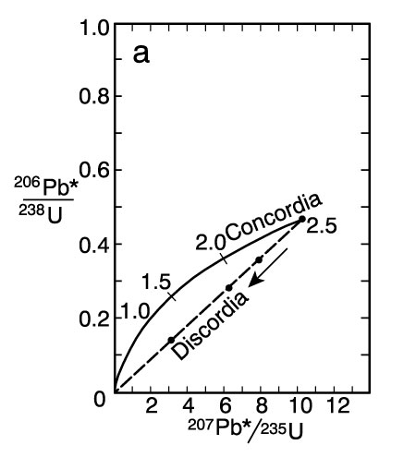

53. Pb is an incompatible large ion lithophile element (LIL). LILs are readily scavenged from rocks by water and melts. If a melting or H₂O-flushing event occurred at 2.5 Ga in the diagram above, why would the “discordia” result?

PROBLEMS

1. Consider a garnet lherzolite with the following mode (volume %):
Olivine 54%
Orthopyroxene 21%
Clinopyroxene 14%
Garnet 9%
Magnetite 2%
Use Equation (9.4) and Table 9.1 plus the accompanying mineral density table to calculate the bulk distribution coefficient for Nd and Sm in the rock by filling in the table below.
Which is element more incompatible, Nd or Sr? Is the difference great?
Will a partial melt of the lherzolite have more Nd and Sm than the initial rock?
Would you expect the concentration of Nd in the melt to vary with the % melted? (Hint: consider the concentration if the source rock were completely melted)
Would variations in % partial melting result in fractionation as great as for Rb/Sr (Figure 9.3)? Explain.
2. Use Equation (9.8) and follow the steps below to create a spreadsheet to model Rayleigh crystal fractionation of Rb and Ni as a basaltic magma crystallizes. Suppose that plagioclase, clinopyroxene, and olivine form and are removed from a liquid in the ratio 5:4:1 over a period of time.
a) Calculate _{Rb} and _{Ni}. Which is more incompatible in this system? On what do you base your answer?
b) Use the Raleigh equation in your spreadsheet to calculate C_{L}/C_{o} for F = 0.05, 0.1, 0.15, 0.2, 0.3, 0.4, 0.5, 0.6, 0.7, 0.8, and 0.9. Plot C_{L}/C_{o} vs. F for each, connecting the points with a line. Note: the exponent function on most spreadsheets is the “^” symbol. Thus 10⁵ is expressed as 10^5.
c) Which element would provide a more sensitive measure of the progress of fractional crystallization? Why? Over what range of F would this measure be most effective? Explain.
d) How, and to what extent, does the Rb/Ni ratio vary with F? Would this make a better or worse indicator of the extent of crystal fractionation than Rb or Ni alone? Why?
3. Open the spreadsheet REE.XLS (from Worked Example 2, available from http://www.prenhall.com/winter). Print a REE diagram for F = 0.05, 0.1 and 0.2. You can print only the chart if you click the chart before printing. Then modify the spreadsheet so that it uses the Rayleigh crystal fractionation model, instead of batch melting, and print REE diagrams for the same values of F. Compare the two models from your printous (you might want to trace the curve for one model onto the chart for the other model for the same value of F). In what ways are the models similar? In what ways are they distinguishable? Could you readily recognize a magma that resulted from partial melting vs. fractional crystallization? Explain.
4. Using the spreadsheet REE.XLS (from Worked Example 2, available from http://www.prenhall.com/winter) and F = 0.1 for a small degree of melting, create a model REE diagram for 100% of each of the minerals listed. Describe how each mineral controls the shape of the REE pattern in the coexisting liquid. This may be important, because some minerals impart a characteristic shape to the REE pattern either to melts from which that phase has been removed, or to melts derived from a rock in which that mineral is a residual phase.
5. The file OCEAN.ROC (available from http://www.prenhall.com/winter) contains the major, minor, and trace element data for a typical mid-ocean ridge basalt (+ signs), and an ocean island basalt (triangles). Using IGPET, create an REE and a spider diagram for these two rock types. Both diagrams can be created under the heading “Spider.” Use the Sun diagram, normalized to chondrite, as your spider diagram. Include both analyses in the diagrams (via the “all” option). Try to explain the slope of the plots for each rock based on what you know about trace element fractionation associated with partial melting and fractional crystallization processes. Assume as a starting point that both are created by partial (batch) melting of a primordial mantle with chondritic trace element characteristics. In both diagrams, the incompatibility of the elements increases from right to left.
6. The Early Paleozoic Stowe Formation in Vermont is part of a discontinuous chain of metabasalts and associated ophiolitic rocks that apparently mark a major suture of the Appalachian system. It is of interest to determine whether the volcanics were created as part of a volcanic arc, or are oceanic slices. The analyses of two samples are listed below:
#1 #2
SiO₂ 47.61 49.95
TiO₂ 1.04 1.07
Al₂O₃ 16.20 15.49
FeO 10.30 9.14
MnO 0.06 0.08
MgO 8.86 6.52
CaO 14.00 13.41
Na₂O 1.52 3.75
K₂O 0.28 0.41
P₂O₅ 0.04 0.09
Zr (ppm) 74 78
Y (ppm) 23 28
Nb (ppm) 11 11
Plot the results on each of the following diagrams:
a) Ti/100 – Zr – Y x 3 (all in ppm. Note 1%=10000 ppm)
b) TiO₂ – MnO x 10 - P₂O₅ x 10
c) Cr - Y
Are the meta-volcanics of the Stowe Formation part of an island arc sequence on the basis of these data?
7. Use Equation (9.12) in a spreadsheet to calculate the concentration of ⁸⁷Rb and the radiogenic ⁸⁷Sr as a function of time. Begin with 100 atoms of Rb and calculate at intervals of 10 Ga spanning 100 Ga. Plot your results for both elements on the same graph (y = abundance, x = time). Discuss the graph in terms of the half-life. Estimate the half-life from the graph, and compare the results to the one you calculate from equation (9.13).
8. Three whole rock analyses from a modern batholith have provided the following Sr/Rb data (I have converted the data to 10⁻¹⁹ moles, but you can treat the data as though they involved individual atoms):
Sample ⁸⁷Rb ⁸⁷Sr ⁸⁶Sr
1 25860 8700 12310
2 59490 8090 11448
3 82860 7230 10230
a) Use your spreadsheet and plot the data on a ⁸⁷Sr/⁸⁶Sr vs. ⁸⁷Rb/⁸⁶Sr diagram. Draw a line through the data. Use an x scale of 0-10 and a y scale of 0.68 to 0.94.
b) For each sample, use the decay equation (9.12) to calculate the amount of ⁸⁷Rb remaining, the amount of additional ⁸⁷Sr created, and the location of the three points after 500 million years have passed. Plot them and draw the best line through the data. Are the three points still collinear? Fit a linear regression to the data and extract the slope. Calculate the age from the slope. Does the age and (⁸⁷Sr/⁸⁶Sr)_{o} value from your intercept fit within reason the ⁸⁷Sr/⁸⁶Sr of the data above? Show your results.
c) Repeat the exercise in part (b) as it would appear after 2 billion years. How does the pattern change?

9. Calculate the slope, Rb-Sr and Sm-Nd isochron ages and (⁸⁷Sr/⁸⁶Sr)_{o} and (¹⁴³Nd/¹⁴⁴Nd)_{o} for the Guichicovi Complex of southern Mexico using Equations (9.18) and (9.19) and the accompanying table (Weber and Köhler, 1999):

For example, use a spreadsheet to plot ⁸⁷Sr/⁸⁶Sr as the ordinate vs. ⁸⁷Rb/⁸⁶Sr as the abscissa. The slope is then λt, where t is the age, and (⁸⁷Sr/⁸⁶Sr)_{o} is the intercept at ⁸⁷Rb/⁸⁶Sr = 0. Using the linearity of the fit as a measure of the accuracy of the results, would you say the age is a good one? How do the Rb-Sr and Sm-Nd ages compare? Which is more likely to be partially reset by later metamorphic events? What can you infer about these rocks from (⁸⁷Sr/⁸⁶Sr)_{o} ?

10. Being as specific as you can, what single rock would you expect to have the very highest present-day ⁸⁷Sr/⁸⁶Sr ratio in the world? Why would you expect it to be so? Explain fully, being clear what factors are involved. What would be the ⁸⁷Sr/⁸⁶Sr ratio of a partial melt of this rock? Why?
11. Use equations (9.15), (9.22) and (9.23) to construct a concordia diagram for 3500 Ma of Earth history. Begin with 1000 atoms each of ²³⁵U and ²³⁸U at an initial time of 0 years, and increment time in 200 Ma increments, calculating N (the number of atoms remaining) and D* (the number of daughter isotopes = N_{o}-N) for both decay schemes at each increment. Then plot ²⁰⁷Pb/²³⁵U vs. ²⁰⁶Pb/²³⁸U to construct a concordia diagram. Once you have a diagram, add the following points as a discordia:

²⁰⁷Pb/²³⁵U | ²⁰⁶Pb/²³⁸U
5 | 0.240
10 | 0.355
12 | 0.400
15 | 0.470
17 | 0.520
19 | 0.560
You can add the points in Excel by copying them, selecting the chart, and using Paste-Special as a new series. Draw a best-fit line through the discordia points and estimate the initial crystallization age and the metamorphic age.

Review Questions for Chapter 10:
Mantle Melting and the Generation of Basaltic Magma
1. Name as many sources of mantle samples as you can.

2. Use Figure 2.2c to describe the differences between dunite, harzburgite, and lherzolite.

3. What does Fig. 10.1 suggest about the relationship between dunite, harzburgite, and lherzolite samples?
Figure 10.1. From Brown and Mussett (1993).

Figure 10.2. Phase diagram of aluminous lherzolite with melting interval (gray), sub-solidus reactions, and geothermal gradient.

4. What features in Fig. 10.2 suggest that mantle melting is not a “normal” process in the “typical” Earth?

5. You described the REE diagrams on the left in the review questions in Chapter 9. Suppose you demonstrated that the two rocks represented primary melts. Using Fig. 10.2, what could you say about the depth of melting for each? Explain.
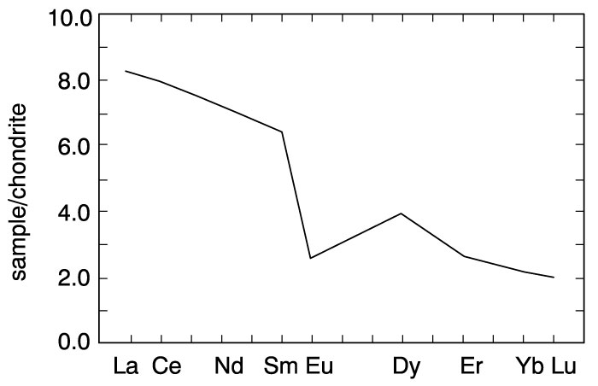

6. If melting is not a “normal” process, under what circumstances can it be accomplished? Note the principles and limitations for each method.

7. As H₂O-undersaturated rocks are heated by burial along the shield geotherm in Fig. 10.6, what should occur at point d? Will any melt be generated? Why? If not, when will melt be generated, and why?
Figure 10.6. Phase diagram (partly schematic) for a hydrous mantle system, including the H₂O-saturated lherzolite solidus, the dehydration breakdown curves for amphibole and phlogopite, plus the ocean and shield geotherms.

8. As H₂O-undersaturated rocks are heated by burial along the ocean geotherm in Fig. 10.6, what occurs at point a? Will any melt be generated? Why? If not, when will melt be generated, and why?

9. In our discussions of partial melting in conjunction with the ternary eutectic phase diagrams in Chapter 7, melting begins at the eutectic point and continues as melt increments are removed until what occurs? What happens as heating continues? How might such a process affect the termination of melting in some source area of the mantle?

10. In what principal ways does a tholeiitic basalt differ from an alkaline basalt?

11. Use Figures 7.27, 9.3 and 10.8 to suggest three plausible ways that might tend to yield an alkaline basalt rather than a tholeiite by partial melting of a chemically homogeneous mantle. (there is more room on the next page, if required)
Figure 10.8. Change in the eutectic (first melt) composition with increasing pressure from 1 to 3 GPa projected onto the base of the basalt tetrahedron. All but the low-T ends of cotectic curves have been omitted to avoid clutter.
Figure 9.3. Change in the concentration of Rb and Sr in the melt derived by progressive batch melting of a basaltic rock.

Figure 7.27. Effect of volatiles on the ternary eutectic point (minimum melt composition) in the system Fo-Ne-SiO₂ at 2 GPa.

12. Although it is possible to derive both tholeiites and alkaline basalts via partial melting of a chemically homogeneous mantle, and “Ockham’s razor” (or the “law of parsimony”) suggests that such a simple explanation is most likely to be correct, what about Fig. 10.13 below suggests that the mantle is not a chemically uniform “fertile” mantle?
Figure 10.13. REE diagram (a) and spider diagram (b) of a typical alkaline ocean island basalt (OIB) and tholeiitic mid-ocean ridge basalt (MORB).

13. The “Mantle Array” in Figure 10.15a below shows the common range of isotopic analyses for oceanic island basalts. These basalts represent relatively primitive mantle melts from throughout the ocean basins, where the contaminating effects of thick ancient continental crust is not a factor. What would be the simplest model for the sub-oceanic mantle that could explain the narrow linear array? Explain how such a model could produce the array. You may want to refer to your answers to review questions 9.46, 9.47, and 9.51 on Sr and Nd isotopes.
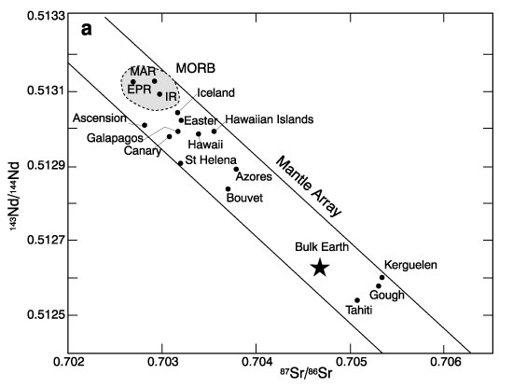

14. Discuss the relative merits of the whole-mantle vs. two-layer convection models.
Review Questions and Problem for Chapter 11. Diversification of Magmas

Simply put, diversification requires:
1) Two (or more) phases in which components are unequally distributed .
2) A physical process in which the phases are separated.
When combined, these two processes allow geologic materials, such as rocks, melts, fluids, etc. to change composition.
1. Provide an example from previous chapters of a magmatic system that diversified. Specify the roles of parts (1) and (b) above in the diversification process.

2. Explain why some critical melt fraction (% melt generated) is required before any melt can be extracted from a melting source area. What factors play important roles in hindering melt escape? What principal factors drive melt separation?

3. Use Appendix A to calculate the viscosity (using the method of Shaw) of the basalt in Table 8.1 if it were magma at 1200ºC. Use only H₂O⁺ and report your results in Pa sec and in poise.

Gravity settling of early-forming minerals is the classically proposed mechanism for magmatic differentiation. For non-Newtonian fluids, the processes is best described by Stoke’s Law:

$V=\frac{{\text{2gr}}^{2}(ρ_{s}−ρ_{l})}{9h}$ (Stokes’ Law) (11-1)
where: V = the settling velocity (cm/sec)
g = the acceleration due to gravity (980 cm/sec² for the Earth)
r = the radius of a spherical particle (cm)
ρ_{s} = the density of the solid spherical particle (g/cm³)
ρ_{l} = the density of the liquid (g/cm³)
η = the viscosity of the liquid (1 g/cm sec = 1 poise)

4. Calculate the settling velocity of a spherical clinopyroxene with a diameter of 5mm and a density of 3.4 g/cm³ in a basaltic magma with a density of 2.6 g/cm³ and a viscosity of 900 poise. Would gravity settling in such a situation be a conceivably important process? Explain why.

5. What is a Newtonian fluid, and do most silicate melts typically qualify as Newtonian fluids? Why or why not? Which melts are most likely to qualify? Why?

6. What is meant by compaction (filter pressing) when the term is applied to magmatic systems? How does it work, and how might it aid liquid-crystal separation?

7. In Chapter 7 we discussed a method by which a rising H₂O-undersaturated magma would reach saturation at shallow levels, and eventually expel an aqueous fluid phase. Briefly describe the process, making it clear why the fluid is released.

8. Retrograde (or resurgent) boiling is the release of an aqueous fluid during the late stages of crystallization of a magma in a magma chamber. Describe how a late magmatic liquid can become H₂O-saturated at a constant pressure due to the crystallization process. Again, make it clear why saturation is attained, and why the fluid is released.

9. In either of the two cases in questions 7 and 8, the late stages of rising and crystallizing hydrous magmas typically reach a stage during which a H₂O-saturated silicate melt coexists with a silicate-saturated aqueous fluid. Why are veins typically created when this stage is reached?

a. Why might porphyritic texture result when H₂O is lost from a magma body? In other words, why the sudden increase in nucleation and the growth of many smaller crystals enclosing the already-formed phenocrysts? Hint: see Figure 3-1.

b. Why do pegmatites typically result from the crystallization of the silicate-saturated aqueous phase (i.e. why the coarse crystals)?

c. What is the typical product when the late magma escapes along a vein?

d. What other principal type of deposit may be generated at such times?

10. What is meant by liquid immiscibility? When did we encounter the phenomenon before?

11. Apply the criteria (1) and (2) for diversification at the beginning of this handout to a situation of immiscible liquids.

12. Is liquid immiscibility likely to play a major role in the typical derivation of andesites, dacites, and rhyolites/granites from primitive basalts? Why or why not?

13. Describe a reasonable scenario for magma mixing. What would a Harker diagram look like for a series of magmas related by magma mixing of a primitive and an evolved magma? How would such a diagram differ from the Crater Lake Harker diagrams?

14. What is the principal limiting factor for wall-rock assimilation by basaltic melts? What elements would be most readily assimilated, and from what types of wall rocks? Explain.

15. In reference to Figure 11-2 (shown below), describe the processes by which a boundary layer forms. What must be present in order for one to form?
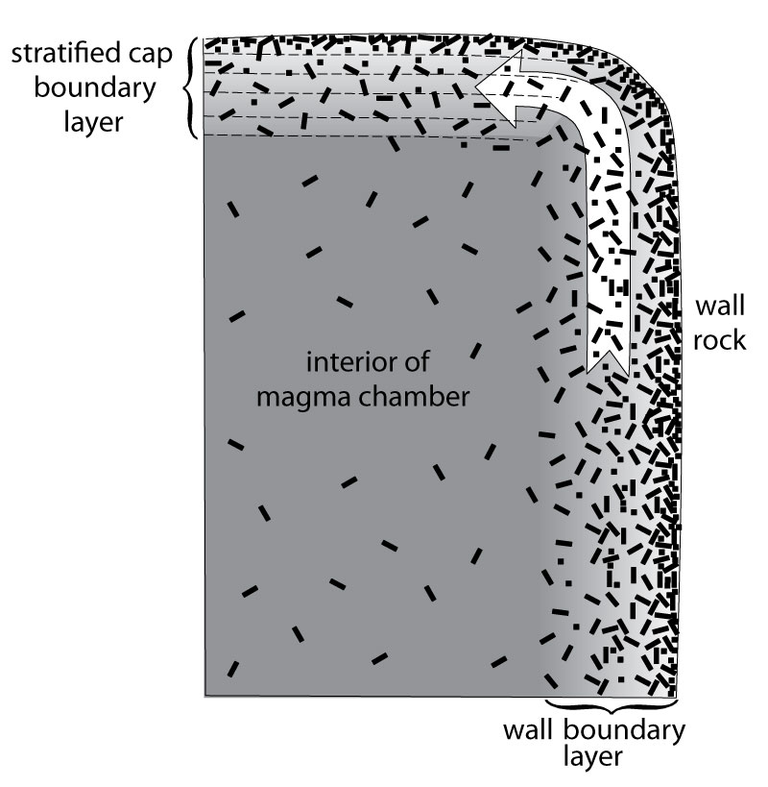

20. What diversification process is most likely to result from an evolved boundary layer? How does such a process create highly evolved liquids in a system that is not largely crystallized?

PROBLEM

1. Pick a point on the high-pressure forsterite liquidus in Figure 6.15 (below) and discuss the cooling history in terms of the minerals formed. Next, consider the amount of forsterite that crystallizes if fractional crystallization takes place while the magma rises toward the low-pressure configuration. Demonstrate geometrically why, and in what way, the relative proportion of olivine will be different than in an isobaric situation. Beginning, for example, with an initial bulk composition at 20 wt. % SiO₂, use the lever principle to compare the relative proportions of Fo and liquid at 1700ºC and 1.2 GPa and at 1600ºC and 0.1 MPa.
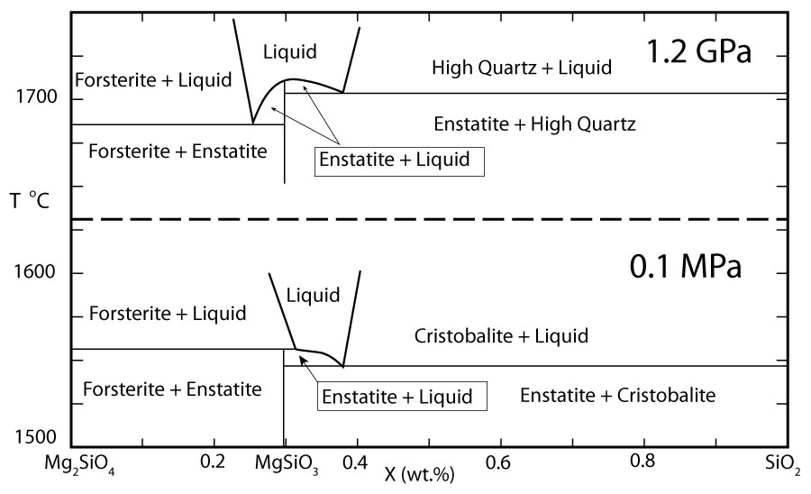

Review Questions for Chapter 12: Layered Mafic Intrusions.

- Explain the difference between an igneous layer, and igneous layering.

- What are the two principal types of graded layers? What is the simplest explanation of how each forms?

- Use Figure 7.2 (below) to explain several different sequences of modal layering that might develop in cooling experimental magmas in the Di-An-Fo system. Be as specific as you can as to the nature and composition of each layer in a sequence. What type or types of layering develop in your model?

- What is rhythmic layering, and how does it differ from intermittent layering?

- Regarding your answer to Review Question 3, why is a layer of pure olivine followed by a pure pyroxenite layer so odd? What type of layering would this represent?

- How might the formation of pure dunite followed by pure pyroxenite during cooling and crystallization be accomplished by varying the rate of gravity settling of the two minerals (hypothetically at least)?

- Suppose the method you proposed in Review Question 6 works. What is the simplest explanation you can then propose for the development of rhythmically alternating dunite/pyroxenite layering similar to the photographs in Figure 12.3 in a shallow magma chamber periodically fed from below?

- What problems would your explanation in Review Question 7 encounter if, after about 10 repetitions, the olivine layers gave way to anorthosite layers? What type of layering would the latter imply?

- How would the problem in Review Question 7 be further complicated if the composition of the olivine were to become smoothly and progressively more Fe-rich from one layer to the next? What type of layering would this represent?

- How do the three types of layering in the previous three questions typically relate to one another in terms of scale?

- What is meant by the fact that some minerals in modal layers in the Skaergård intrusion are not “hydraulically equivalent”? Cite examples. What other features of the Skaergård argue against gravity settling?

- Consider a liquid descending along the Fo-An cotectic in Figure 7.2 (see Review Question 3). Propose several mechanisms that could cause the liquid to leave the cotectic path. How can the mixing of two liquids on the En-Q cotectic in Figure 7.4 (below) produce an off-cotectic liquid?

- Briefly describe a vortex cell as proposed by Irvine et al. (1999). How might such a cell produce a concentrically stratified layer from the roof to the floor of a mafic magma chamber?
Review Questions and Problems for Chapter 13: Mid-Ocean Ridge Volcanism.

- What are the dimensions of a typical mid-ocean ridge?

- How does oceanic lithosphere most effectively cool? Briefly describe the process.

- The accompanying diagram illustrates a popular theory on the origin of ridge–hotspot associations. Three upwelling hotspots form on the left side, and each is soon joined by incipient spreading segments (right side), much like the Afar triangle today (Figure 19.2). Propose a method by which the right side can become a mid-ocean ridge. What would probably happen to the remaining incipient ridge segments, and what would they then be called?
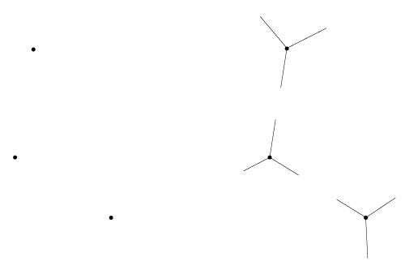

- Briefly describe the stratigraphy of a typical ophiolite.

- On what basis were the layers of the oceanic crust defined? What characterizes each in terms of the original definition?

- Harker/Fenner diagrams of most MORBs do not appear to vary much. What startling inference was drawn from the variation in incompatible minor elements on such variation diagrams (Figure 13.5)?

- How do N-MORBs, E-MORBs, and T-MORBs differ from one another in terms of suspected origin?

- How does a transform fault differ from a fracture zone?

- What is an OSC? How does an OSC differ from a deval? In what way is an OSC a plate tectonic problem?

- Explain the (ideal) correlation between tectonic ridge segments and magmatic ridge segments. Why are the centers of ridge segments typically higher (shallower) than the ends? How might the idea of magma migration within a ridge segment make the idea of OSCs more understandable?

- Why is it difficult to find a parental MORB composition that could be in equilibrium with residual mantle in experiments?

- Are MORBs tholeiitic or alkaline basalts? Does your answer and what you now know about the generation of MORBs correlate well with the melting variables discussed in Chapter 10 that favor one type of basalt versus the other? Explain.

- Briefly describe how a large, persistent axial magma chamber could produce the principal (sub-sediment) layers and sublayers of the oceanic lithosphere.

- Why is the model described in Review Question 13 no longer considered tenable?

- According to the gabbro glacier models, how might a thin melt lens and lower mush zone produce the foliated gabbros of Layer 3?

- What features of the lower gabbros might better be explained by the sheeted sill model?

- Estimate the values of Na_{8.0} and Fe_{8.0} (as defined by Klein and Langmuir, 1987) for the 1959 Kilauea lavas from Figure 11.2. Estimate similarly definable values of Na₆₅ and Fe₆₅ (based on SiO₂) for the Crater Lake volcanics from Figure 8.2. Explain the potential use of such values when comparing different volcanic provinces.

Problem.

- Using IGPET and the file MAR.ROC, create three graphs using K₂O, P₂O₅, and La/Sm as the abscissas versus latitude as the ordinate. The three plateaus the Azores, Iceland, and Jan Mayen are at latitudes 38 - 40º, 63.6 - 66º, and 71 - 72º, respectively. Briefly describe and interpret your results.

Review Questions for Chapter 14: Oceanic Intraplate Volcanism.

- What is the difference between a hotspot, a plume, and a superplume?

- If plate tectonics is the process of mantle cooling, what is responsible for major plumes? See Section 1.7.3.

- Sketch a cross section through a newly initiated rising plume. Why does it have the shape you have drawn?

- What is meant by plume entrainment? Over what part of the mantle traversed by a plume is it most effective?

- How does a seamount differ from an oceanic plateau? Which is more likely to result from a plume-head outbreak? Why?

- What do hotspot tracks indicate about plate motion?

- What are the three major OIB magma series? What is the parental magma for each? Name three or four intermediate rock types and the most evolved rock type for each series.

- What are the typical stages of Hawaiian volcanism?

- Which is more likely to have olivine phenocrysts, a tholeiitic basalt or an alkaline basalt? Which is more likely to have quartz in the norm and which nepheline?

- Why does a MORB-normalized spider diagram of an OIB (Figure 14.5) typically have a central hump shape?

- Why might the ratio of similarly compatible trace elements be nearly the same for partial melts as for the source of those melts?

- Suppose the mantle is thoroughly homogeneous. Explain how the major element and trace element concentrations of partial melts could be highly variable yet the ratios of heavy isotopes should be uniform.

- Describe how the distribution of isotopic ratios of OIBs can be used to indicate the number and constrain the isotopic character of the mixing components required. Is the number a minimum or a maximum? Explain.

- What suggests that the depleted mantle is generally shallower than the mantle containing more enriched components?

- Compare the most likely sources of EMI versus EMII and explain the basis for your conclusions.

- Why is HIMU more obvious on ²⁰⁷Pb/²⁰⁴Pb versus ²⁰⁶Pb/²⁰⁴Pb diagrams than ⁸⁷Sr/⁸⁶Sr versus ¹⁴³Nd/¹⁴⁴Nd diagrams?

- What is the DUPAL component, and what does its global distribution suggest?

- What leads to low ³He/⁴He values? Explain. What is the simplest explanation for low-but-uniform ³He/⁴He in N-MORBs and higher ³He/⁴He in many deep-seated OIBs?

- Why have ¹⁸⁷Os/¹⁸⁸Os and δ¹⁸O been called the “smoking guns” of recycled crust and sediment?

- What is meant by an isotopic convergence reservoir, and why have some, such as FOZO and C, been proposed?

- Compare (strict) two-layer and whole-mantle convection models. What are the strengths and weaknesses of each?

- Why would a negative Clapeyron slope for the 660-km mantle transition zone make it a more effective barrier to convection?

- Mixing of contrasting materials consists of two processes. What are they? Describe them.

- Which mixing process is the limiting factor in mantle homogenization within a convecting region? Why? To what scale does the difference in effectiveness leave the mantle heterogeneous? What term is typically applied to the result?

- Describe the process of partial melting of rising material in a plume tail. At what depth is it most likely to be copious? Why? What components will probably melt first in a marble-cake mantle? Explain.

- Describe how a rising superplume from the D" layer could give rise to a series of secondary plumes. What would enhance this effect and where is it most likely to occur?

- What are some proposals for the creation of non-plume OIBs?
Review Questions for Chapter 15: Continental Flood Basalts.

- What is a LIP, and what types of oceanic and continental LIP occurrences are there?

- What are the major prerequisites for developing a CFB? Why is each necessary?

- In what way are the prerequisites for developing a CFB met by the Columbia River Basalt Group?

- What are the commonly cited potential mantle sources for OIB magmas in Chapter 14?

- In what principal ways do the sources for CFBs differ from those of OIBs?

- Are CFBs typically more evolved or less so than OIBs? Why?

- What is the major problem with relating the CRBG to the Yellowstone hotspot? How is the problem addressed?

- Name the hotspots associated with the Deccan Traps, the Paraná Province, and the North Atlantic Province.

- Which two major CFBs are not associated with runaway rifting? What else do they have in common?

- What are seaward-dipping reflectors, and how are they formed? Why do they have that name?

- Why isn’t fractional crystallization a logical basis for bimodal basalt–rhyolite volcanism? What is a more logical explanation? Support your answer in terms of process and location of bimodal occurrences.

- Contrast the active and passive models of rifting and mantle upwelling. How would the timing of extension and magmatism differ? Why? Which one would result in land at a higher elevation? Why?

- Suppose a plume rose from the D" layer. What depth would that be? What is the physical state of matter in the plume at 400 km depth—solid, liquid, or vapor? Why?

- At what depth is significant partial melting likely to occur in a rising peridotite plume? Why?

- Suppose a plume head encountered 130-km thick lithosphere beneath a continental craton. Would it generate much melt? Why?

- Propose four ways to allow significant partial melting in a plume if it did encounter lithosphere 130 km thick.

- How might plume head impact lead to extension?

- How might plate tectonics cause extension? See Section 1.7.3 for help if needed.

- Where is a modern example of a three-ridge triple junction with a hotspot at the center? Begin with a sketch of Figure 19.2 and continue to sketch the Dewey and Burke model for hotspot-induced continental breakup as it might apply to the future of Africa.

- Provide a reasonable explanation for the size of the Ontong Java oceanic plateau.
Review Questions for Chapter 16:
Subduction-Related Igneous Activity, Part I: Island Arcs.

- Sketch from memory a cross-section through a typical island arc, showing the major crustal and plate tectonic features. Include a secondary arc.

- What is h, and what is a reasonable average value for it? Label it on your sketch for Review Question 1.

- What is the major control on the horizontal distance from the trench to the volcanic front and the width of the volcanic zone? Explain.

- What is the most likely cause of back-arc spreading?

- How does the average composition of arc magmas compare to MORBs and OIBs? How does the range compare? Explain this in three or four concise sentences.

- In what way is magmatism at a subduction zone a paradox?

- What is the most likely solution to the paradox of magmatism at a subduction zone? Why is it more likely in subduction zones that at mid-ocean ridges and intra-oceanic islands? On what basic principles is the effect based?

- Describe at least two mechanisms that might be responsible for the common development of calc-alkaline andesites in the island-arc environment. In what way is H₂O important to each?

- Describe two systematic spatial variations and one temporal variation in island-arc magma compositions.

- What is meant by K₂O_{(57.5)} and FeO*/MgO_{(57.5)} in Figure 16.5? Can these values be determined on the basis of a single rock analysis? Why or why not? Estimate the values of each for the Guatemala data in Figure 16.7.

- What are LIL and HFS elements? In what way does the LIL/HFS ratio in arc magmas typically differ from the ratio in MORBs and OIBs? What is probably responsible and why?

- What evidence is there to indicate that a depleted MORB-source type of mantle is involved in island-arc petrogenesis?

- The EM (enriched mantle) signature in many OIBs may have been resident in the mantle source for hundreds of millions of years. What isotopic evidence suggests that enriched components were mixed with the depleted mantle component beneath island arcs relatively recently? Explain.

- What plate tectonic variables produce the hottest subduction zones, and why?

- Why were thermal models of subduction zones one of the main arguments against slab melting, and why is the argument less strong today than it was in the past?

- What are the two principal criteria for H₂O-induced partial melting of an H₂O-undersaturated rock following some P-T-t path in a subduction zone? Explain your reasoning.

- Recalling the difference between discontinuous and continuous reactions from Chapters 6 and 7, why would the former type be applied to a dehydration reaction and why would it release H₂O more suddenly from the slab than the latter?

- Pretend you are an OH– molecule in chlorite in altered subduction oceanic crust. Describe your route from the beginning of your being subducted to your explosive eruption in an evolved calc-alkaline dacite.

- Describe a similar trip in which you end up in the deep mantle. What is a “choke point,” and under what circumstances would you most likely escape one?
Review Questions for Chapter 17:
Subduction-Related Igneous Activity, Part II: Continental Arcs.

- Cite some reasons why crustal contamination is more evident in continental arcs than in island arcs.

- Why is the subcontinental lithospheric mantle likely to differ significantly from the sub-oceanic lithospheric mantle?

- How would you expect ⁸⁷Sr/⁸⁶Sr to vary in magmas that traverse a significant thickness of ancient continental crust? ¹⁴³Nd/¹⁴⁴Nd? Why? Why might the CVZ of the Andes show higher ⁸⁷Sr/⁸⁶Sr and lower ¹⁴³Nd/¹⁴⁴Nd than the NVZ or SVZ?

- Why might a low dip angle of subduction inhibit volcanism in a continental arc?

- What are bimodal volcanic suites, and how do they probably form?

- How do the major batholith belts relate to continental-arc volcanics? Why are the batholiths exposed in some areas and covered by volcanics in others?

- Describe the underplate remelting model for tonalites and explain why, if it is true, arc batholiths may not strictly conform to intrusive equivalents of arc volcanics.

- Why is a hydrous melt less likely to reach the surface as lava than an anhydrous melt? Use an appropriate P-T phase diagram to illustrate.
Review Questions for Chapter 18: Granitoid Rocks

- What is the difference between a granite (sensu stricto) and a granitoid?

- Using sketches of appropriate binary Ab-Or phase diagrams, illustrate an example of the alkali feldspars in both subsolvus and hypersolvus granites. Mark the feldspar compositions clearly. What physical conditions might be responsible for the occurrence of one versus the other?

- What is the difference between a xenolith and an enclave? What is an autolith, and how does one form?

- How might you tell if a zircon crystal in a granitoid is igneous or restite?

- The chemical analyses in Table 18.2 are converted to molecular proportions in the table below. Which granitoids are peraluminous, metaluminous, and peralkaline? Which type appears to be most common? What types of granites seem to be peraluminous? Why?

Oxide | 1 | 2 | 3 | 4 | 5 | 6 | 7 | 8 | 9 | 10 | 11 | 12
Al₂O₃ | 0.138 | 0.115 | 0.128 | 0.149 | 0.139 | 0.137 | 0.122 | 0.153 | 0.148 | 0.156 | 0.149 | 0.158
CaO | 0.083 | 0.002 | 0.009 | 0.076 | 0.055 | 0.034 | 0.013 | 0.057 | 0.055 | 0.132 | 0.075 | 0.152
Na₂O | 0.056 | 0.089 | 0.063 | 0.064 | 0.051 | 0.040 | 0.066 | 0.079 | 0.059 | 0.050 | 0.063 | 0.045
K₂O | 0.003 | 0.050 | 0.050 | 0.013 | 0.037 | 0.043 | 0.049 | 0.019 | 0.036 | 0.012 | 0.036 | 0.003

- What principal genetic factors control the major element chemical composition of an igneous rock?

- Why does high LIL/HFS suggest a subduction-related origin?

- What is the difference between fluid-saturated and fluid-absent melting?

Which would occur at a lower temperature? Explain.

Which is more likely in the deep crust? Why?

What requirements, in terms of P-T-t path, metamorphic reactions and H₂O-saturated solidus, must be met for fluid-absent melting to occur?

- How does I-type granite differ from S-type? From M-type? From A-type?

- What type of granitoids are formed with no genetic connection to continental or arc crust? How do they form?

- What is a mafic underplate and why do they form where they do? Once solid, are they part of the mantle or the crust? Why?

- Compare the shield geotherms in Figure 1.11 with the H₂O-saturated granitoid solvus in Figure 18.5. Do they intersect? If so, why aren’t granitoids formed everywhere in the continental crust?

- What is the probable heat source for post-orogenic granitoid formation?

- What is usually meant by bimodal magmatism? Cite a typical example and describe briefly the source of each component.

- What are the probable roles of the crust and of the mantle in granitoid formation?

- What events might trigger the formation of extensive granitoids?

- What is a komatiite and why, given what you learned in Section 11.1, are they unlikely to form today?

- In what ways were tonalites probably formed? Be sure you make the principles clear.

- Compare the rates of formation of continental crust in the past with those of today.

- How can the continental crust be andesitic on average when the majority of modern magmatism that adds to the crust be basaltic?
Review Questions for Chapter 19: Continental Alkaline Rocks

- How do active and passive rifting differ from one another? What is actually active or passive in these situations?

- Sketch a three-rift triple junction and indicate the motion of the three plates, with mutually consistent vector arrow, one on each plate, such that one rift arm spreads much more slowly than the other two.

- Cratons are the oldest part of the continents. What are the two major younger parts, and how do they relate to the cratons?

- What mineralogical characteristics do nephelinites, leucitites, and melilitites have in common? What would they be called if plotted on Figure 2.4 (see Table 19.2)? What is melilite?

- How do tephrites and basanites differ from the three rock types in the previous question, and how do they differ from each other?

- Briefly describe the stages of African rifting and volcanism.

- In what ways does the subcontinental lithospheric mantle differ from the sub-oceanic lithospheric mantle? What evidence supports the contention? What is responsible for the difference?

- Cite a few reasons why continental intraplate volcanism is typically more alkaline (and occasionally much more alkaline) than oceanic intraplate volcanism.

- Cite examples of small-scale, medium-scale, and large-scale heterogeneity in African volcanics.

- Why might some liquids evolve toward increasing silica saturation whereas similar liquids evolve toward highly undersaturated compositions?

- What are the likely sources of EMI, EMII, and HIMU, as described in Chapter 14?

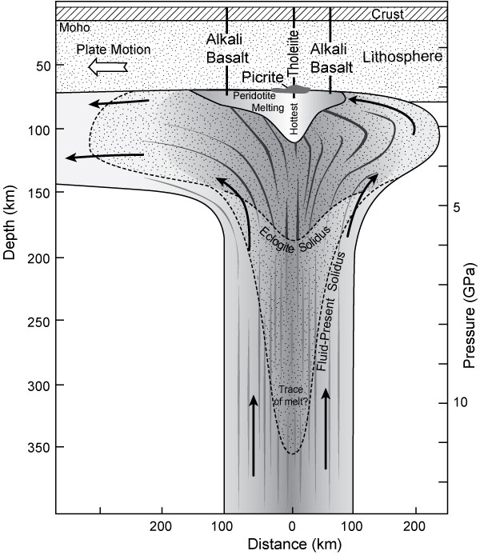
Figure 14.20
- What are the three levels at which melting occurs in a rising plume, as illustrated in Figure 14.20? What components of the plume probably melt first? Are the deepest/earliest melts likely to reach the surface? Explain.

- Being as precise as you can, what, according to the IUGS classification, is a dolomite–carbonatite? What is a dolomite urtite?

- How do carbonatites typically occur in the field, and in association with what other igneous rocks?

- What are the three principal ways that carbonatites are believed to be created?

- What are likely sources of CO₂ in the mantle?

- Why would a high Sr content in a magma (such as carbonatite) make its ⁸⁷Sr/⁸⁶Sr ratio less susceptible to the effects of contamination by crustal Sr?

- What are probable contributors to HIMU and EMI in carbonatite source areas? Explain.

- What is a fenite, and how does it probably occur?

- Why are primary carbonatite magmas unlikely to reach shallow levels in the crust?

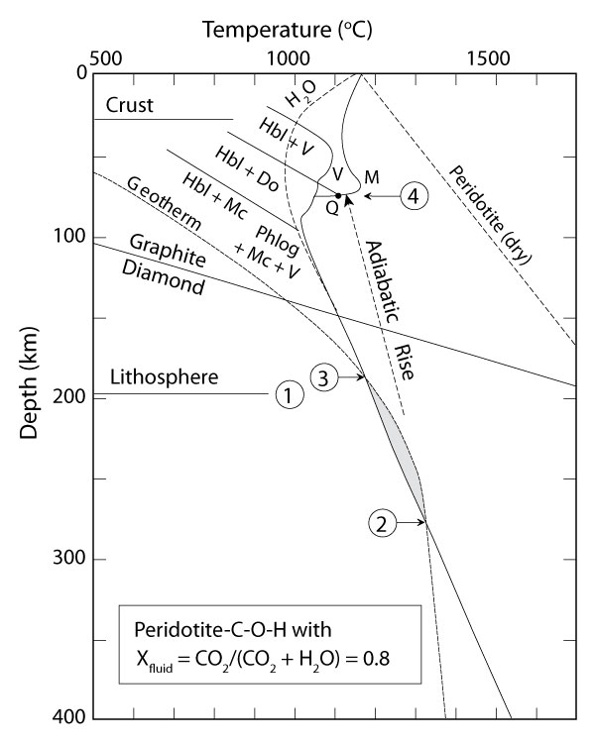
Figure 19.13

- What is responsible for the “ledge” in Figure 19.13? What is its petrologic significance?

- What evidence suggests that carbonatites and their associated alkaline silicate rocks may be related by liquid immiscibility?

- What genetic types of highly potassic rocks were recognized by Mitchell and Bergman (1991)?

- Which major elements are abundant in most lamproites and which aren’t?

- What aspect of many lamproites suggests that their geochemical enrichment is not limited to crustal contamination, but must be a mantle characteristic?

- What field and geochemical characteristics suggest a link between lamproites and subduction?

- Briefly describe the three-stage model for lamproite genesis.

- What are lamprophyres and why are they such a broad category of rocks? What features do they tend to have in common?

- Describe the origin a typical (group 1) kimberlite from initial partial melting to eruption.

- How do group 1 and group 2 kimberlites differ from one another? What is an alternative name for group 2 kimberlites? Why that name?

- In what rocks do diamonds principally occur? How do those rocks get into kimberlites?

- Are diamonds phenocrysts in kimberlites? If not, what are they? Explain your reasoning.

- What have we learned from inclusions in diamonds? Why are diamond inclusions typically more informative that minerals carried upward in the kimberlite matrix?

- How does modal metasomatism differ from cryptic metasomatism?

- Cite evidence supporting the theory that the SCLM was depleted at some point. What process or processes might be responsible?

- Cite evidence supporting the theory that the SCLM was later re-enriched. What process or processes might be responsible?
Review Questions for Chapter 20: Anorthosites

- Why are anorthosites difficult to categorize? What characteristics do they have in common with granitoid rocks (Chapter 17) and what in common with mafic rocks?

- Refer to the Di-An-Fo ternary phase diagram (Figure 7.2), and, using pure anorthite as a reasonable proxy for An-rich plagioclase, determine the crystallization temperature of plagioclase from a parental melt of anorthositic composition (at atmospheric pressure). How does this compare to the shield geotherms at the base of the crust in Figure 1.11? Again using Figure 7.2, suggest a plausible way to crystallize and concentrate nearly pure plagioclase at temperatures nearly 300ºC lower. From what range of melt compositions (area on the diagram) would this be possible?
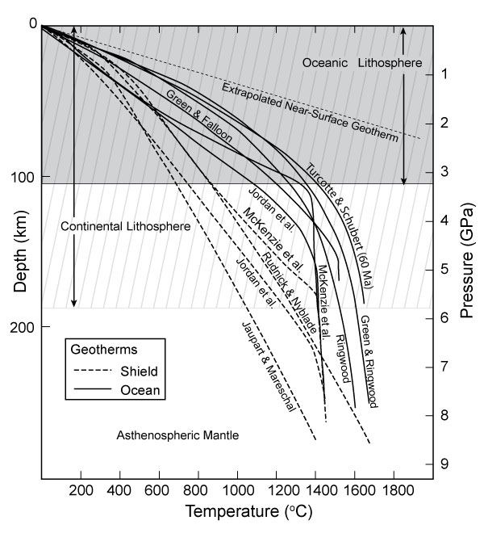
Figure 7.2 Figure 1.11

- How do Archean and Proterozoic anorthosites typically differ from one another?

- In what ways may a suitably Al-rich basaltic parent liquid be created to reach plagioclase saturation early on?

- What indicates that at least part of anorthosite crystallization occurred at 30 to 35 km depth? What is special about that depth?

- How would anorthosites form from melts under the circumstances implied by questions 4 and 5?

- In what ways is the formation of lunar anorthosites similar to terrestrial ones? In what ways does it differ?
Review Questions for Chapter 21: An Introduction to Metamorphism

- What defining processes may occur during metamorphism? Briefly describe each.

- Into what does metamorphism grade at the low-grade end?

How do we define the low-grade boundary of metamorphism?

Why is this a rather difficult distinction to make?

- Metamorphism grades into what at the high-grade end?

How do we define the high-grade boundary of metamorphism?

Why is this a rather difficult distinction to make?
- In what ways may changing temperature affect metamorphic mineral assemblages and textures?

- What is a metamorphic field gradient, and how do they differ from a geothermal gradient (at the time of metamorphism)?

Describe a situation in which a metamorphic field gradient and a geothermal gradient would be the same.

- What is lithostatic pressure?

What would be the shape of a strain ellipsoid for rocks experiencing lithostatic pressure?

- How does flattening differ from shear?

- Suppose you had a deformed rock with cleavage and markers (such as fossils, oolites, etc.) that permitted you to determine a strain ellipsoid, as in the figure below. Can you distinguish whether either rock has been deformed by flattening or shear? Explain. 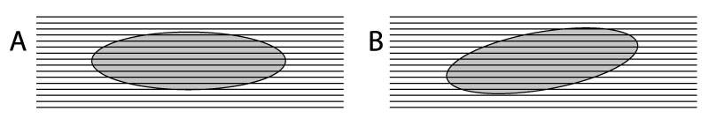

- Think of a common object with a shape corresponding to the strain ellipsoid for each of the following stress situations. Also state for each whether particles contained within your object should conform to a foliation or lineation.
a. σ₁ > σ₂ = σ₃

b. σ₁ = σ₂ > σ₃

c. σ₁ > σ₂ > σ₃

- Describe two plausible ways that p_{H2O} could be less than P_{total}.

- Cite one major reason why P_{fluid} is probably equal to P_{lith} during prograde metamorphism.

- Why might P_{fluid} be much less than P_{lith} after metamorphism has passed its peak?

- What is metasomatism?

- Describe a typical field occurrence of contact metamorphism.

What typically causes it?

How might the contact metamorphic rocks vary spatially, and over what scales?

What kinds of textures are typical of contact metamorphism?

- Describe a typical field association of regional metamorphism.

What typically causes it?

How might regional metamorphic rocks vary spatially, and over what scales?

What kinds of textures are typical of regional metamorphism?

- Why might relict textures be more common in contact metamorphism than in regional?

In what part of a contact aureole are relict textures most likely to occur? Why?

- Describe a typical field association of fault-zone metamorphism. What kinds of textures are typical of fault-zone metamorphism?

- What is prograde metamorphism?

What is retrograde metamorphism?

Which is more likely to be maintained? Why?

- What is meant by the term progressive metamorphism?

At what metamorphic grades is it less likely to occur? Why?
- What are the six most common types of metamorphic protolith? What chemically characterizes each?

- What are metamorphic zones?

What is an isograd?

What is an index mineral?

How are zones conventionally named? Be specific and give an example, specifying the lower and upper boundaries.

How does the stability range of an index mineral compare to the limits of the zone named for it?

- What does the notion of progressive metamorphism imply for the geometry and location of isograds over time during a metamorphic event? In what way would you expect them to change? Why?

- How did the conditions and metamorphic field gradient of metamorphism along the Buchan coast of Scotland differ from that in the classical Barrovian area?

- What are paired metamorphic belts?

How does the outer belt differ from the inner belt in terms of P/T gradient and setting? Explain why.
Review Questions for Chapter 22: A Classification of Metamorphic Rocks

- What do a slate and a phyllite have in common?

How are they distinguished from one another?

What is responsible for the difference?

- What does a schist have in common with a slate and phyllite?

- How does schistosity differ from cleavage?

- What distinguishes a gneiss from a schist?

- How might you tell an orthogneiss from a paragneiss?

- What does a cataclasite have in common with a mylonite?

In what way do they differ?

- What does a calc-silicate granofels and a skarn have in common?

In what way do they differ?

- What is a preferred name for a quartz granofels?

- What would you name the following rocks?
- An incipiently metamorphosed siltstone in which the original texture and mineralogy is largely intact

- A rock with good cleavage and looks like a shale but rings when you hit it with a hammer

- A rock composed of chlorite and actinolite with a pronounced alignment of the minerals

- A rock dominated by sub-equal amounts of hornblende and plagioclase with a random fabric

- A rock with the same mineralogy as the previous rock, but with an obvious foliation

- A rock containing quartz, orthoclase, plagioclase, and biotite, with a discontinuous metamorphic banding of dark and light layers (include an indicator of composition in your name)

- The same rock as the previous one but with large eye-shaped grains of orthoclase in a finer matrix

- A rock composed of coarse calcite grains with a slight foliation

- A rock composed of 20% biotite, 35% quartz, 15% muscovite, 5% plagioclase, and 10% garnet, with good foliation

- A slate-like rock with a satiny sheen on the cleavage and 5-mm-sized ovoid blobs of cordierite

- A fine-grained rock with random fabric and splintery fracture

- A green clinopyroxene granofels with red garnets

- A glaucophane, albite, epidote rock with a distinct fabric

- A tremolite, diopside grossular, carbonate granofels

- A gneissic rock containing feldspar, quartz, and orthopyroxene
Review Questions and Problems for Chapter 23:
Structures and Textures of Metamorphic Rocks

- What is the difference between rock texture and rock structure?

- Imagine the mineral albite experiencing sufficiently high temperature that it breaks down to jadeite (new) + quartz (already present). Write the reaction and describe what occurs at the atomic scale, using the four steps introduced at the beginning of this chapter.

- How does cataclastic flow differ from intracrystalline plastic deformation?

- What causes strain hardening?

- What is recovery, and what processes aid it?

- What is recrystallization, and what processes aid it?

- Explain how deformation might enhance the prospects of recovery and recrystallization.

- Sketch a thin section view of porphyroblastic and poikiloblastic texture in a groundmass of granoblastic polygonal quartz.

- What is the difference between a porphyroblastic, a porphyroclastic, and a blastoporphyritic feldspar in a metamorphic rock?

- Sketch an S-C texture with sinistral shear and explain how it can be used to determine the sense of shear.

- Sketch a σ-type mantled porphyroclast with sinistral shear and explain how it can be used to determine the sense of shear.

What would be the sense of shear if the porphyroclast itself were rotated and not the result of dragging the tails in the foliation? Explain.

- Find a sense-of-shear indicator in Figure 23.18 and t4race or sketch it. Does it indicate dextral or sinistral shear? Explain.

- Sketch a P-T-t path (see Figure 16.19) for the burial, heating, uplift, cooling and exposure of a polyphase orogenic metamorphic event with two thermal climaxes.

Can you imagine a plate tectonic process that might be able to produce this?

- Briefly describe the various types of foliations (including three primary/inherited types).

- In what ways can fabric elements become aligned in a metamorphic foliation?

- Briefly describe the various types of tectonic/metamorphic lineations.

- What determines whether a lineation or a foliation develops?

- How might an originally homogeneous rock develop gneissose layering?

- What is S₀?

What is S₁?

What is S₂?

What is L₁?

- If S_{i} in a poikiloblast does not lead continuously into S_{e}, what can you say about the duration of deformation versus poikiloblast growth? Why?

- What is the relationship between deformation and crystallization in a continuous schistosity?

- How many deformational phases are indicated by a polygonal arc?

With respect to deformation, when did crystallization of the arc mineral occur? Explain.

- Describe four examples of clearly syn-kinematic porphyroblast growth. Explain why each is so.

- Redraw Figure 23.45, interpreting the spiral in garnet (Figure 23.44) as a second deformational/metamorphic event.

- What is a major advantage of TIMS over conventional methods of isotopic analysis?

What is a major advantage of UV-LA-ICPMS and IMP over TIMS?

- What are the desirable properties of a mineral for textural dating? Cite an example for each quality from the list of studies provided, if available.

- Use the average duration of growth and rate of growth to estimate the diameter of the garnets in the study of Christensen et al (1989) in Section 23.7.1.

Problems.
- Try to diagram the deformation/crystallization history of the six poikiloblasts in Figure 23.37. What controversy exists as to whether one or two deformational events are involved?
- Discuss the deformation/crystallization history of the garnet porphyroblast shown in a muscovite, biotite, quartz schist. Chart the deformation–crystallization history. Support your conclusions with evidence.
- Describe the textures that you see in Figure 23.46, interpret the metamorphic crystallization–deformation history, and create your own diagram that depicts your interpretation.
- Suppose you began with a mole of uranium in average crustal proportions listed in Section 9.7.2.4 and half a mole of thorium. Use the decay constants in that section to calculate the proportions of Pb isotopes you would expect in the same sample after 1 Ga. Why might this free you from having to do isotopic analysis to determine a mineral age? What other assumptions would this require?

Review Questions and Problems for Chapter 24:
Stable Mineral Assemblages in Metamorphic Rocks

- What is meant my mineral paragenesis?

What minerals are typically excluded in paragenesis?

How does paragenesis differ from the similar sounding petrogenesis?

- Goldschmidt’s mineralogical phase rule is φ = C. Why should this be true for a typical metamorphic rock?

- What are the implications for a metamorphic rock in which φ < C?

- One alternative explanation for a metamorphic rock in which φ > C is that equilibrium was not attained. Explain why disequilibrium would tend to raise φ.

- Another alternative explanation for a metamorphic rock in which φ > C is that the sample was collected exactly on an isograd. Explain how this might be possible.

- A “perfectly mobile” component is one for which the chemical activity is controlled externally to the system, whereas the activity of other components is controlled within the system. As a slight simplification, let’s treat activity as though it were composition. Consider a system of your own creation in which a saline NaCl solution acts as a pore fluid able to flow through a porous container of sand-sized grains of quartz and halite. Devise a simple system in which Na⁺ and Cl⁻ would be considered perfectly mobile (concentrations controlled externally) and another in which they would not (concentrations controlled internally). Describe the two systems (using the mineralogical phase rule), both before the fluid is added and after equilibrium is attained.

- Why would NaCl be counted as a component in the mineralogical phase rule in one of your systems in question 6 and not in the other?

- The figure below is a ternary CaO-MgO-SiO₂ (CMS) compatibility diagram for medium-grade metamorphosed siliceous dolomites. H₂O and CO₂ are perfectly mobile. Begin with a pure dolomite and describe the sequence of equilibrium mineral parageneses for rocks of successively greater SiO₂ content. Discuss each paragenesis in terms of Goldschmidt’s mineralogical phase rule. Remember, φ = C, where φ is the number of phases, and C is the minimum number of (immobile) components required to describe every phase in a rock. Note that some assemblages will be degenerate.
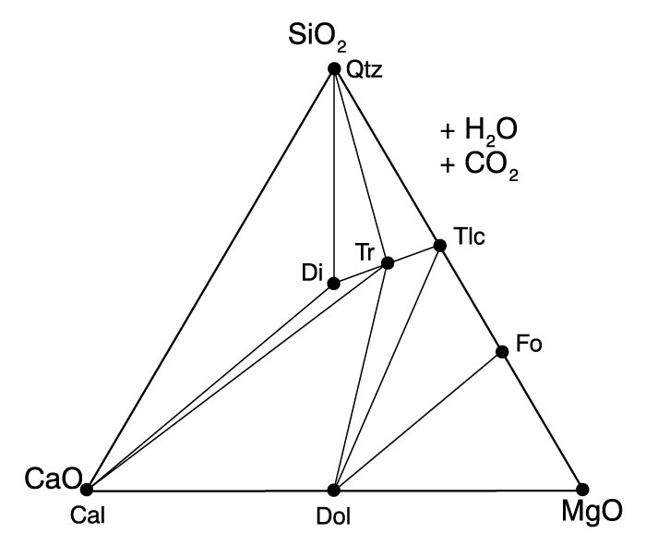

- Figure 25.7 (below) is a ternary ACF compatibility diagram for medium-grade metamorphosed basalts. H₂O is perfectly mobile, and the parageneses can be treated as three-component systems. The shaded area represents the typical range of metabasalt compositions. Discuss each paragenesis for the shaded range in terms of the full phase rule and Goldschmidt’s mineralogical phase rule. What variables are associated with F when φ = C and when φ < C?
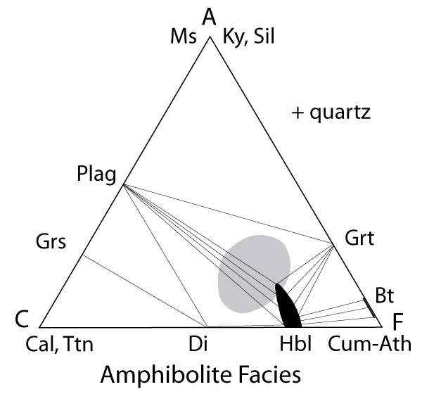

- Why might garnet occur in some medium-grade metabasalts but not in others in the same field area as in Review Question 9?

- Sketch an x-y-z triangular chemographic diagram with x at the top, y on the left and z on the right (as in Figure 24-2). Suppose you wanted to project a mineral with the formula xy₂z₂ from the mineral x₃y to the y-z pseudo-binary. What would be your formulas for calculating y' and z', and where would xy₂z₂ plot? Compare the plot point mathematically and graphically.

Problems

1. Given the following mineral compositions (Fe is Fe⁺² unless indicated):

Staurolite (St) (Fe,Mg)2Al9O6[(Si3Al)O16](OH)2
Chloritoid (Ctd) (Fe,Mg)2Al4O2[Si2O8](OH)4
Anorthite (An) CaAl2Si2O8
Glaucophane (Gln) Na2Mg3Al2[Si8O22](OH)2
Vesuvianite (Ves) Ca10(Fe,Mg)2Al4[Si2O7]2[SiO4]5(OH)4
Calcite (Cal) CaCO3
Epidote (Ep) Ca2Fe+3Al2O[Si2O7][SiO4](OH)
Kyanite (Ky) Al2SiO5
Biotite* (Bt) KFeMg2[AlSi3O10](OH)2
Garnet* (Grt) Fe2.1Mg0.9Al2[Si3O12]
Muscovite (Ms) KAl2[AlSi3O10](OH)2
Cordierite (Crd) (Fe,Mg)2Al4Si5O18 .H2O
Diopside (Di) Ca(Fe,Mg)Si2O6
Grossular (Grs) Ca3Al2Si3O12
Andalusite (And) Al2SiO5
Hypersthene (Hy) (Fe,Mg)SiO3
Wollastonite (Wo) CaSiO3

* I picked an intermediate composition rather than one of the end-members.

Show your calculations for all of the following:
a) Calculate and plot St, Ctd, Ves, Cal, An, Glc, and Ep on an ACF diagram (next page).

b) Calculate and plot Ky, Bi, Grt, and Ms on an AKF diagram (next page).

c) Calculate and plot Bt and Grt on an AFM diagram (projected from Mu, page 8).

You are studying a suite of rocks from a field area. You notice that the rocks contain the following mineral assemblages:

And-An-Crd An-Di-Grs Grs-Di-Wo

An-Crd-Hy An-Hy-Di

d) Calculate and plot these assemblages on an ACF diagram (page 8, plot the minerals, and connect coexisting phases with tie-lines). What metamorphic facies is represented (see Chapter 25)? Why do some rocks have cordierite and others diopside?
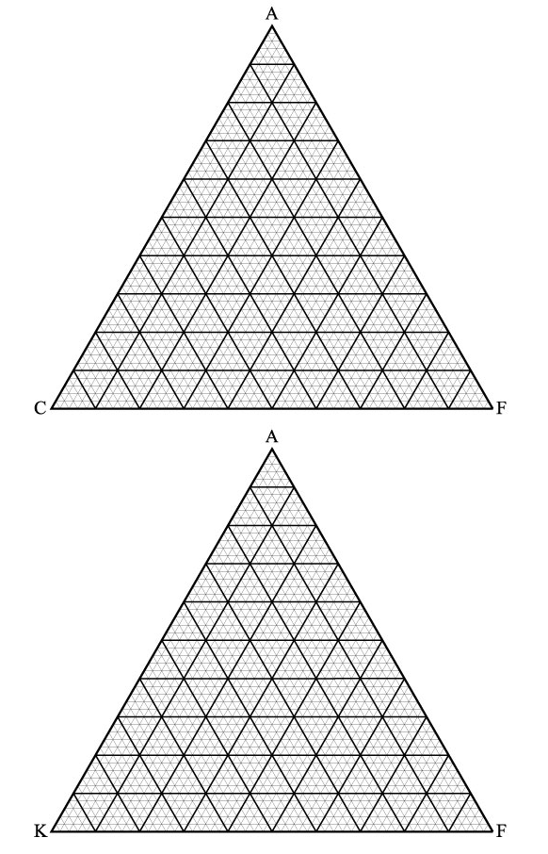

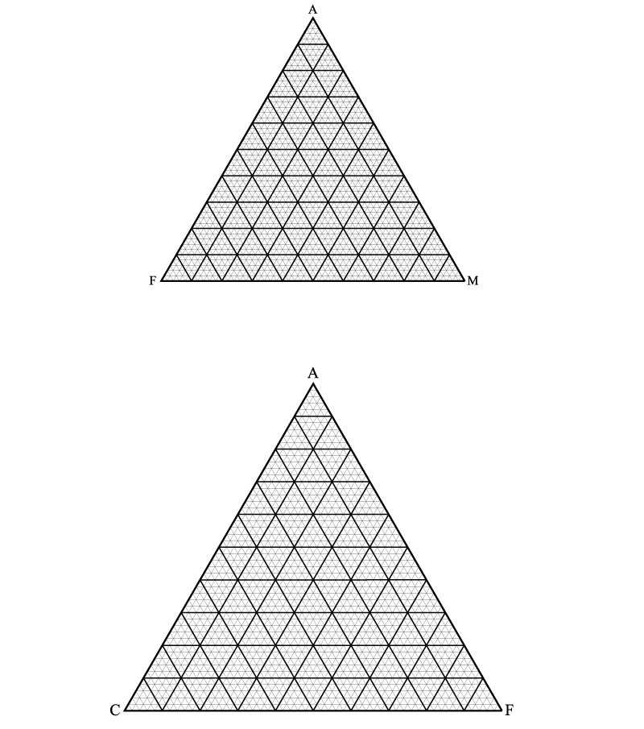

2. As a review of some important concepts from this and previous chapters, and a preview of things to come in the following chapters, consider the figure below (Figure 27.1).
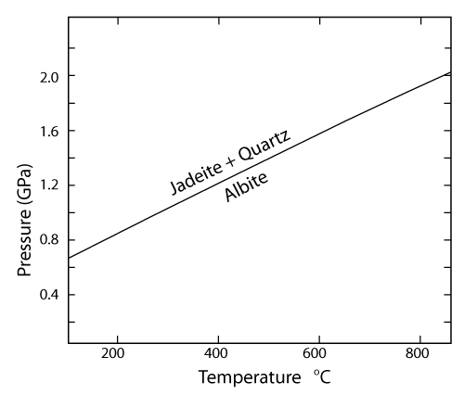

- Look up the formulas and balance the reaction jadeite + quartz = albite.

- Do the reaction and figure suggest that the molar volume of albite is high or low, compared to that of jadeite and quartz? Explain. (See Section 5.4.3 if you need to review.)

- Where on the diagram is albite stable? Explain.

- Where on the diagram is jadeite stable? Explain. (Hint: Review the second Important Concept in this chapter).

- Another reaction is possible in the same Na-Al-Si-O system: jadeite = albite + nepheline. Nepheline has an end-member formula NaAlSiO₂. Balance the reaction.

- The reaction in part (e) has a slope similar to the first reaction. Draw a possible equilibrium curve for the new reaction (properly labeled with reactants on each side) on the P-T diagram.

Does it occur at a higher or lower pressure?*

On what principle(s) do you base your answer?*

Once you have added a properly labeled reaction to the P-T diagram above, draw an isobaric traverse across the reactions and discuss what might occur during both heating and cooling.

*Note that the relationships you seek are entirely general. They are based on your answers to parts (c) and (d) above and you do not need any more specific information than you have before you. A “trial-and-error” approach on the P-T diagram should work for this.

Review Questions for Chapter 25:
Metamorphic Facies and Metamorphosed Mafic Rocks

- Pentii Eskola originally defined metamorphic facies on the basis of predictable mineral assemblages that develop in metamorphosed (mafic) rocks and occur worldwide. How does a modern approach to metamorphic facies differ?

- Compare the concepts of facies and facies series.

- What are the three common types of facies series, and what sequence of facies occurs along each series?

- To what tectonic situations might you attribute each facies series?

- What mineral or minerals impart the green color to greenschists?

- What is the composition range of plagioclase in the greenschist facies?

Where does Ca from the original igneous plagioclase (and clinopyroxene) go?

- What are the two important mineral changes that accompany the transition from greenschist facies to amphibolite facies in mafic rocks?

Which change occurs first at higher pressure?

Which change occurs first at lower pressure?

Show how this variation is possible on a sketched P-T phase diagram.

- Sketch an ACF diagram for mafic rocks in the amphibolite facies. What two coexisting minerals serve to define amphibolite facies mafics? Why does garnet occur in some amphibolite facies mafic rocks and diopside in others?

- What do minerals of the granulite facies typically have in common?

- What mineral is diagnostic of the blueschist facies in mafic rocks?

- What mineral’s absence is diagnostic of the eclogite facies in mafic rocks? Why is it missing and what replaces it?

- What minerals are characteristic of UHP metamorphism?

In what context are they typically found/preserved (on the microscopic scale)? Why?

- What principal tectonic implications do the 20+ UHP localities have for crustal behavior?

- What is UHT metamorphism, and what mineralogical evidence is there for it?

- Describe the tectonic–petrologic evolution of a rock along a typical clockwise P-T-t path.

- Describe the tectonic–petrologic evolution of a rock along a typical counterclockwise P-T-t path.

- How does the sequence of pressures and temperatures along a typical metamorphic field gradient differ from the sequence along a typical clockwise P-T-t path? Explain.
Review Questions for Chapter 26: Metamorphic Reactions

- Compare the classical notion of an isograd to treating an isograd as a reaction.

- What are the potential advantages of treating an isograd as a reaction?

- On what variables does the grade at which a polymorphic transformation reaction occurs depend?

- How do solid–solid net-transfer reactions differ from polymorphic transformations? Give an example of the former.

Why is net transfer typically involved in your example? Be as specific as you can.

- In section 26.2 the text states that “Discontinuous reactions are univariant and tend to run to completion at a single metamorphic grade…There is thus an abrupt (discontinuous) change from the reactant assemblage to the product assemblage at the reaction isograd. (The reaction behaves as though invariant in such situations, because P and T are not independent, but constrained by the P-T-t path.)” Explain this by sketching Reaction 26.2 on a hypothetical P-T phase diagram and adding a P-T-t path. It the reaction univariant? Will it take place entirely at a single metamorphic grade? Why?

- What type of reaction is the one below?
KAl₂Si₃AlO₁₀(OH)₂ + SiO₂ = KAlSi₃O₈ + Al₂SiO₅ + H₂O
Ms Qtz Kfs Al-silicate fluid

- Sketch the typical shape of the reaction curve from Review Question 5 on a P-T phase diagram and label which phases occur on which side of the reaction curve.

What criteria can you use to decide which minerals go on the low-temperature side?

Use the Clapeyron equation [Equation (5.15)] to explain why the reaction has the shape it has.

- Determine the P-T-X_{H2O} values for each of the points on Figures 26.2 and 26.4 below. Is there any correlation between the two sets of points? Explain.
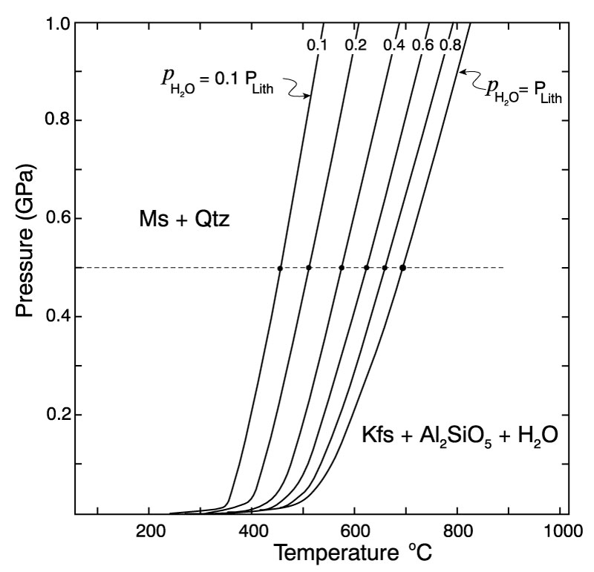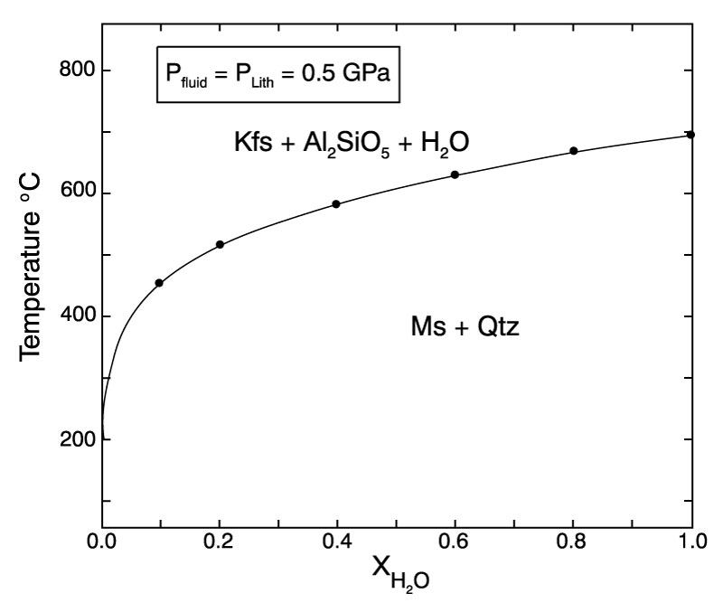

- Use the nature of the fluid products, the volatile-bearing minerals, and Le Châtelier’s Principle to explain the shapes of the five types of curves in Figure 26.6 (below).
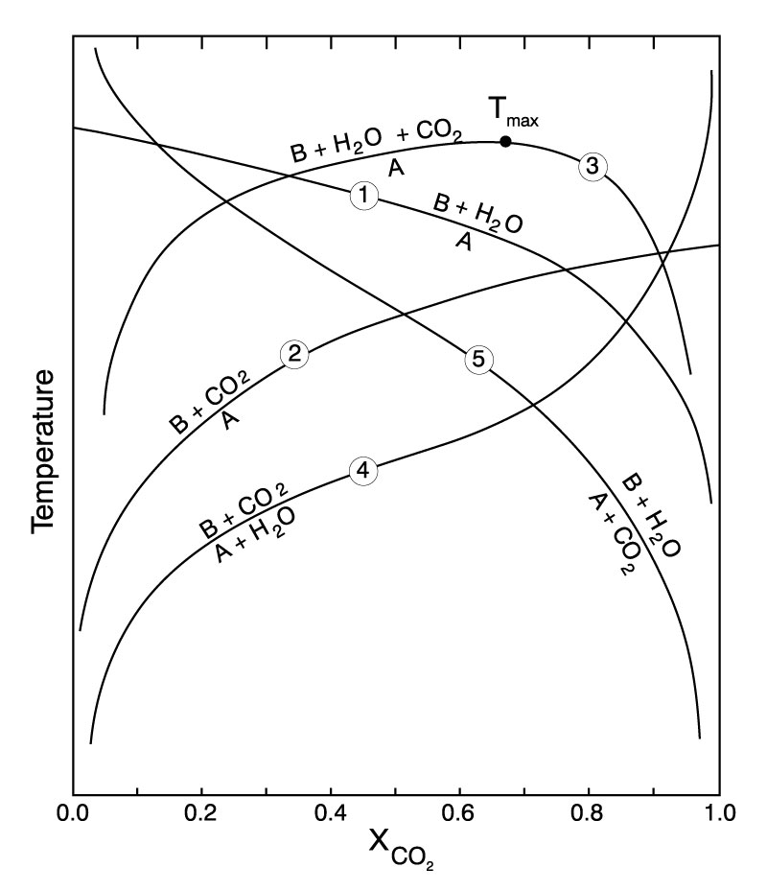

- Contrast open-system versus closed-system fluid evolution during heating of a tremolite–calcite–quartz calc-silicate rock, beginning at X_{CO2} = 0.2, using Figure 26.7 (below).
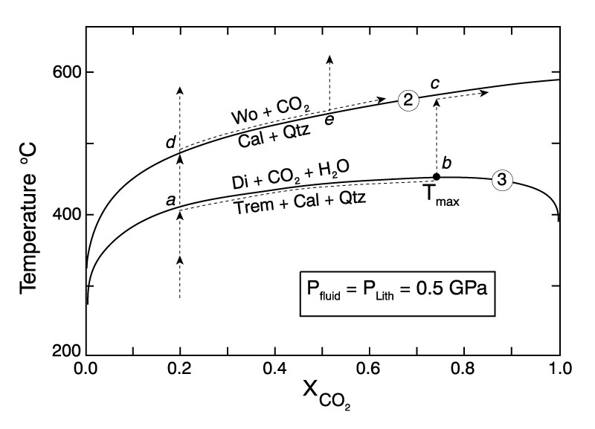

- Use the phase rule to describe the difference between a discontinuous reaction and a continuous reaction in reference to the reaction chlorite + quartz = garnet + water in the isobaric phase diagram shown in Figure 26.9a (below). Assume a (pseudo-) binary system (C = 2) for the diagram.

- Discuss the relative merits of Figures 26.9a and b (below) as they might be used to analyze rocks experiencing the chlorite + quartz = garnet + water reaction in the field. How might you add the (specific) compositional variation of chlorite and/or garnet within the shaded reaction interval to Figure 26.9b? How would you get the required information to do so quantitatively?
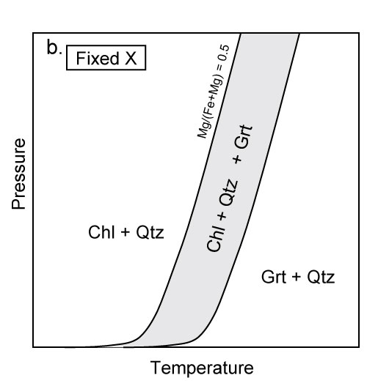

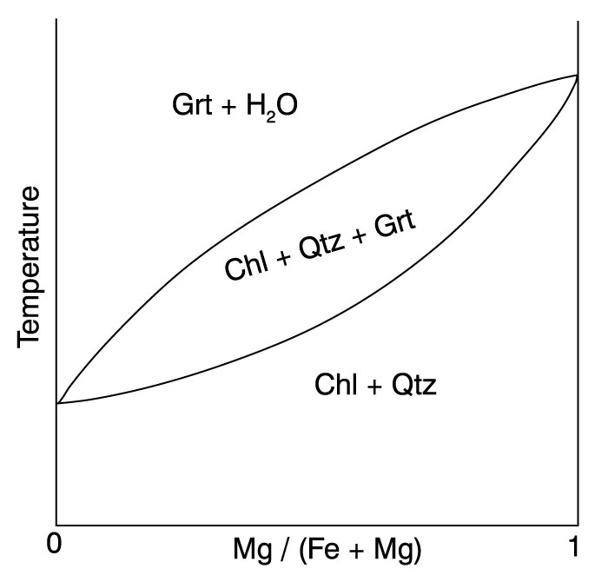

- From a strictly geometric approach, what four possible mineral reactions can you propose for the binary system in Figure 26.11 (below)? Explain your reasoning. Pick two reactions and use the lever principle to determine the stoichiometry required to balance them. Then balance the reactions in the usual mathematical way. Compare your results.
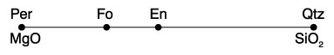

- From a strictly geometric approach, what possible mineral reaction(s) can you propose for the ternary system shown in Figure 26.12 (below)? Explain your reasoning.
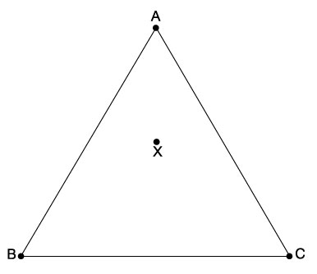

- From a strictly geometric approach, what possible mineral reaction(s) can you propose for the quaternary system shown in Figure 26.13 (below)? Explain your reasoning.
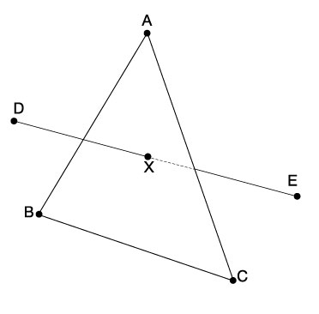

- Suppose figure (a) below represents a compatibility diagram for a particular metamorphic facies in which the minerals A, B, C, D, X, and Y are stable in the associations shown. Suppose that with increasing metamorphic grade, minerals A and D become unstable together (although both are stable individually). Using a strictly geometric approach, derive the reaction (assuming that no new mineral develops). Draw the appropriate tie-lines at the isograd in part (b) and above the isograd in part (c).
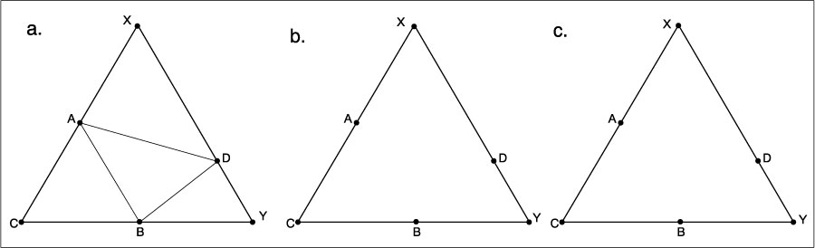

- What are three common reasons for crossed tie-lines in a compatibility diagram? Sketch an example of each.

- Look at the intersection of the Lws = An + Qtz + F (H₂O) and the Ep + Ky + Qtz = An + F reactions on Figure 26.19 (below). Use the method of Schreinemakers to determine what other reactions are necessary from that invariant point and where each should be located. Sketch your finished invariant point with metastable extensions and write the proper reactants and products on appropriate sides of the reaction curves. Are any of the curves degenerate?

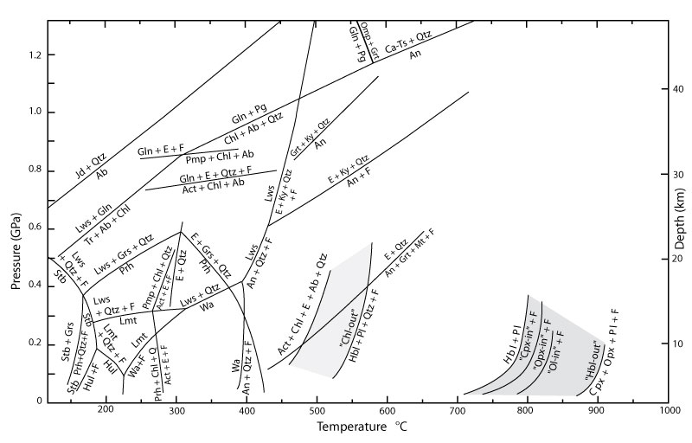

Problem
1. Assume the following minerals and formulas (A, B, and C are fictitious elements):

a: ASiO₃ b: BSiO₃ c: CSiO₂(OH)₂
w: C₂ASi₂O₇ x: BCSi₂O₆ y: A₂BCSi₄O₁₂
z: ABSi₂O₆

In a portion of a field area, the following mineral assemblages occur in equilibrium:

a-x-z b-x-z a-x-c
- Draw an accurate A-B-C compatibility diagram (projected from quartz) for this area. Assume that quartz is present in all rocks as you answer the following questions.

- Can a quartz-bearing rock contain both z and c at this grade? Why or why not?

What controls whether a quartz-bearing rock contains z or c?

- As we traverse up metamorphic grade, we encounter the “w-in isograd.” Show/explain how you can use the chemographics to determine the approximate (unbalanced) reaction involved with this isograd #1.

- Balance the reaction.

- Illustrate the T-P dependence of the reaction on a T-P phase diagram (assuming ), drawing and explaining the appropriate shape of the reaction curve (see Figure 26.2). Also label the appropriate phases on each side of the curve.

- Illustrate the T-X_{fluid} dependence of the reaction on a phase diagram (assuming that the fluid is a CO₂-H₂O mixture), drawing and explaining the appropriate shape of the reaction curve. Also label the appropriate phases on each side of the curve.

- What is the actual stability range of mineral w on the P-T diagram? In other words, under what P-T conditions can w be stable? Explain.

- Draw the compatibility diagram for the zone above isograd #1.

- At a higher grade yet, minerals a and x are no longer stable together. Show/explain how you can use the chemographics to determine the approximate (unbalanced) reaction involved with this isograd #2 (assuming that mineral y does not become stable until higher grades).

- Balance the reaction.

- Why might isograd #2 make a poor field-based (first appearance of a mineral) isograd?

- Why might some rocks show no evidence of the reaction? Be specific and refer to your diagram.

- What would you name isograd #2 and the zone above it? Why?

- Draw the compatibility diagram for the zone above isograd #2.

- As we traverse up metamorphic grade, we encounter the “y-in isograd.” Show/explain how you can use chemographics to determine the approximate (unbalanced) reaction involved with this isograd #3.

- Balance the reaction.

- Is isograd #3 a better or worse practical field isograd than isograd #2? Why?

- Draw the compatibility diagram for the zone above isograd #3.

- What are three possible reactions that may occur at the next isograd? (You need not balance them.)

t. Assuming that you won’t be able to get into the field in the near future, what would you need in order to determine which of the three reactions should occur next, if at all?

Review Questions and Problems for Chapter 27:
Thermodynamics of Metamorphic Reactions

- Is ΔG for the quartz = albite + jadeite reaction positive or negative at 600ºC and 0.4 GPa? Explain.

- Considering Figure 27.1 (below), which has a larger molar volume, albite or jadeite + quartz? Explain your reasoning.

- Geologically, where would you expect to find jadeite on the basis of Figure 27.1? (Be careful; this is a tricky question.)

- Modify Equation (27.6) by substituting appropriate pressure and/or fugacity coefficient terms, assuming that Pº = atmospheric pressure.

(27.6)

- How does the chemical potential of a component relate to the Gibbs free energy of the pure component as a phase at the same pressure and temperature?

- Given the reaction Mg₂SiO₄ + SiO₂ = 2 MgSiO₃, write an expression of the form of Equation (27.16) for the reaction assuming non-pure Fe-Mg mixtures. Use an ideal solution model for the activities, noting that olivine involves mixing on two octahedral sites.
(27–16)

What would be appropriate for the quartz activity expression? Explain.

- What is the difference between the K_{D} expression used in Chapter 9 and the equilibrium constant, K?

- Suppose you analyzed coexisting garnet and biotite, yielding Mg/Fe = 0.110 for garnet and 0.450 for biotite. Use the Ferry and Spear geothermometer to estimate the temperature of equilibration.

- What are internally consistent thermodynamic data, and why can they be expected to be more reliable than data supplied independently from myriad experiments?

- Suppose you were a hunter dependent on shooting birds for food. Would you rather be precise than accurate or vice versa? Why?
Problems
1. Calculate the equilibrium curve for the reaction calcite + quartz = wollastonite + CO₂. This problem is similar to the example problem in this chapter, with the addition of the gas pressure terms in Equation (27.8). The pertinent thermodynamic data are listed in the table below.

Thermodynamic Data at 298 K and 0.1 MPa
Phase | S (J/K mol) | G (J/mol) | V (cm³/mol)
Calcite | 92.72 | −1,130,693 | 36.934
Quartz | 41.36 | −856,648 | 22.688
Wollastonite | 82.05 | −1,546,497 | 39.93
CO₂ | 213.79 | −394,581
From the SUPCRT Database (Helgeson et al., 1978).
Begin by writing a balanced reaction using the formulas for the phases as you find them in your mineralogy text. Set up a spreadsheet similar to that in the example problem, and calculate the values of ΔGº₂₉₈ and ΔS (using all four phases) and ΔV_{s} (for the solids only). Treat the behavior of CO₂ as ideal to simplify your spreadsheet calculations. The simplest way to determine the equilibrium pressure at a given temperature is by trial and error. Set up Equation (5.22) and reference the pressure term to a particular cell of your choice. Enter values for P in that cell until ΔG_{P,T} is essentially zero. You need not vary P in increments of less than a few MPa as ΔG_{P,T} approaches zero in an attempt to get it to exactly 0.000. Compare your results to Figure 27.19 calculated using heat capacity and compressibility data.

2. Jadeite + Quartz = Albite Revisited
When the composition of a system at equilibrium is changed, the new equilibrium (for which ΔG = 0) at a given P and T differs from the old equilibrium (which was ΔG, but, because it represents pure phases, is now ΔGº) by the compositional shift. So now ΔG = 0 = ΔGº + RTlnK. We should wisely choose our reference state such that ΔGº is the equilibrium value for the pure end-members at the same P and T as ΔG. ΔGº would then be the values that we already calculated in the example problem on in this chapter for P₂ at 298, 600, and 900 K. In this case, all the ΔGº values are zero because we were seeking equilibrium conditions. If we use the ideal solution model for all of our mineral phases, we get the following expression for the equilibrium constant:
where X = Na/(Na + Ca) in each Na-Ca-bearing phase because mixing involves a coupled substitution in both the pyroxene and the plagioclase (if we consider the pyroxene mixture to involve only a diopside-jadeite exchange, clearly a simplistic assumption for real pyroxenes, but it serves for our present purpose). The compositional shift will of course create a new equilibrium curve. It is easier to calculate this as a pressure shift at constant T, so we can avoid the complex temperature dependence of ΔG (just as we did in the original problem). So if we have thermodynamic data for pure phases and can subsequently determine the compositions of the actual phases involved, it is possible to calculate the new P-T conditions of equilibrium. Go back to the spreadsheet for Problem 2 and recalculate the equilibrium, using and (these are entirely fictitious values). Because we can think of the shift in the equilibrium curve as we go from pure phases to mixtures as a pressure shift at constant temperature, we can substitute for ΔGº in Equation (27.17) and get:

Because both and are zero ( because we are seeking equilibrium, and was at equilibrium from the earlier calculation for pure phases), the equilibrium shift can easily be calculated from the above equation. P₃ is the new equilibrium pressure, and P₂ was the old equilibrium pressure calculated for each temperature in the original (pure phases) problem. We could envision the overall process as one in which the compositional change shifts the original (pure) system from equilibrium at a given pressure and temperature, and we must calculate the pressure change required to shift the system back to equilibrium (ΔG = 0). Plot both the old equilibrium curve for the example problem, and the new curve on the same graph. Note and qualitatively explain the direction of the shift calculated using Le Châtelier’s Principle.

3. Use the data in the table on the next page and one of the geothermobarometry programs, such as GTB, using independent calibrations, to calculate the temperatures and pressures at which the rock equilibrated. Plot your results and shade the bracketed conditions as in Figure 27.10. How does your bracket compare to that in Figure 27.10? If both brackets are typical of the facies represented, how does geothermobarometry in the granulite facies compare to the amphibolite facies?

4. Using the tutorials by Cam Davidson:
http://serc.carleton.edu/research_education/equilibria/twq.html
and Julie Baldwin
http://serc.carleton.edu/research_education/equilibria/avpt.html
apply the internally consistent geothermobarometry programs TWQ and THERMOCALC to estimate the pressure and temperature of equilibration. How does this technique compare to independent geothermobarometry?
Review Questions and Problems for Chapter 28:
Metamorphism of Pelitic Sediments

- What are pelites (the protolith) and where are they typically deposited?

- What are their principal chemical characteristics of pelites, and how does that affect the predominant minerals that develop upon metamorphism?

- What is meant by “in excess” when referring to a phase? If a reaction A + B + C → D + E occurs with increasing grade, how would A being either in excess or not for all natural rocks, affect the mineral assemblages that develop above the isograd?

- Using the fictitious phases A, B, C, and D, propose a reaction that (a) represents the absolute stability limit of phase A.

Next propose a reaction (b) that involves all four phases but does not absolutely limit the stability of any.

Illustrate the topology changes of both reactions using an imaginary triangular compatibility diagram within which these phases plot. Show the topology both above and below the reaction conditions. Describe which phases appear and/or disappear at the reaction isograds for various bulk compositions within your diagrams.

- Use the phase rule to determine the variance of Reaction (28.17).
(28.17)

Why is it considered discontinuous?

Why is it considered “terminal” for staurolite?

How does the geometry of the chemographic topology change differ from most non-terminal reactions?

Under what (equilibrium) circumstances would staurolite be stable above this isograd?

Why is Reaction 28.17 generally considered the common St-out isograd?

- Can you tell whether garnet or chlorite will be consumed first at point 7 in Figure 28.2? Why or why not?

- Use Figure 28.12 to address the following questions:
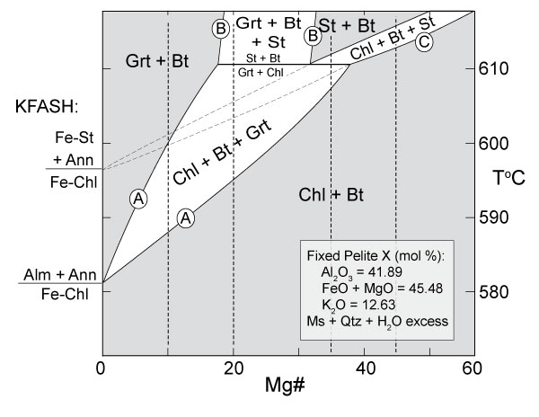

Over what range of Mg# will garnet never form due to any reaction depicted? Explain.

Over what range of Mg# will staurolite never form due to any reaction depicted? Explain.

Over what range of Mg# will Reaction (28.12) consume chlorite before garnet? Explain.

Over what range of Mg# will Reaction (28.12) consume garnet before chlorite? Explain.

Over what range of Mg# will Reaction (28.12) never occur (but staurolite can be generated anyway)? Explain.

- Pick a steep P/T path on Figure 28.14 and describe the reactions responsible for the transition from the Chl to the Chl + Cld to the Chl + Cld + Grt fields. Determine the variance of each reaction, using the reduced three-component AFM system. Show how each reaction causes the mineral change by sketching an appropriate portion of an AFM diagram both before and after the change occurs. Show your fixed X_{bulk} and indicate any continuous reactions by arrows showing the motions of migrating fields or field boundaries.
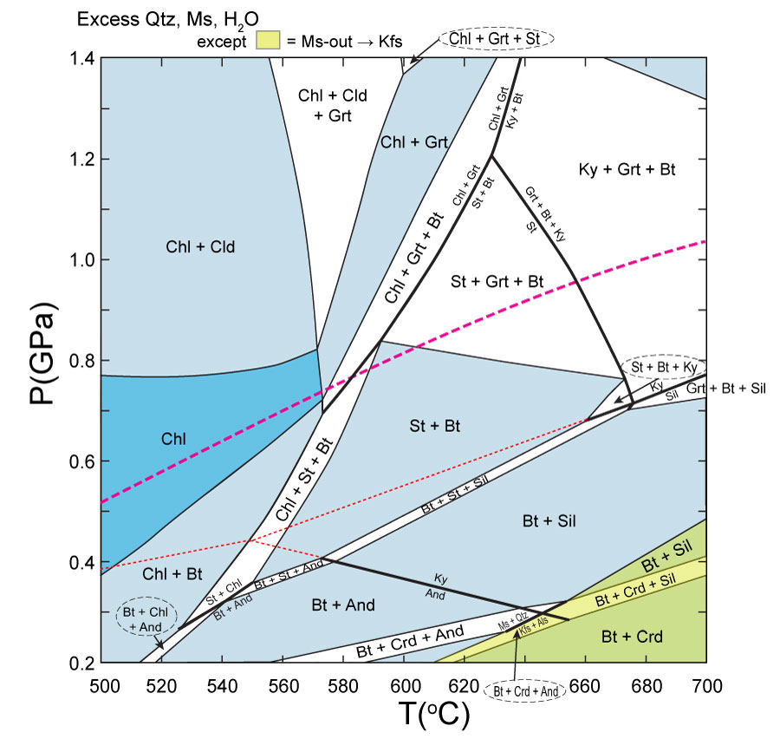

- Complete Review Question 7 for the transition from the Chl + Grt to the Chl + Grt + Bt to the Ky + Grt + Bt fields in Figure 28.14.

- Sketch on Figure 28.14 a P-T-t path that most closely corresponds to the classical Barrovian sequence of isograds. Is there a broad range of choices? If not, why do you suppose the sequence is so common?

- In Section 21.6.4 we looked at development of contact metamorphic minerals in the Skiddaw aureole. Andalusite and cordierite formed at nearly the same metamorphic grade there. How would contact metamorphism for the pelite modeled in Figure 28.14 along a low P/T traverse compare? Would either mineral form appreciably earlier than the other? IF so, which one?

- Describe the mineral changes that occur with increasing grade in the X_{bulk} corresponding to the white dot in Figures 28.19a and b. Infer the reaction(s) and sub-triangle migrations (continuous reaction) or tie-line reorganizations (discontinuous reactions) responsible.
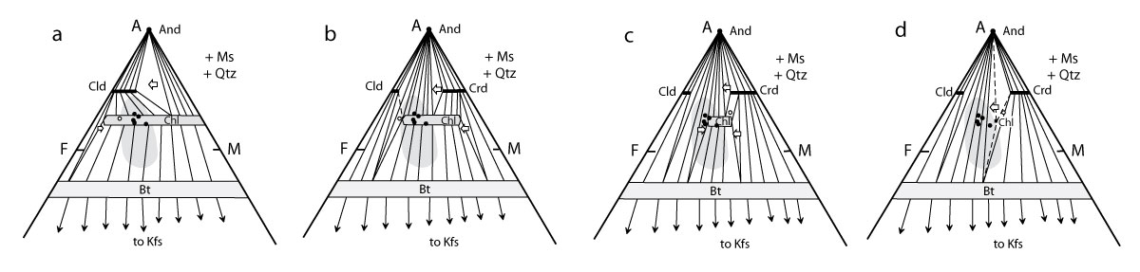

- Describe the mineral changes that occur with increasing grade in the X_{bulk} corresponding to the white dot in Figures 28.19c and d. Infer the reaction(s) and sub-triangle migrations (continuous reaction) or tie-line reorganizations (discontinuous reactions) responsible.

- From a geometric standpoint Use Figures 28.14 and 28.19 to propose how X_{bulk} might be responsible for the difference in sequence between the andalusite-in and cordierite-in isograds.

In what way are the Skiddaw rocks most likely to differ from the rock in Figure 28.14?

- How does leucosome differ from melanosome? Where have we seen similar terms before? What did they mean?

- In what three principal ways might leucosomes form?

- Describe the debate over the origin of migmatites. How was it “resolved”?
Problems
1. Using Frank Spear’s program GIBBS (see Section 27.5 for the download site), load the Spear and Cheney (S&G) grid and plot it. Choose your own P/T metamorphic field gradient (perhaps between the medium and low P/T gradients in Figure 28.2) and create a series of AFM diagrams along the gradient. Describe the changes in mineral assemblage that occur for a point on the diagram representing analysis 1 in Table 28.1 (North American shale composite). Remember that mineralogical changes can occur as a result of either discontinuous or continuous reactions.
2. Consider the two following reactions:

(1)
(2)
a. Which occurs at the higher temperature? Why? Note: This can be determined from basic principles, and need not reflect the specific nature of any of the minerals involved in the reactions.
b. Remembering the common shape of dehydration reactions, sketch both reaction curves on a P-T phase diagram (qualitatively, you need assign no values to P and T).
In three different field areas, the following occurs with these reactions:
Field area A: Reaction (1) produces andalusite, whereas Reaction (2) produces sillimanite.
Field area B: Reaction (1) produces kyanite, whereas Reaction (2) produces sillimanite.
Field area C: Both reactions produce andalusite.
Field area D: Both reactions produce sillimanite.

c. Experiment around with the two reactions and the Al₂SiO₅ phase diagram by trial and error until you can explain the four sequences. Sketch the final phase diagram and list the four field areas in order of P/T metamorphic field gradients.

3. Sketch appropriate AFM diagrams below and above the kyanite-in isograd:
Reaction (28.15).
Balance the reaction for ideal Fe end-members. Discuss which minerals are really lost and gained for rocks in each of the four quadrants of the Ky-St-Bt-Chl quadrilateral. In what types of rocks will all four phases coexist stably above the isograd? What rocks are unaffected by Reaction (28.15), and why? Why is this called the kyanite-in isograd? Label a rock in your above-the-isograd drawing that did not develop kyanite by Reaction (28.15) but does develop it by Reaction (28.16) and explain why.

4. Play the animated AFM diagram (for 3 kb: AFM3.MOV), available from your instructor or the documentation page from Roger Powell’s THERMOCALC web site
www.earthsci.unimelb.edu.au/tpg/thermocalc/
a few times using your QuickTime player. What reaction is responsible for the introduction of cordierite into most rocks? How did you determine this? Next play AFM6.MOV (6 kb). Why doesn’t cordierite occur in this animation? Place a small dot on your computer screen with an erasable (!) marker in an area affected by chloritoid and describe the sequence of mineralogical changes that affect it. What reaction introduced Cld into your rock? What reaction removed it?
5. Using your laboratory computer and a sample input from your instructor (or download one from my web site, www.prenhall.com/winter/ run Jamie Connolly’s Perple_X program to generate a pseudosection for a specific X_{bulk} equivalent to my original input, but with Mg#60. To do so, you will have to run VERTEX and supply the name of the input (.dat) file you have used (copied and modified) and then run PSVDRAW, giving it the name of the plot file named in the .dat file. You can then review your graphical results (in a Postscript file) in Adobe Illustrator. How has your new P-T pseudosection differed from Figure 28.14? How prevalent are true univariant reactions? How does the relative development of andalusite versus cordierite differ at low P/T (Review Question 8). You may elect to try pseudosections at other compositions as well. Among many possible lessons from this exercise is the “garbage-in/garbage-out” lesson of computer packages. Most require careful study of the documentation and several trials before getting reasonable results. For example, the input file I have available specifies aqueous fluid and SiO₂ saturation (quartz in excess, so you don’t have to specify an amount of SiO₂), but care was given to the amounts of Al₂O₃, K₂O, FeO, and MgO in order to meet the Ms-excess requirement as well. Injudicious variations of these input parameters may invalidate this assumption, leading to erroneous results.
Review Questions and Problems for Chapter 29:
Metamorphism of Calcareous and Ultramafic Rocks

- How does a skarn differ from other calc-silicate rocks?

- Explain the transition from Figure 29.4a to b to c using the geometric principles of reaction-based chemographic topology changes (Section 26.9). Pick three well-distributed points on the diagrams and discuss the mineralogical changes in each.
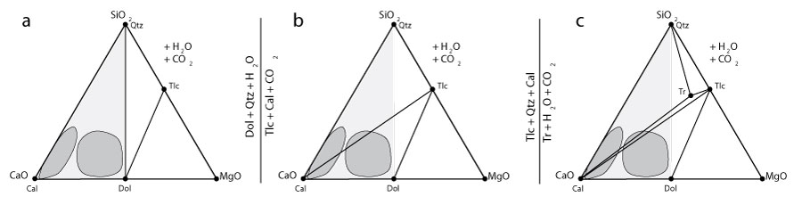

- Which reaction is most likely to introduce tremolite into the majority of siliceous dolostones? Why?

- Consider a simple system of sand, salt, and water. Propose a realistic system in which the water composition is externally controlled (at low m_{NaCl}). How many solid phases are in your system at equilibrium? Why?

Next propose a system in which the water composition is internally controlled (buffered). How many solid phases are in this system? Why?

Which system is open and which closed? Explain.

- At what value of X_{CO2} is T_{max} of Reaction (29.4)?
(29.4)

How did you determine this (see Section 26.4)?

Describe the closed-system evolution of fluid composition due to Reaction (29.4) with reference to Figure 26.7. What determines whether or not the fluid is buffered to T_{max}?
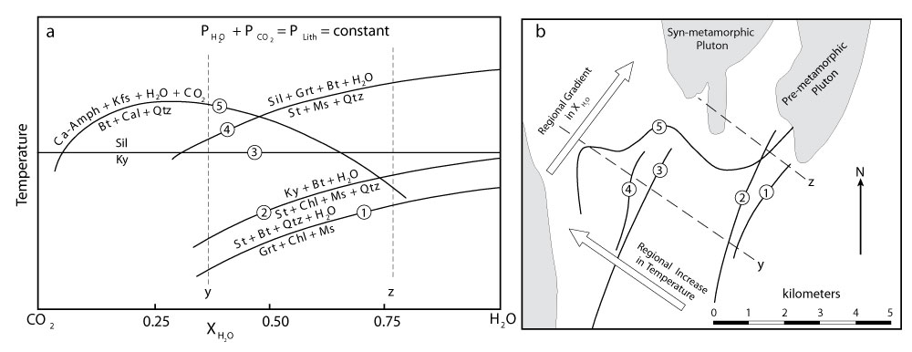

What might impede progress toward T_{max} even in relatively closed systems?

- Why is talc more common in contact metamorphosed carbonates than in regionally metamorphosed ones?

Why is diopside less common?

- Why does the sequence of isograds vary between traverses x and y in Figure 28.7?

Why are reaction isograds 1, 2, and 4 parallel?

Why do reactions 3 and 5 differ?

What controls the isograd geometry in the field?

- Using the star composition in Figure 29.11discuss the mineralogical changes with metamorphic grade. Explain the transitions using the geometric principles of reaction-based chemographic topology changes (Section 26.9).
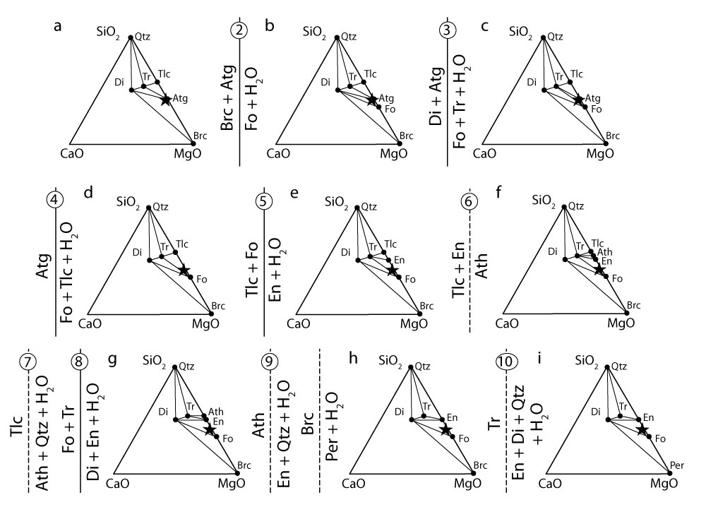

- What would you consider the most important controls on whether or not anthophyllite develops during the metamorphism of hydrous ultramafic rocks? Explain.

Problem
1. Discuss the progressive regional metamorphism from 350 to 600ºC of a siliceous limestone in which Cal > Qtz > Dol, beginning with and assuming closed-system behavior with impermeable marbles. How does the sequence of isograds differ from the first one discussed in Section 29.1.2?

Review Questions and Problems for Chapter 30:
Metamorphic Fluids, Mass Transport, and Metasomatism.

- What direct evidence is there for fluids having been present during metamorphism of rocks?

- Are fluids in regionally metamorphosed rocks a vapor, a liquid, or neither/both? Explain.

- If K_{SP} for NaCl is 36 (in the lab), what are the activities of Na⁺ and Cl⁻ at saturation?

Would you expect K_{SP} for quartz to be higher or lower than 36? Why?

- How does diffusion differ from infiltration?

Propose a simple demonstration of each using common household materials.

- Why is infiltration more rapid than diffusion through minerals?

- What is the principal limitation on diffusion through fluid infiltration?

Briefly describe processes that might circumvent this problem.

- Explain why the monomineralic layers must form in Figure 30.8 (below). What determines the thickness of the layers?
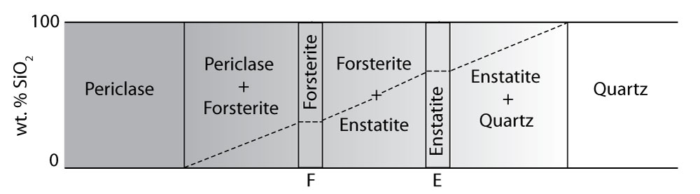

- Explain what would happen at equilibrium if were initially lower in one phase than in a neighboring phase. Why would this occur? What would you call the process?

- Why is Figure 30.11 (below) considered in local equilibrium but not in complete equilibrium? What would have to occur before it reached complete equilibrium?
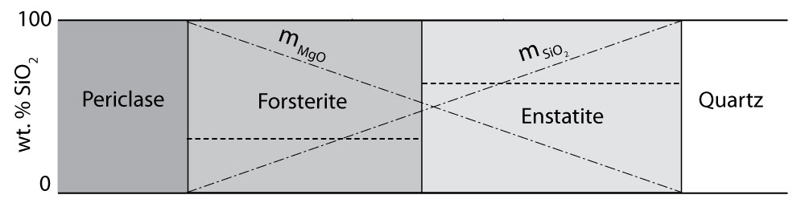

- Why can’t C_{i} reduce to zero?

- Suppose you see an outcrop dominated by subparallel monomineralic zones. What would you say is responsible?

- How do magmatic, vein, and metamorphic skarns differ? How might you distinguish them in the field?

- Why might primary hornblende in a granodiorite be replaced by pyroxene at the contact with a carbonate?

What type of “skarn” would this be called?

- Write and balance the calcite → spurrite reaction [use Equation (30–14) as a basis]. What would be the resulting slope of the calcite–spurrite boundary in Figure 30.25. Explain.

- Illustrate all five of the zonal sequences noted by Joesten in the Christmas Mountain by arrows in Figure 30.25 (below).
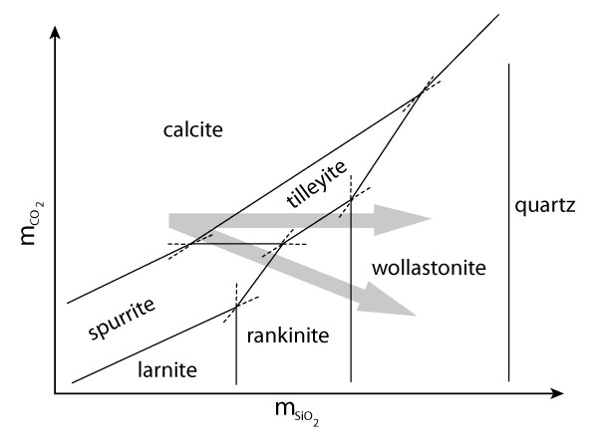
Problems
- One approximation for the time-integrated fluid flux (q_{TI}) for regional devolatilization in m³ of fluid per m² cross section from Ague (2003) is:
(30–16)
where: f_{m} = weight fraction of fluid expelled
ρ_{s} and ρ_{f} = densities of the solid rock (not including porosity) and fluid, respectively (in kg/m³)
φ = porosity (volume fraction)
L_{C} = length of the crustal column from which the fluid is derived (in meters)

Assuming fairly typical values of 3 wt. % water loss from a sedimentary pile (f_{m} = 0.03) and densities of fluid and solid of 950 and 2800 kg/^{M}₃ (respectively), porosity of 0.01. Calculate q_{TI} through a m² cross section for a crustal column 10 km long. How does your value compare to the estimates in Figure 30.6? How would your flux change if porosity were 10 times greater?

2. Given the following two rock analyses, A from Table 28.1 and B an altered equivalent, construct a Gresens-type diagram based on the estimated specific gravities based on calculations at f_{v} at 0.6 and 1.4. On the basis of your diagram, does any value for f_{v} make any more sense to you than others? Why? What elements are mobile for your chosen value of f_{v} (list them in order of decreasing mobility)? Which is added and which lost?

g_{B} = | 2. 65
g_{A} = | 2. 7
 | Analysis A | Analysis B
SiO₂ | 64.7 | 60.6
TiO₂ | 0.8 | 1.20
Al₂O₃ | 17.0 | 15.45
FeO* | 5.69 | 4.38
MgO | 2.82 | 2.97
MnO | 0.25 | 0.73
CaO | 3.5 | 3.62
Na₂O | 1.13 | 3.33
K₂O | 3.96 | 6.88

